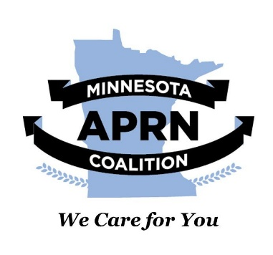


Action Scripts: Support SF 1794
🚨 IMPORTANT REMINDER: When contacting your representative, be sure to tell them you are a constituent right away! To ensure your message is logged as a constituent contact, you must include your full name and your home address in your email or at the end of your voicemail. Legislators prioritize hearing from the people who live and vote in their own districts, so your voice will carry extra weight.
Not sure who your State Senator is? You can look up your district and find your Minnesota Senator using the official District Finder tool here: https://www.gis.lcc.mn.gov/iMaps/districts/
Once you find them, click their information link, and you will get a link to contact that Senator by email or through the Capitol Contact system. Their office phone number is also listed for you to call.

Option 1: Email Template
Please personalize this template, especially if you have a specific story about how the Transition to Practice (TTP) requirement has affected your clinic or career.
Dear Senator _______:
My name is [First name Last name], and I am writing to you as your constituent [and nurse title] to ask for your support for SF 1794, the bill to remove the outdated and burdensome “transition -to-practice" requirement.
The House companion just passed off the House floor with overwhelming support! Please help us increase access to care by supporting this bipartisan, no-cost bill this year.
Current statute requires nurse practitioner (NP) and clinical nurse specialist (CNS) graduates to complete their first 2080 hours in a setting that also employs a physician. This requirement [insert personal experience here instead of/in addition to sample message] limits APRN-led clinics from hiring new graduates, drives the APRN workforce to neighboring states that do not have this barrier, and limits new graduate employment opportunities to larger systems that can easily meet the statutory requirement of having a physician on staff, regardless of whether that physician works closely with the newly hired APRNs. Evidence spanning almost 60 years demonstrates the quality, safety, and cost effectiveness of NP and CNS care. Additionally, evidence does not support the belief that TTP hours improve quality, safety, or health outcomes. By repealing TTP, Minnesota would join 16 other full practice authority states and D.C. that don’t have a TTP barrier.
Click here to read stories of impacted clinics and learn more about the policy.
Minnesota can't wait to address the shortage of health care providers, especially in rural and underserved urban areas. By eliminating this statutory barrier, this bipartisan, no-cost bill, can expand access to essential primary care and mental health services throughout the state. I ask that you continue working to find a path forward for this policy this year.
Sincerely,
First name, Last Name, credentials,
Address including city, state and zip, phone number, and email
[Your Name], [Your Credentials] [Your Home Address] (Crucial if you are a constituent!) [Your Phone Number] [Your Email]

Option 2: Email message (short version)

Dear Senator ______:

My name is [first name , last name] and I am writing to you as your constituent [and nurse title] asking you to please support SF1794, a bipartisan no-cost bill whose companion just passed off the House floor on Monday. This bill addresses the outdated and burdensome transition-to-practice requirements of nurse practitioner (NP) and clinical nurse specialist (CNS) graduates. By adopting SF1794, Minnesota would align with 16 other states and DC that have full practice authority but do not require a transition-to-practice period. This bill would have immediate impacts on expanding access to primary care and mental health services.

As your constituent, I ask that you continue to work to find a path forward for this policy this year. Thank you,

Sincerely,

First name, Last name, credentials

Address including City, State and zip, phone number, and email.

Option 3: Phone Script
Use this script if you prefer to call your legislator's office directly.
Caller: "Hello, my name is [Your Name], I am a constituent calling from [Your City]. Can I speak with someone regarding Senator [Last Name]’s position on healthcare legislation?"
Staffer: "I can take a message for the Senator. What is this regarding?"
Caller: "Thank you. The no-cost, bipartisan Transition-to-Practice Repeal Act just passed off the House Floor Monday with overwhelming support, but it’s stalled in the Senate. The TTP requirement is hurting me/my clinic/my students/my patients. [You can add a sentence or two of your experience, or leave it at that.] Please ask leadership to pass SF 1794 this year. I/my clinic/my patients can’t wait. Thank you.
Staffer: "I will pass that message along to the Representative."
Caller: "Thank you so much for your time and for passing along my support for SF 1794. Have a great day."

