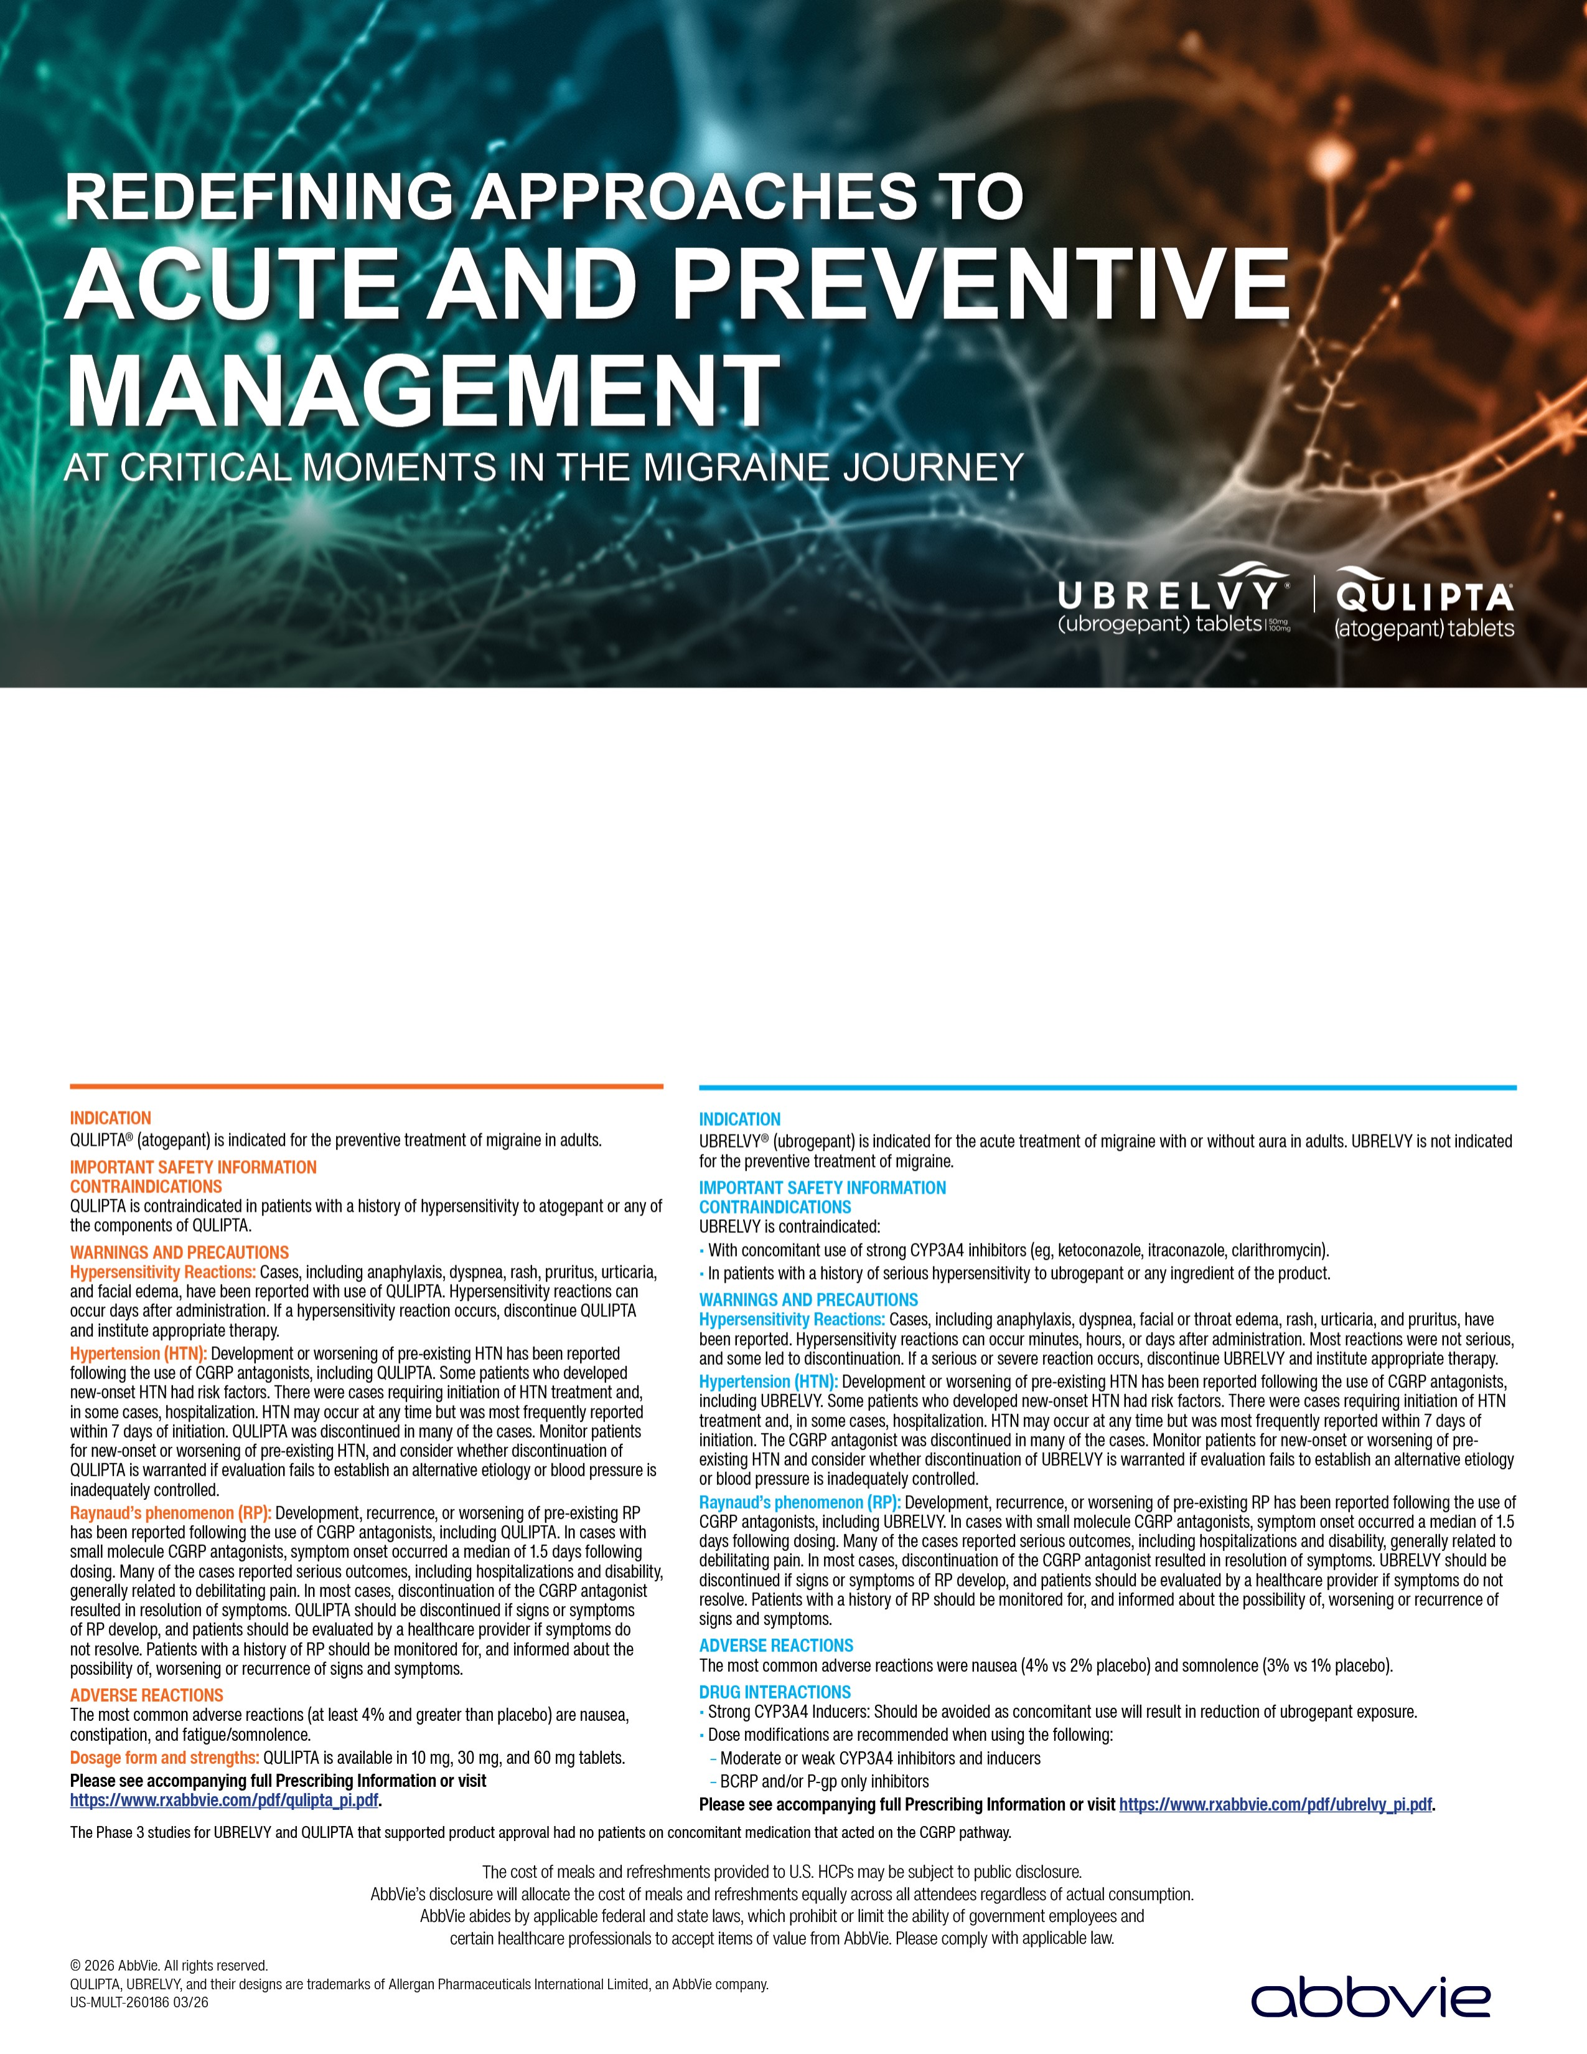
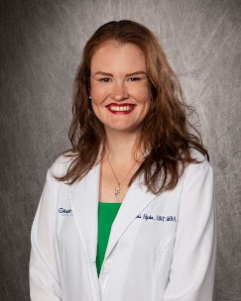

PRESENTED BY:

Tuesday, May 19, 2026
at 6:00 PM CT

Culinary Dropout
35243
241
Summit Boulevard Birmingham, AL

Keri Hyde, DNP, MBA, CRNP,
FNP-C, AOCNP
Grandview Medical Center - Chelsea
Primary Care Clinic

Please RSVP using the link or QR code at left:
https://migrainelive.com/register/24200
1
Contact your AbbVie Representative with questions
Kerstin Kyes
Phone: 2057254350 Email:
kerstin.kyes@abbvie.com
__________________________
_
__________________________
_

