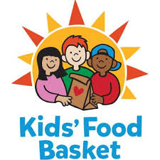 Volunteer Event

Hello MICNP members!
We have been wanting to do an activity together as a chapter that is both fun and beneficial to our community. We were able to set up a group time for volunteering at our local Kid’s Food Basket. We hope this will be a good time of socializing and networking with all our members. There is such a need for this food program in our communities and what a great way we can give back and have fun at the same time.
We will meet on:
Tuesday, 5/19/26 from 6:00-7:30 PM. Kid’s Food Basket is located at 1300 Plymouth Ave NE, Grand Rapids, MI 49505.
For anyone planning to come you will need to complete this Kid’s volunteer sign-up link to register.
https://vhub.at/micnpoliai
They have reserved 10 spots for our group. (We can sign up for more slots in the future if this is an event that interests you all.)
Hope you all can make it.

MICNP Grand Rapids Chapter Board

