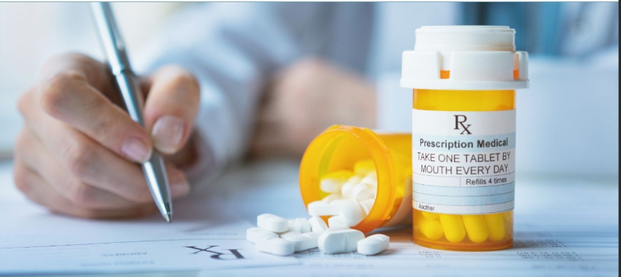  PCNP  Pharmacology Conference  Date: April 11th, 2026  Time: 8 am - 2 pm EST  Location:  Allegheny General Hospital  George J. Magovern, MD Conference Center  320 East North Ave,  Pittsburgh, PA 15212  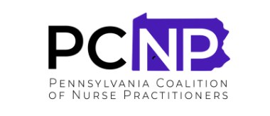 | Presentation of Newest evidenced Based Practice Suggestions  ────  ELIGIBLE FOR FIVE PHARMACOLOGY CONTINUING EDUCATION CREDITS  ────  COST:  MEMBERS: $40  NON-MEMBERS: $45  STUDENTS: $25  ────  Lunch will be provided  Please RSVP  Email: bmarturano@francis.edu

