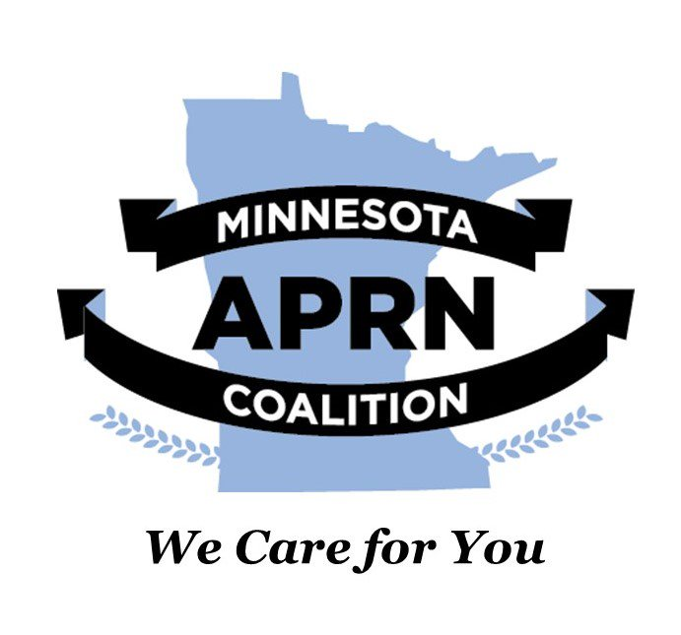
Advocacy Action Alert
Protect Graduate Nursing Education: Demand that Nursing Be Recognized as a Professional Degree
The U.S. Department of Education’s new definition of “professional degree” excludes nursing, capping federal loans for graduate nursing programs at half the level available to other professional programs (e.g., medicine, law) and eliminating Grad PLUS loans.
This proposed action threatens access to Nurse Practitioners, Clinical Nurse Specialists, Certified Registered Nurse Anesthetists, Certified Nurse Midwives, and other graduate nurse education programs. It will worsen workforce shortages, especially in rural and underserved communities.
What you can do!
JOIN the Minnesota APRN Coalition!
The Coalition’s mission is to improve access to quality healthcare by removing legal, regulatory, and institutional barriers and enabling APRNs to practice to the full extent of their education. The proposed legislation would limit nurses’ ability to become APRNs and threaten Minnesota’s future healthcare workforce. The Minnesota APRN Coalition advocates for full-practice authority, professional recognition, and equitable access to care. If you are an APRN, receive care from an APRN, or support this mission, please join our advocacy efforts.
To join, find us on the internet at www.mnaprnc.org
Sign the Petition!
Sign the petition hosted by the American Nurses Association, and supported by over 50 professional nursing and health organizations, calling for the Department of Education to revise the definition of ‘professional degree” to include nursing explicitly.
- Click the link below or go to RNAction.org → look for the campaign on Professional Student Loan Caps / Professional Degree Definition.
- Enter your contact information (name, email, address – used to match you with policymakers).
- Review the pre-written message, personalize with 1–2 sentences about your role (student, NP, faculty, patient, etc.).
- Click Submit to add your name to the petition and send your message.
Link to ANA Petition
Contact Congress with AACN!
American Association of Colleges of Nursing (AACN)
- Action Center – Email Your Lawmakers:
➤ AACN “Support Nursing as a Professional Degree” Campaign
- What you’ll do there:
  - Enter your address to identify your Members of Congress.
  - Send a pre-drafted email asking them to sign onto congressional letters urging the Department of Education to recognize post-baccalaureate nursing as a professional degree
Use Advocacy Tools of the APRN Professional Organizations!
American Association of Nurse Practitioners: Issue Hub and Advocacy Center
American Association of Nurse Anesthesiology
American College of Nurse Midwives
National Association of Clinical Nurse Specialists
On these pages, you can:
- Explore the issue more thoroughly, and understand each APRN's roles, concerns, and requests for change.
- Send targeted messages to Congress and the Department of Education.
- Download AANP’s one-pager summarizing the NP-specific impact of the professional degree definition.
Provide comments on the Federal Register!
The opportunity to make public comments on the proposed DOE changes will be available through the Federal Register, likely in January or February 2026. There is typically a 30-day period to make your opinion on these proposed changes known directly to the DOE and members of Congress. Keep a close watch on the Minnesota Coalition’s website, which will alert you when you can make comments and direct you on how to do so.
The time for action is now!

