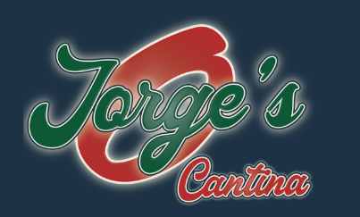

You are cordially invited to attend a CTNP Association discussion

Incorporating CGM to OPTIMIZE Outcomes for Your Patients with Diabetes

Discussion facilitated by:
Jason Davis
Territory Business Manager

Thursday, November 20 - 6:30pm
Jorge’s Cantina- 4225 Franklin Dr.

RSVP to: Jason.Davis2@Dexcom.com or 254-855-8400

