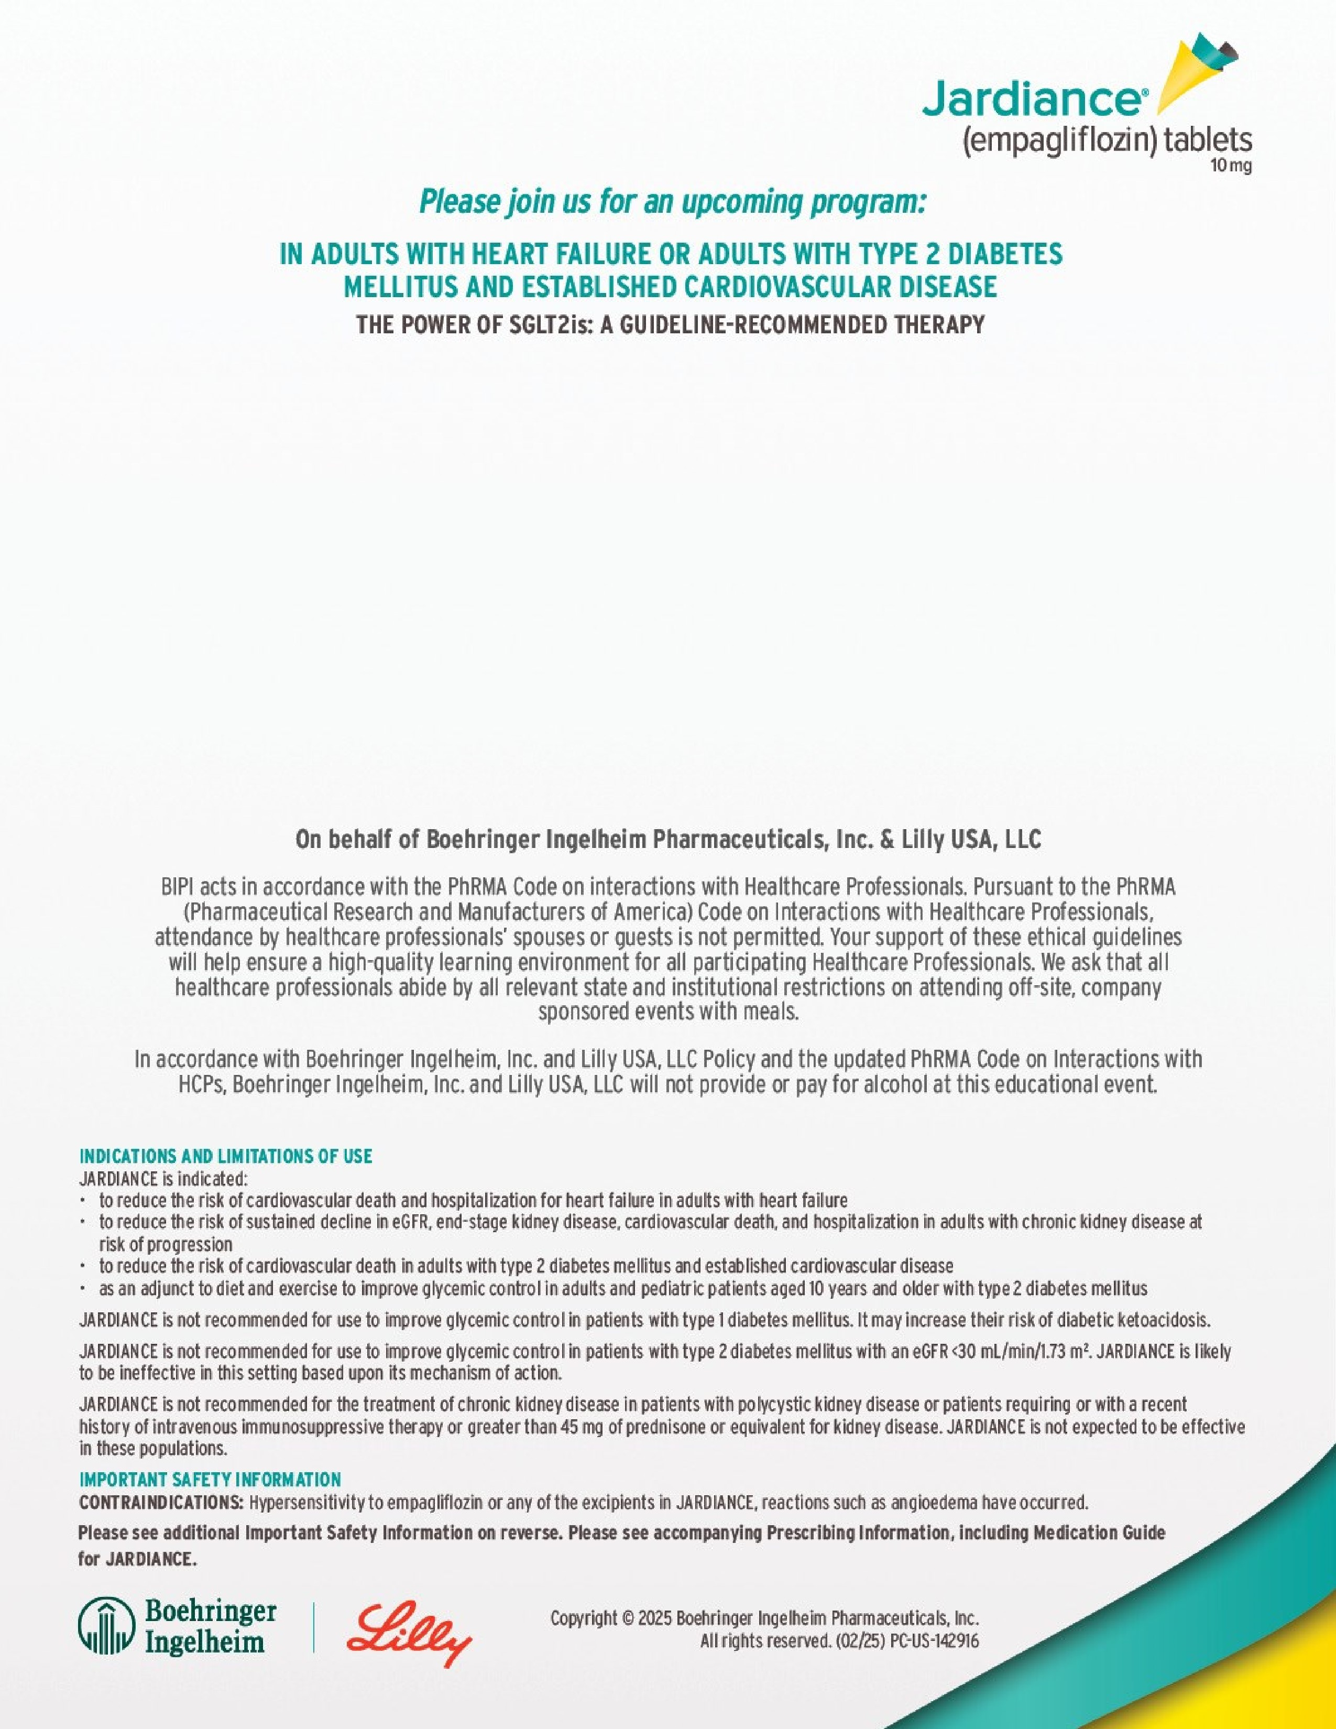

**Date and Time:**

*Wednesday, September 10, 2025 06:30 PM*

*-*

*07:30*

*PM EDT*

**Speaker:**

*Jesus Vargas, MD. Medical Director, Heart Failure Program, UPMC Central PA*

**Event Location:**

*Oralee's Golden Eagle Inn*

*131*

*E Pitt St*

*Bedford*

*,*

*PA*

*15522*

Please RSVP to

Lori Myers

at

lori.myers@boehringer

-

ingelheim.com

or

717

-

649

-

3706

Please RSVP by

9

/

7/2025

