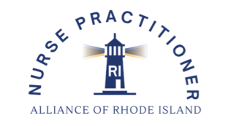

**NPARI Administrative Assistant Job Description**

**Job Description:** Part-Time 1099 Administrative Assistant

**Experience:** Administrative tasks including attending meetings, meeting minutes, website management, assisting with events and conference material. (previous healthcare experience encouraged)

**Skills:**

* **Decision-Making**: Ability to make independent decisions on day-to-day administrative tasks, ensuring smooth operations and timely follow-through.
* **Communication & Collaboration**: Strong interpersonal skills with the ability to work closely with the Administrative & Event Assistant, President, Board of Directors, and committee chairs. Write professionally, using proper spelling and grammar.
* **Organizational Skills**: Excellent ability to track deadlines and keep materials in order so that meetings and events run efficiently.

**NPARI Job Duties:**

* Attend and record minutes for all meetings (BOD, Education, Business, Strategic, Legislative, By-Law, Executive).
* Collaborate with Administrative/Event Assistant, President and committee leaders.
* Submit meeting minutes to President for review.
* Provide general administrative support for NPARI.
* Post meeting reminders, save the dates, registrations, announcements, agendas, and minutes on the website.
* Send scheduling polls for upcoming meetings.
* Coordinate Zoom links, agendas, and minutes with committees.
* Communicate professionally via phone, email, and text.

The Administrative Assistant will support the Administrative & Event Assistant with planning and executing the annual conference, including:

* Assisting with **conference materials,** such as posters, QR codes, and evaluation links.
* Helping to **monitor and report evaluation outcomes** to the Board of Directors.
* Preparing and sending **CE certificates** upon completion of evaluations.
* Coordinating and purchasing **conference supplies** as needed.
* Supporting **vendor needs** before and during the event.
* Helping with **event setup**, clean up, organization and **registration of members** on the day of the conference. Supporting **vendor needs** before and during the event.
* Additional tasks as needed

**Please submit your resume to NPARIPRESIDENT@gmail.com**