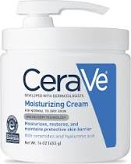 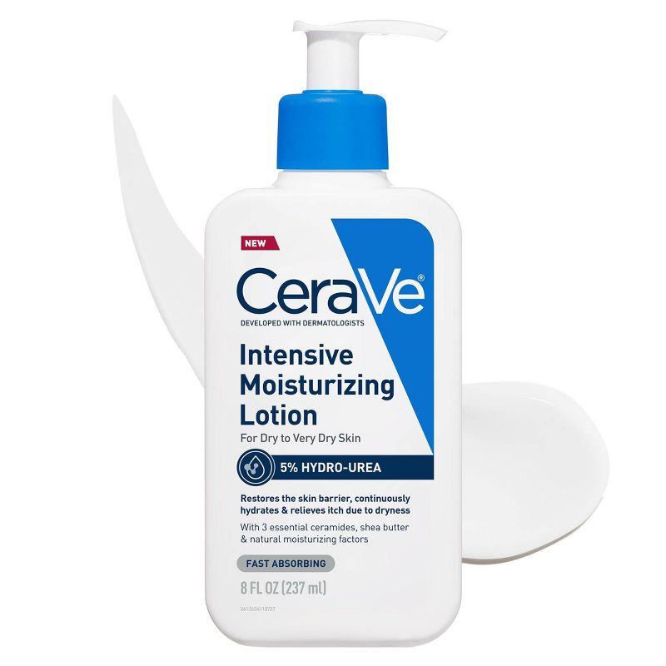

*Wash with liquid cleansers or cleansing bar only

*Mupirocin antibiotic ointment twice a day for 5-7 days as needed for signs of skin infections



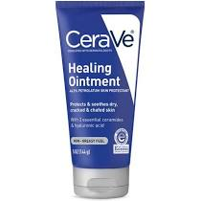

**FLARE CONTROL PLAN WHEN THERE IS ECZEMA**

USE OINTMENTS INSTEAD OF CREAMS + MEDICATION

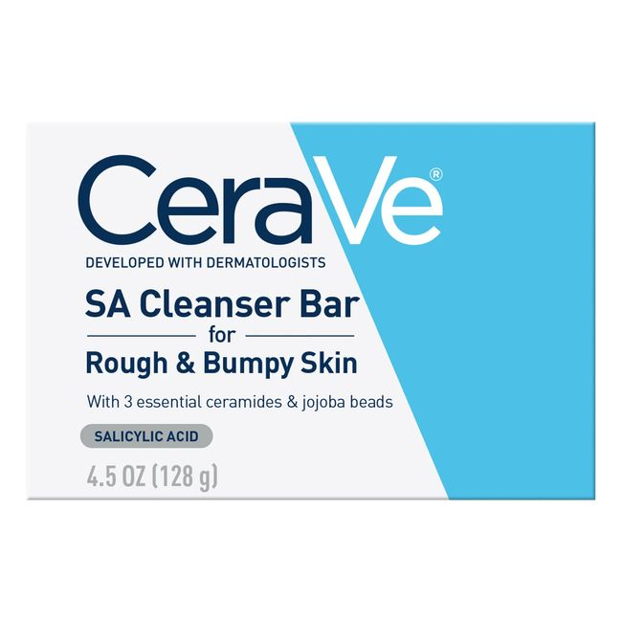 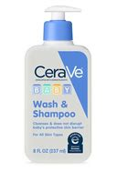

**EVERYDAY PLAN WHEN SKIN IS NOT FLARING**

**FACE, UNDERARMS, GROIN:** *improved in 3-7 days*

Hydrocortisone 2.5% ointment (1/10)

**THIN RASHES ON THE SCALP/BODY:** *improved in 1-3 days*

Triamcinolone 0.1% ointment (5/10)

**THICK RASHES ON THE BODY:** *improved in 5-7 days*

Fluocinonide 0.05% ointment (7/10)

**CLEANSE SKIN REGULARLY:**

**Use a liquid cleanser or cleansing bar to wash the body**

*Soak in luke warm water 5 min daily or EOD*

**MOISTURIZE OFTEN:**

**As often as the skin is dry with a ceramide based product**

**PREVENTION MEDICATIONS DURING FLARING SEASON**

Apply on ALL areas you commonly flare 2-3 x/wk

tacrolimus/Protopic

Opzelura

Zoryve

Vtama (once a day everyday for 4 weeks)

**NOT GETTING BETTER AT ALL**

**Clear or almost clear skin**

**Red/bumpy/itching**

**Reduce Inflammation & prevent infection**

***Do as often as they seem helpful and not drying***

*Dilute bleach baths, chlorine pool or hypochlorous acid*

**URGENT because eczema is not improving**

Send message through portal with photos and text the office

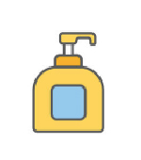

**Ointments**

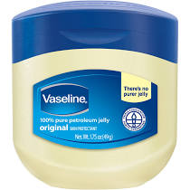

**Moisturizers**

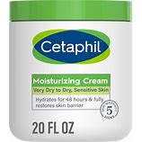

**Non-soap cleansers, shampoo, conditioner**

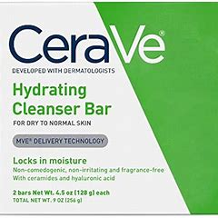 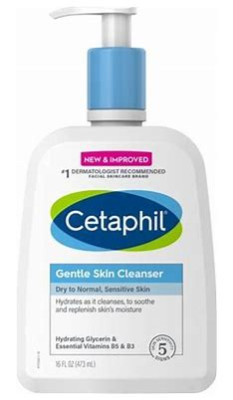 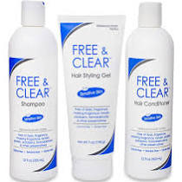

*

**Luke warm water baths daily with gentle cleanser**

* • If your moisturiser comes in a tub, use a spoon to scoop the moisturiser out. Getting it out with your hands can contaminate the container and lead to skin infections.

• PAT your skin dry after bathing and apply your moisturizer within 3 minutes of bathing.

* Wash with cleansers that keep the skin at 4-6 pH

**Bathing and moisturizing**

**Things that can make the skin worse**

• Soaps and bubble baths

• Perfumed products, air fresheners, oil diffusers

• Detergents or fabric softeners with scent

• Wool or rough clothing/material

• Extremes of temperature (e.g. hot bath water)

• Sand, soil, modelling clay, paints, slime

• Stress

Links to check out

-National Eczema Association: www.nationaleczema.org

-Gladskin <https://gladskin.com/products/eczema-cream-for-babies-kids> **(20% off: HAPPYSKINDERM20)**

-ScratchMeNot sleeves [Amazon.com : scratch me not sleeve](https://www.amazon.com/s?k=scratch+me+not+sleeve&adgrpid=1343604573673596&hvadid=83975481852843&hvbmt=be&hvdev=c&hvlocphy=77219&hvnetw=o&hvqmt=e&hvtargid=kwd-83976190336039%3Aloc-190&hydadcr=24798_13514811&msclkid=031a1ebd9036117a80f27873a8d7224e&tag=mh0b-20&ref=pd_sl_xwnutoz8p_e)

-Hypochlorous spray: Activ Kids Spray <https://shop.bldgactive.com/?rfsn=6419770.ee7ec85>

**Top Tips**

• Avoid fragrance, botanicals and food products on open, flaring skin

• Do an extra rinse when washing clothes

• Cold moisturizers or cold packs calm itchy skin

• Distract itchy fingers with toys, games, music

**[Eczema essentials]**

**Sun Safety Tips**

* Seek shade between the hours of 10AM and 4PM. This is when the sun’s rays are strongest.
* Application rules:
  + Apply every 2 hours when sun-exposed
  + Apply every 20-30 minutes when you are sweating or getting wet
* Use an SPF of at least 30, especially when going outside, *even on cloudy days*. The sunscreen should either say it protects from UVA *and* UVB or offers “broad-spectrum” sun protection, which means the same thing. Look for the American Academy of Dermatology (AAD)SEAL OF RECOGNITION ®. Sunscreen should be applied 15-30 minutes before your child goes outside.



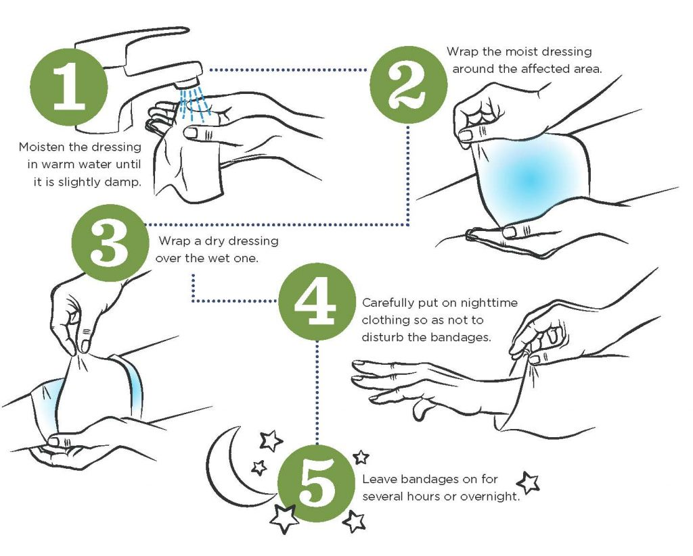

**WET WRAPS:**

**Used for severe flares to improve rashes in areas that can be wrapped with gauze or clothing**

**Warning: This treatment will increase the strength of medications and should only be used when directed.**

**Wet wraps also promote hydration to targeted areas**

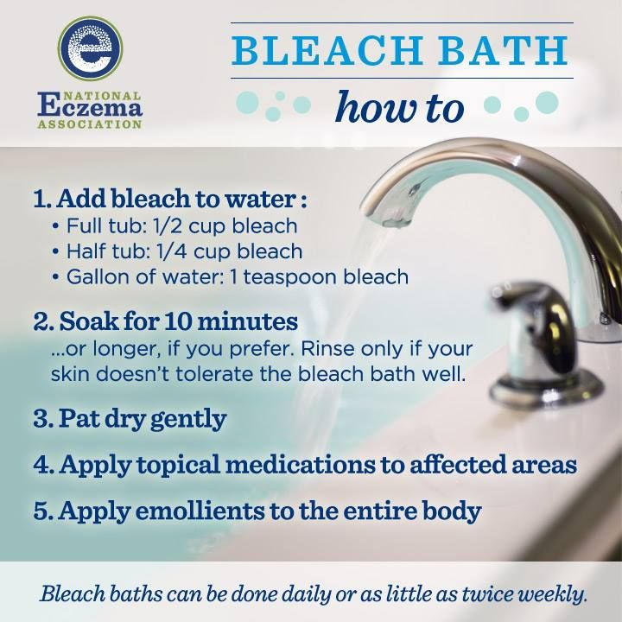

5