Target Audience: Registered Nurses, Pharmacists, Physician Assistants, and Nurse Practitioners.  Program Objective: This activity will provide knowledge affording the audience to identify two latest treatment strategies to practice as well as be able to discuss new medications and trends in healthcare  Contact Hours: To receive a statement of credit, attendee must sign in, attend the entire program, and complete the program evaluation.  This activity is being submitted for 6.0 contact hour(s) of continuing education (with 2.0 pharmacology hours) by the American Association of Nurse Practitioners |  |  | - Registration:  - PCNP Members: $35.00  - PCNP Non-Members: $50.00  - Student: $25.00  Registration deadline is August 30, 2024 if mailing and September 10, 2024 if done electronically  - You may go to following link to register and you will have a registration fee of $3-5 or can mail in check.  - https://www.eventbrite.com/e/the-curves-of-healthcare-tickets-887232214437  - Parking: Free parking at Blair County Convention Center  - Discounted hotel accommodations will be available at the Courtyard by Marriott: 2 Convention Center Dr Altoona, PA 16602  - Phone: (814) 312-1800  Cancellations: A full refund of the registration fee, if within 5 days of conference. No-shows will not receive a refund.  Special Requests: All special diet requests should be submitted to Tammie Payne at paynetm@upmc.edu by August 30, 2024. |  |  | The Curves  Of  Healthcare  September 13, 2024  7:30 am – 4 pm  Blair County Convention Center  7

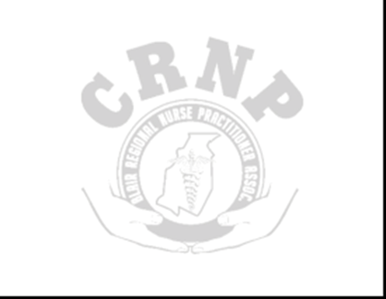  Speakers:  Sabrina Brown, MPAS, PA-C Hyndman Health  Ryan Matthews, CRNP, FNP-C James E. Van Zandt VA Medical Center  Sandra Rhodes, CRNP, AP-PMN James E. Van Zandt VA Medical Center  Danielle Gibbons, PMHNP-BC, FNP-BC Nolton Diagnostic and Treatment Center  Pam Lorditch, CRNP Conemaugh Neuroscience/Neurology  Molly Vargo, CRNP Windber Medical Center |  |  | Agenda  7:00 a.m.-7:50 a.m. Registration and Sponsors ~Continental Breakfast~  7:50 a.m. Opening remarks  8:00 a.m.-9:00 a.m. --Sabrina Brown, MPAS, PA-C – Medical Assisted Therapy  9:00 a.m.-10:00 a.m. -- Ryan Matthews, CRNP – CHF with acute kidney disease  10:00 a.m.-10:30 a.m. Sponsors/Break  10:30 a.m.-11:30 a.m. -- Sandra Rhodes, CRNP- Bippity Bobbity Bup  11:30 a.m.-12:30 p.m. -- Danielle Gibbons, PMHNP-BC, FNP-BC – Identifying and treating Major Depressive Disorder (MDD) across the lifespan  12:30 p.m.-1:30 p.m. LUNCH/ Sponsors  1:30 p.m.- 2:30 p.m. --Pam Lorditch, CRNP – Brain Pain Explained  2:30 p.m.-3:30 p.m. -- Molly Vargo, CRNP –What’s the Skinny on Obesity and GLP-1/GIP RAs for Weight Management?  3:30 p.m. – 4:00 p.m. Closing remarks, basket raffles, Sponsor card winner, Scholarship awards |  |  | Registration form  Name ___________________________  Address _________________________________  ________________________________  Phone number____________________  Special meal requests _________________________________  Please make check out to: Blair Regional NP Association  Mail to Blair Regional NP Association  PO Box 1295  Altoona, PA 16601  Registration deadline is August 30, 2024 if  mailing and September 10, 2024 if done electronically  PCNP Member $35 __________________  Membership number  Student $25 _______________________  School  Nonmember $50  Contact Us  Blair Regional NP Association  PO Box 1295  Altoona, PA 16601  blairregionalNPs@yahoo.com

