### 

### PRIMARY CARE NURSE PRACTITIONER RESIDENCY PROGRAM

*Black Hills VA Healthcare System in partnership*

*With South Dakota State University College of Nursing*

**NOW SEEKING APPLICATIONS FOR THE FALL 2024 COHORT DUE BY MAY 30, 2024**

**Our Goal:**

Provide newly graduated NPs with an individually tailored program that expands on their current clinical foundation, enhances knowledge, independence, comfort, and clinical skills that are necessary to serve as experienced providers within the VHA healthcare system.

**Program Structure and Application Criteria Highlights (see application for complete list)**

The residency will begin in September 2024 and includes a salary with federal benefits. Residents are guided through a one year training program custom tailored for their individual needs as a new graduate. Residents will complete extensive additional training with multiple specialties including but not limited to cardiology, urology, oncology, emergency medicine, orthopedics, surgery, dermatology, mental health, and procedure specific training including suturing, biopsies, joint injections and womens health procedures. Residents will receive additional didactic content utilizing simulations, grand rounds, and complete yellow belt training for continued professional development and process improvement.

* Program has no contract but is designed for individuals whom desire to work with the veteran population and graduated residents will be given priority to openings with the VA
* Program offers paid holidays, paid time off, sick leave and a M-F schedule with no evenings, holidays or on call expectations
* Residents earn progressive responsibilities based on their individual skills and will advance at their own pace in each area.
* Must be a recent graduate (within 12 months of start date) of an Adult/Family Practice /Gerontology NP program
* Must be applicants first job as a nurse practitioner
* APRN/ CNP license (due by program start date September 1, 2024)
* National Certification / AANP or ANCC (due by program start date September 1, 2024)

<https://www.va.gov/black-hills-health-care/work-with-us/internships-and-fellowships/primary-care-nurse-practitioner-residency/>

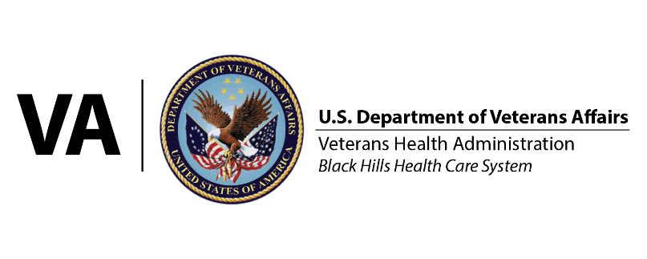Karron Zopp, MSN, FNP-BC, ANCC

PC-NPR Residency Director

VA Black Hills Health Care System

[karron.zopp@va.gov](mailto:karron.zopp@va.gov)

(605)-347-2511 ext 17968