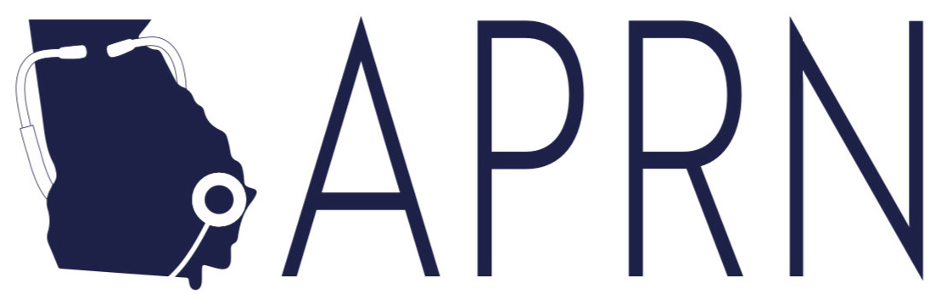

Advanced Practice Nurses Council of Coastal Georgia

Dinner Meeting Minutes
January 11, 2024
Dinner Meeting:
- Our meeting was sponsored by Horizon Therapeutics with representative Cheryl Kennedy and speaker Dr. Michael Hemphill present. The meeting was held at Cohen’s Retreat in Savannah. The topic was “Understanding the Disease Burden and Clinical Implications of Neuromyelitis Optical Spectrum Disorder
Business Meeting:
- Introduction of and welcome to new members and guests
- Treasury Report (Kim)
  - The balance remains largely stable - $16,720.76
    - The only reoccurring expense is the ENP Website
      - Other expenses include dinner meetings the APRNCCG has been sponsoring as well as new APRN logo / supplies.
  - Tax paperwork was completed and approved! Our group is formally a 501(c)6 organization again.
- New Business
  - Dinner Meetings (Analicia)
    - February 8, 2024, at 6:30pm
      - Speaker: Jeff Durthaler, M.S., PharmD
      - Topic: Chronic Kidney Disease and Diabetes Current Guidelines
      - Location: HUSK Restaurant in Savannah.
    - March meeting
      - We have decided to not host a meeting for March unless we have a rep-sponsored dinner as March is very busy with St. Patrick’s Day and GSU spring break.
    - April 2024 meeting
      - This will be sponsored by the APRNCCG and hosted by GSU at their Armstrong Campus location. More to come!
        - The meal will be Italian!
    - May 2024 meeting
      - We are planning for the May 2024 meeting to coincide with Nurse’s Week (the week of May 6) in a casual, family friendly setting for our members to mingle in a more casual setting.
    - Monthly casual meet ups
      - MEMBER INPUT: please let Analicia know if you want to help set this up!
    - Pharmaceutical / representative sponsored meetings
      - MEMBER INPUT: Please send us any representatives that may be interested in sponsoring a meeting to Analicia
  - Member Engagement
    - Social media engagement (Kaitlyn)
      - We have followers! We are planning to have members speak on topics of interest (such as RSV, Diabetes, etc.) in brief videos catering towards social media audiences.
    - Small business highlight (Christen)
      - We love supporting our members and community! Please let Christen know of any small businesses that we should highlight.
    - We will also pass along any rep sponsored dinners that members may be interested in attending through the website and email list.
  - Community Impact
    - Community activities / health fairs / etc (Ingrid)
      - This is in process – thank you to Ingrid who has been leading on this!
        - We will need a list of people who want to volunteer – Christen will look into starting a GroupMe once we get specific dates / activities established.
      - Christen has reached out to the Lion’s Club on the Islands – they are very energetic, but a newer group so do not currently have the capability to help our group at this time.
      - We are looking into fundraising and other opportunities to help purchase items for community outreach!
      - Christen has started an Amazon wish list!
        - https://www.amazon.com/hz/wishlist/ls/3EHVNKEL838KH?ref_=wl_share
        - MEMBER INPUT: If you have ideas as to what needs to be on our wish list or have knowledge of grants we should apply for, please let Christen know!
    - UAPRN
      - We continue collaborating with the UAPRN and appreciate their hard work for APRNs in Georgia. Christen is leading on this.
      - The group has decided to financially sponsor the UAPRN. We will give them $1000 for this month and will plan to give a specific percentage each year of our income as a planned donation to their organization.
    - Nurses week / APRN celebrations
      - We will hold a raffle twice a year for our members - this will coincide in November with NP week and May with Nurses week.
      - This was a huge success at our November (NP Week) meeting and we look forward to May (Nurses Week)!
    - CME / educational offerings
      - We would love to offer CME at our meetings when appropriate.
      - However, after research at this point it is not a time or cost effective option for the APRNCCG as a group unless we plan for a bigger event (ex: seminar, conference).
      - The best option is to partner with other organizations that are pre-approved for CME.
        - Ex: GSU, Augusta University, MCG, SJC
        - One member recommended looking into collaboration with GANE.
        - MEMBER INPUT: If you have any contacts, please let Christen know
      - Thank you, Lisa, for taking the time to investigate this!
    - Scholarship for APRN students
      - Christen is going to work on this and hopefully implement for Fall 2024 students.
    - Precepting APRN Students
      - One of the best ways we can support our community is by supporting our schools and students! Please reach out to Christen or to APRNCCG member Dr. Kat Tremblay - KTremblay@GeorgiaSouthern.edu.
    - Georgia Nurse Honor Guard – Savannah Chapter
      - Christen will send out information regarding services when she is alerted as to a need.
  - Policy (Kelly)
    - Legislative session has started!
    - During legislative session, you may receive urgent emails requesting action – please take the time to reply with your feedback as this is how change is made and policy is created that directly affects our practice.
    - UAPRN Update
      - Julianna McConnell (lobbyist) and Robin Pingeton / Regina Canty (UAPRN representatives)
        - Increasing support from legislators throughout the state, but limitations with local support in Savannah.
        - Several legislators have approached the UAPRN for assistance in removing limitations to APRN practice in Georgia.
      - Legislation that is in motion:
        - Movement from “authority to practice” to receiving a license – marching towards removing practice barriers.
        - Signing of death certificates
        - Signing of handicap tabs (as below)
        - Prescribing of class 2 controlled substances
        - Amendments to the protocol agreement process
        - Writing / ordering home health
        - “Alternative to discipline” action / changes for APRNs who previously were treated for substance / alcohol use disorder and obtaining a license (as below)
      - Specific bills:
        - SB 164 - https://legiscan.com/GA/bill/SB164/2023
          - Summary: A BILL to be entitled an Act to amend Chapter 26 of Title 43 of the Official Code of Georgia Annotated, relating to nurses, so as to provide for licensure of advanced practice registered nurses; to revise definitions; to provide for licensure requirements; to provide for renewal of licenses; to provide for a misdemeanor to practice advanced nursing practice without a license; to provide for related matters; to repeal conflicting laws; and for other purposes.
            - Basically, this allows APRNs to have independent practice licensure and is a hopeful stepping point towards full practice authority.
        - HB 557 - https://legiscan.com/GA/bill/HB557/2023
          - Summary: A BILL to be entitled an Act to amend Chapter 34 of Title 43 of the Official Code of Georgia Annotated, relating to physicians, assistants, and others, so as to authorize physicians to delegate the authority to advanced practice registered nurses and physician assistants to prescribe Schedule II controlled substances; provide for requirements; to provide for automatic approval of nurse protocol agreements and job descriptions under certain conditions; to provide for legislative findings; to provide for related matters; to repeal conflicting laws; and for other purposes.
            - This is a APRN/PA amendment regarding class II restrictions (specific drugs).
        - HB 215 - https://legiscan.com/GA/bill/HB215/2023
          - Summary: A BILL to be entitled an Act to amend Chapter 26 of Title 43 of the O.C.G.A., relating to nurses, so as to provide for licensure of advanced practice registered nurses; to revise definitions; to provide for licensure requirements; to provide for renewal of licenses; to provide for a misdemeanor to practice advanced nursing practice without a license; to amend Article 3 of Chapter 2 of Title 40 and Article 2 of Chapter 34 of Title 43 of the O.C.G.A., relating to prestige license plates and special plates for certain persons and vehicles and medical practice, respectively, so as to authorize advanced practice registered nurses and physician assistants to execute affidavits certifying an individual is disabled for purposes of obtaining special vehicle decals for persons with disabilities; to provide for related matters; to repeal conflicting laws; and for other purposes.
            - Allows APRNs to sign disability tags.
      - How can you help?
        - Try to attend local events with those legislators who are voting or supporting / not supporting APRNs in order to “put a face to the profession.”
        - Join local groups such as the UAPRN and GNA as well as the new Government Relations Council (GRC) of the UAPRN
  - Subcommittees
Thank you SO MUCH to everyone who has volunteered to help lead with a subcommittee! We truly appreciate your time and support!
    - CME / education – Lisa
    - Social media – Kaitlyn
    - Collaborate with other local nursing groups and APRN students – Kat
    - Coordinating with local groups for community outreach – Ingrid
    - Policy and UAPRN collaboration – Kelly
  - Upcoming events
    - AANP Health Policy Day ,January 28 – 30 in Washington DC
    - APRN Day at the Capitol, February 22
    - AANP National Conference, June 25 – 30 in Nashville, TN
- Job opportunities
  - Georgia Southern University is seeking 4 full time doctorally prepared candidates for tenure track positions as well as instructors for their nursing programs.
    - Please reach out to APRNCCG member Dr. Kat Tremblay - KTremblay@GeorgiaSouthern.edu.

Next Meeting: February 8, 2024 at 6:30pm – please RSVP through the website!

Contact information:
Executive Council Members: Analicia Patterson, Christen Standiford, and Kim Wilke
Website: www.aprnccg.enpnetwork.com
Email: APRNCouncil@gmail.com
Christen: 912-596-2896 (call or text)

Website Instagram
https://aprnccg.enpnetwork.com @APRNCCG
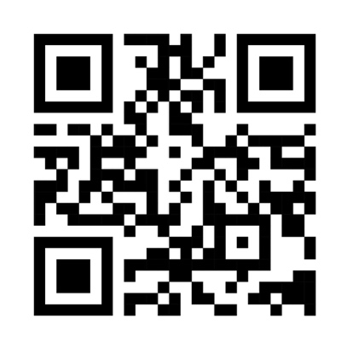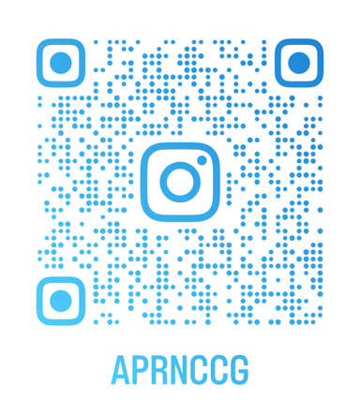

Facebook Page (public) Facebook Group (private, members-only)


