IOWA NAPNAP SNIP-ITS **December 11, 2023**

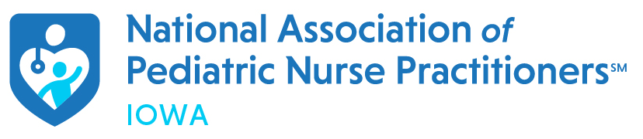

PRESIDENT’S MESSAGE

Hello to All,

Here is a sneak peek at what will happening in the next few months:

Mid-March is the national conference in Denver. If you haven’t had a chance to register, the discounted registration price extends until January 31st. This year the conference is in Denver. I have seen the conference layout and it looks fantastic with great presentations and lots of time for networking. Hope to see some of you there.

We are hoping to attempt another social event this spring, with time and place to be determined. If any of you have suggestions, we are open to listening.

The executive board will be working on restructuring our current committees as we continue to try to re-build after Covid-19. If anyone would like to join a specific committee, please contact one of the board members. We would be happy to have the help and your expertise.

Conference planning has already begun for Fall, 2024. Please save the dates of 9/12 and 9/13 in the Iowa City area. We are extending to include Thursday afternoon as well as all day on Friday. We have some wonderful activities already planned and hope you will consider joining us for both days. Much more information to come.

Moving forward national NAPNAP and the membership committee would like us to do what we can to engage PNP/FNP students. Watch for upcoming information for how you can become involved at the state level with mentoring. It’s very exciting!

Last but not least, Iowa NAPNAP members partnered with SFCH on Nov 18th, which was Child Injury Prevention Day. A few of us did our “pre-tailgating” at Hy-Vee (Waterfront Dr, Iowa City) handing out gun locks and discussing firearm safety with Hy-Vee patrons. It was a lot of fun to be out in the community again, raising awareness. We will continue to work with SFCH a few times a year, providing child safety education and awareness. Let us know if you are interested in joining next time.

As we embark on the holiday season, I would like to extend warm wishes and blessings to you all. Have a wonderful rest of 2023 and we look forward to more NAPNAP community and educational events in 2024!

With Gratitude,

Jodi Bloxham, DNP, ARNP, CPNP-AC, CPNP-PC

President

[Jodi-bloxham@uiowa.edu](mailto:Jodi-bloxham@uiowa.edu)

Legislative Updates

The 2024 Legislative session will begin January 8 2024.  Legislative priorities for us this session are a preceptor tax credit for ARNP’s and expanding Medicaid coverage from 60 days postpartum to 1 year.  You will be hearing more from us regarding these issues and actions we need to take as session progresses.  We are also looking at possibility of a Day on the Hill.  Stay tuned for more information.  Our joint Legislative Committee with INPS and the Nurse Midwives state group will be meeting bi monthly with our lobbyist during the session.  Wishing everyone a safe and happy holiday.

Cheryll A. Jones, ARNP, CPNP, FAANP

Legislative Chair

[bacjones@netins.net](mailto:bacjones@netins.net)

**2023 Iowa NAPNAP NP of the Year**

**Dan Crawford**

I am pleased to nominate Dr. Daniel Crawford for PNP of the year, 2023. I remember working with Dan years ago in pediatrics on 2JCP at the University of Iowa Hospitals and Clinics. I was a house supervisor, and he was a staff nurse, just starting out. I was always impressed by the nursing care he delivered, but I was even more impressed with his smarts, kindness to others, and compassion for children. I could tell he was professionally going to go places; it was a no-brainer.

Fast-forward a decade and a half and I find myself on the interviewing panel for the director of the pediatric primary care program at our College of Nursing. And there I find Dan. He nailed the interview; he was a shining star. Filling this position with the right person was important to me and the rest of our faculty. I had worked so closely with Dan’s predecessor and knew to build our DNP programs, all of our working relationships would need to gel. Dan has completely surpassed my expectations of a co-worker. I am in awe of him in meetings. I am in awe of him presenting at conferences. And I am in awe of him most recently by becoming the first national NAPNAP President-elect from the great state of Iowa. But I am in awe of him most as I watch him just being a really great human. Not only is Dan a brilliant and wonderful clinician and educator, he is genuinely one of the most kind-hearted humans I have ever known. His positivity lights up a room and his passion for children is infectious. He speaks of his patients with such empathy and care, it is truly heart-warming to listen to. I could go on and on about how wonderful Dan is by giving example after example, but anyone that has encountered Dan and spent any amount of time with him will understand it when I say, he rocks and everyone just knows it. I want Dan to know how much I appreciate him as a pediatric nurse practitioner, as an educator, and as a friend. Dan goes out of his way to help whenever he is asked and his contributions to our profession are many and great. I don’t know anyone else that deserves this award more than he does this year. He has worked tirelessly and effortlessly to create positive change for our profession and for the children of Iowa, the Midwest, and across the country. Congratulations Dan! You are a tremendous role model for us all.

Nominated by Jodi Bloxham, DNP, ARNP, CPNP-AC/PC

**Iowa NAPNAP Loretta Ford Preceptor of the Year 2023**

**Josh Petersen**

It is with great pleasure that I nominate Josh Petersen, ARNP for the Loretta Ford Preceptor of the Year Award. As a current nurse practitioner student, Josh serves as an invaluable role model for my future practice. I witness first-hand his clinical expertise and dedication to the health and development of his patients. Josh consistently models what it means to go above and beyond in providing patient- and family-centered care. His approach to building rapport is genuine. The impact of this is obvious when witness to patients’ open trust in him with their care. He works collaboratively within the healthcare team to ensure the needs of the families he sees are met in entirety. In imparting his clinical knowledge and skills, Josh creates an environment which both supports and challenges; he investigates comprehension of concepts, provides space to rationalize patient assessment and plan of care, and willingly initiates instruction for deeper understanding.

I strongly believe Josh is deserving of this recognition for his efforts in mentoring aspiring nurse practitioner students and in modeling exceptional care.

Nominated by Emily Puetz, 4th year DNP, PNP-PC student

Josh Petersen serves as a pediatric primary care nurse practitioner at UnityPoint Pediatric Clinic in Cedar Rapids, Iowa. It is my pleasure to nominate Josh for this prestigious honor due to his extraordinary role as a preceptor and mentor for the current and future pediatric primary care nurse practitioners. As a preceptor, he is dedicated to fostering the growth of his students clinically and professionally by providing a thorough balance of education, supervision, and support. Josh passionately cares about helping his students become knowledgeable and competent providers, while also serving as a leader by consistently demonstrating culturally sensitive care to patients and their families. His desire and commitment to educating nurse practitioner students is evident as he often precepts multiple nurse practitioner students throughout a given semester. Josh is patient, empathetic, and truly one of the most compassionate providers I have ever worked with. It has been my honor and privilege to be a preceptor of Josh’s and I unequivocally believe he is incredibly deserving the Loretta Ford Preceptor of the Year Award.

Nominated by Katie Wick Pediatric-PC/PMH DNP student

Recent Updates from Members:

Feel free to send me your news to share: publications, new positions or appointments, uplifting stories, retirement. Thank you for your continued support of this vital organization.

Trudy Pierick, ARNP, CPNP-PC, FAHA

News editor

trudy-pierick@uiowa.edu

Iowa NAPNAP members celebrated awareness of National Child Injury Prevention Day on 11/18/23 by handing out FREE gun locks to shoppers at HyVee Waterfront in Iowa City.

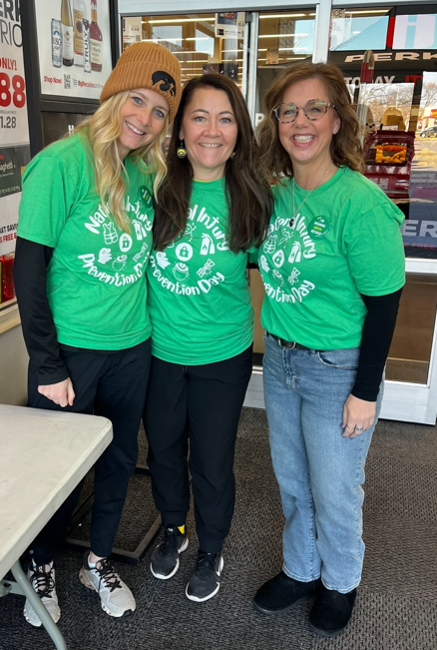 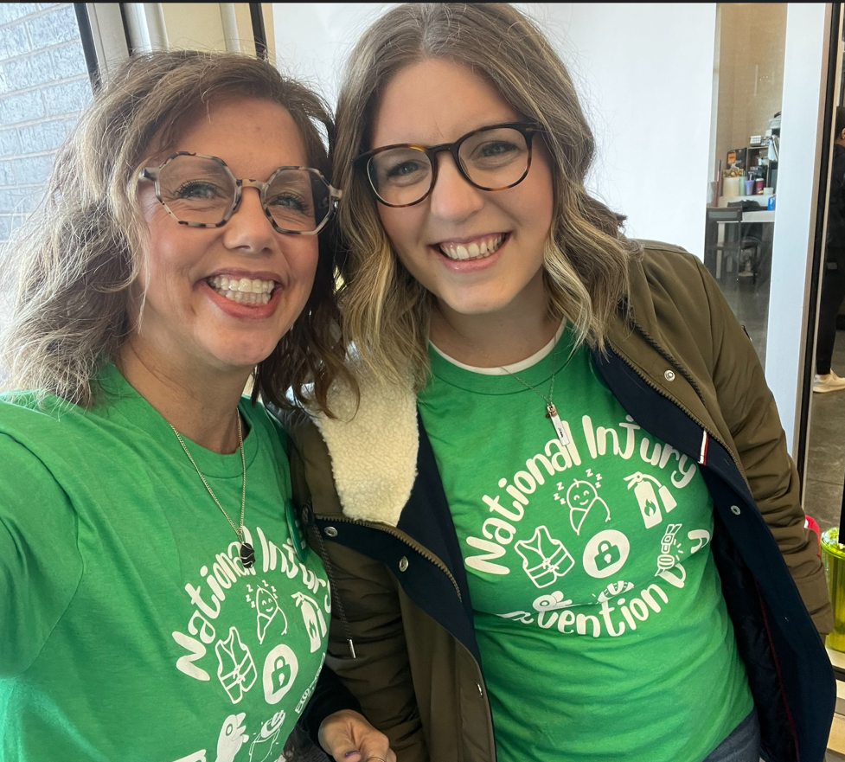

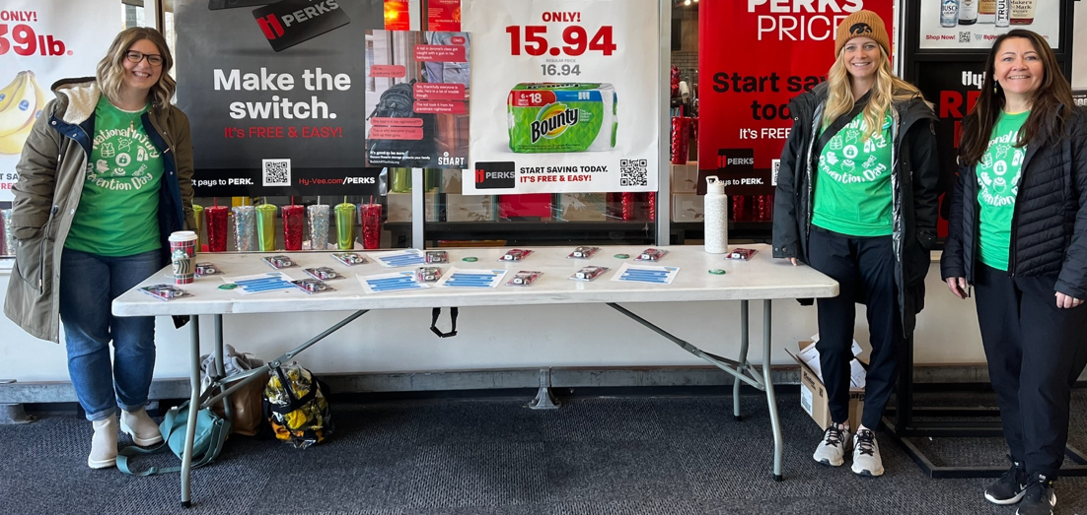

***************************************************

**Meet the Board**

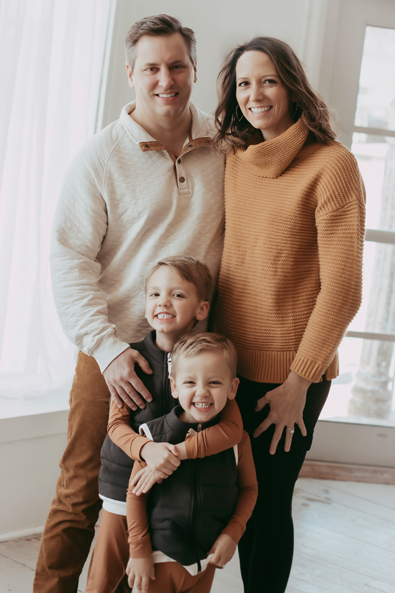

Hometown: Shorewood, IL

Nursing Education: BSN from U of Iowa, MSN and AC PNP from Rush University, DNP from U of Iowa

Current employment: U of Iowa College of Nursing as Assistant Professor Instructional Track and Acute Care PNP at UIHC-SFCH Pediatric Pulmonary

Special Nursing Interests: Pediatric acute care (PICU, ED, transport), Peds Pulmonary (asthma, trach/vent population)

Family: I have been married for the last 10 years to my love, Mason. We have 2 beautiful boys (ages 4 - Preston and 5 - Greyson). Our weekends usually consist of spending time at our home away from home at Lake Carroll in Illinois. In the summer we spend our time on the water (boating, tubing, wakesurfing). In the winter, we spend our time at the indoor pool and snow tubing hill.

Hobbies: Caring for my children, working out at Barre3 Iowa City, massages, shopping alone

Why did you become involved in Iowa NAPNAP?

I recently came back to Iowa NAPNAP after serving as the treasurer and then taking a few years off to raise babies. I decided to come back to help represent and advocate for our profession. Our lobbyists work diligently to advocate for us, but without our expertise, it would be difficult. ARNPs are very well respected and have significant autonomy in Iowa and we need to keep it that way. Keeping our lobbyists informed so they can properly advocate is essential to our career.

**Name: Samantha Lee**

**Board position: President Elect**

**Iowa NAPNAP Board and Committee Chairs**

**President**: Jodi Bloxham, DNP, ARNP, CPNP-AC/PC

[Jodi-bloxham@uiowa.edu](mailto:Jodi-bloxham@uiowa.edu)

**Past President:** Mary Drury, ARNP, CPNP

[Mary-drury@yahoo.com](mailto:Mary-drury@yahoo.com)

**President-elect:** Samantha Lee, DNP, ARNP, CPNP-AC

[Samantha-b-lee@uiowa.edu](mailto:Samantha-b-lee@uiowa.edu)

**Treasurer:** Teresa Schenck, DNP, ARNP, CPNP

[TerSchIA@hotmail.com](mailto:TerSchIA@hotmail.com)

**Secretary:** Katherine Scott, DNP, ARNP, CPNP

[Katherine.scott@unitypoint.org](mailto:Katherine.scott@unitypoint.org)

**Membership:** Haley Stoll, DNP, ARNP, CPNP-AC/PC

[Haley-stoll@uiowa.edu](mailto:Haley-stoll@uiowa.edu)

**Constitution/Bylaws Committee**: Samantha Lee, DNP, ARNP, CPNP-AC

[Samantha-lee@uiowa.edu](mailto:Samantha-lee@uiowa.edu)

**Legislative Committee Chair:** Cheryll Jones, ARNP, CPNP, FAANP

bacjones@netins.net

**Continuing Education Chair**: Hannah Jepson Slaughter, MSN, ARNP, CPNP

[HannahJ@Childserve.org](mailto:HannahJ@Childserve.org)

**Public Relations**: Megan Mobley, DNP, ARNP, CPNP-PC, and Christine Ries, DNP, ARNP, CPNP-PC

[Megan-mobley@uiowa.edu](mailto:Megan-mobley@uiowa.edu)

[Christine-ries@uiowa.edu](mailto:Christine-ries@uiowa.edu)

**Website**: Tracy Sheets, DNP, ARNP, PNP-PC

[Tsheets03@gmail.com](mailto:Tsheets03@gmail.com)

**Nominations:** Christine Ries, DNP, ARNP, CPNP-PC

[Christine-ries@uiowa.edu](mailto:Christine-ries@uiowa.edu)

**Scholarship/Awards:** Courtney Kremer, MSN, ARNP, CPNP-PC, and Elizabeth Faine, MSN, ARNP, CPNP-PC

[Courtney-kremer@uiowa.edu](mailto:Courtney-kremer@uiowa.edu)

[Elizabeth-faine@uiowa.edu](mailto:Elizabeth-faine@uiowa.edu)

**News:** Trudy Pierick, MSN, ARNP, CPNP-PC, FAHA

Trudy-pierick@uiowa.edu

**Student Representative:** Madison Loftsgard, BSN, RN, DNP student

[Madison-loftsgard@uiowa.edu](mailto:Madison-loftsgard@uiowa.edu)