

Advanced Practice Nurses Council of Coastal Georgia

Dinner Meeting Minutes
November 16, 2023
Dinner Meeting:
- Our meeting was sponsored by Astra Zeneca with representative Christi Carden and speaker Luis Polo, NP, present.
- The was speaker Luis Polo, a Savannah nephrology nurse practitioner who gave an excellent presentation on hyperkalemia. He was kind enough to offer his contact details for local members who may want to speak with him further – please reach out to Christen if you would like his cell phone number.

Business Meeting:
- Introduction of and welcome to new members and guests
- Treasury Report (Kim)
  - The balance remains largely stable - $16,744.28
    - The only reoccurring expense is the ENP Website
      - Other expenses include dinner meetings the APRNCCG has been sponsoring as well as new APRN logo / supplies.
  - Tax paperwork is submitted and still pending.
    - We will need to review / update the bylaws (once this is done) sometime next year.
  - Members who are on subcommittees will receive a 50% discount in dues - Christen has added this to the website!
- New Business
  - Dinner Meetings (Analicia)
    - January 11, 2024, at 6:00pm (not our usual 6:30pm)
      - Speaker: TBA
      - Topic: TBA
      - Location: Vic’s on the River in Savannah
The executive council understands parking downtown can be difficult, especially near River Street. Vic’s on the River does offer valet parking and Christen has reached out to inquire about having this available for our members.
    - February 8, 2024, Meeting
      - We are waiting for the rep to confirm
      - Sponsor / Location / Topic: pending
    - March / April 2024 meetings
      - One of these will be an APRN sponsored, member led meeting (hopefully at GSU again!)
        - Current topics include: Members presentation, business plans for the APRN, and new graduate APRN help
        - MEMBER INPUT: please let us know what you want the topic to be and where you want the meal to be from!
      - One of these meetings will be a family fun night for our members to get together in a more casual setting.
    - May 2024 meeting
      - We will try to have this coincide with Nurse’s Week (the week of May 6).
    - Monthly casual meet ups
      - MEMBER INPUT: please let Analicia know if you want to help set this up!
    - Pharmaceutical / representative sponsored meetings
      - MEMBER INPUT: Please send us any representatives that may be interested in sponsoring a meeting to Analicia
  - Member Engagement
    - Social media engagement (Kaitlyn)
      - See QR codes at the bottom for the website / Instagram / Facebook!
    - Small business highlight (Christen)
      - We love supporting our members and community! Please let Christen know of any small businesses that we should highlight.
    - We will also pass along any rep sponsored dinners that members may be interested in attending through the website and email list.
  - Community Impact
    - Community activities / health fairs / etc (Ingrid)
      - This is in process – thank you to Ingrid who has been leading on this!
        - We will need a list of people who want to volunteer – Christen will look into starting a GroupMe once we get specific dates / activities established.
      - Current plan is to collaborate with other groups (Lion’s club, etc) while we build up a list of volunteers and get supplies.
        - Christen has started an Amazon wish list!
        - https://www.amazon.com/hz/wishlist/ls/3EHVNKEL838KH?ref_=wl_share
        - MEMBER INPUT: If you have ideas as to what needs to be on our wish list or have knowledge of grants we should apply for, please let Christen know!
    - UAPRN
      - We continue collaborating with the UAPRN and appreciate their hard work for APRNs in Georgia. Christen is leading on this.
    - Nurses week / APRN celebrations
      - We will hold a raffle twice a year for our members - this will coincide in November with NP week and May with Nurses week.
      - This was a huge success at our November (NP Week) meeting and we look forward to May (Nurses Week)!
        - Congratulations to our winners!
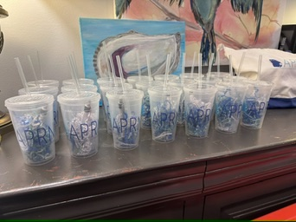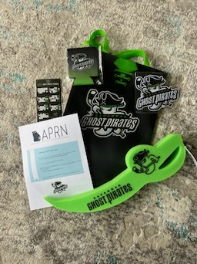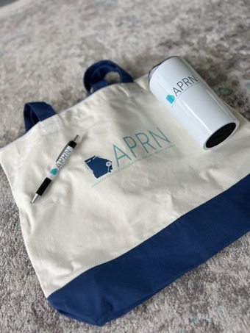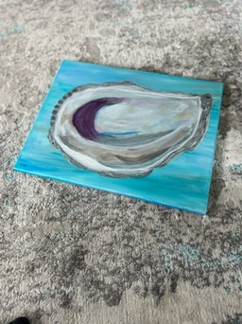
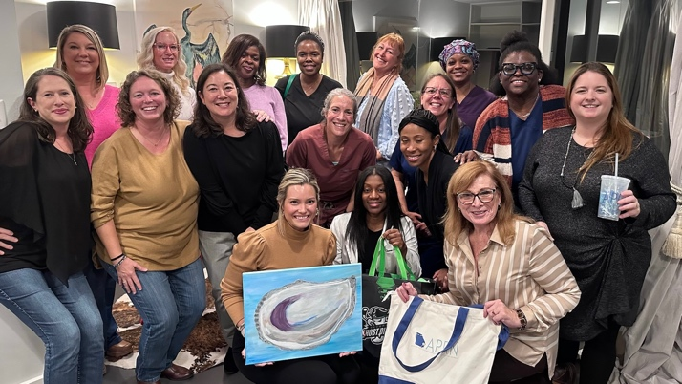
    - CME / educational offerings
      - We would love to offer CME at our meetings when appropriate.
      - However, after research at this point it is not a time or cost effective option for the APRNCCG as a group unless we plan for a bigger event (ex: seminar, conference).
      - The best option is to partner with other organizations that are pre-approved for CME.
        - Ex: GSU, Augusta University, MCG, SJC
        - One member recommended looking into collaboration with GANE.
        - MEMBER INPUT: If you have any contacts, please let Christen know
      - Thank you, Lisa, for taking the time to investigate this!
    - Precepting APRN Students
      - One of the best ways we can support our community is by supporting our schools and students! Please reach out to Christen or to APRNCCG member Dr. Kat Tremblay - KTremblay@GeorgiaSouthern.edu.
    - Georgia Nurse Honor Guard – Savannah Chapter
      - Christen will send out information regarding services when she is alerted as to a need.
  - Policy (Kelly)
    - Legislative session will be upon us before we know it! Kelly gave us updates regarding legislation that is related to APRNs.
    - During legislative session, you may receive urgent emails requesting action – please take the time to reply with your feedback as this is how change is made and policy is created that directly affects our practice.
    - SB 164 - https://legiscan.com/GA/bill/SB164/2023
      - Summary: A BILL to be entitled an Act to amend Chapter 26 of Title 43 of the Official Code of Georgia Annotated, relating to nurses, so as to provide for licensure of advanced practice registered nurses; to revise definitions; to provide for licensure requirements; to provide for renewal of licenses; to provide for a misdemeanor to practice advanced nursing practice without a license; to provide for related matters; to repeal conflicting laws; and for other purposes.
        - Basically, this allows APRNs to have independent practice licensure and is a hopeful stepping point towards full practice authority.
    - HB 557 - https://legiscan.com/GA/bill/HB557/2023
      - Summary: A BILL to be entitled an Act to amend Chapter 34 of Title 43 of the Official Code of Georgia Annotated, relating to physicians, assistants, and others, so as to authorize physicians to delegate the authority to advanced practice registered nurses and physician assistants to prescribe Schedule II controlled substances; provide for requirements; to provide for automatic approval of nurse protocol agreements and job descriptions under certain conditions; to provide for legislative findings; to provide for related matters; to repeal conflicting laws; and for other purposes.
        - This is a APRN/PA amendment regarding class II restrictions (specific drugs).
    - HB 215 - https://legiscan.com/GA/bill/HB215/2023
      - Summary: A BILL to be entitled an Act to amend Chapter 26 of Title 43 of the O.C.G.A., relating to nurses, so as to provide for licensure of advanced practice registered nurses; to revise definitions; to provide for licensure requirements; to provide for renewal of licenses; to provide for a misdemeanor to practice advanced nursing practice without a license; to amend Article 3 of Chapter 2 of Title 40 and Article 2 of Chapter 34 of Title 43 of the O.C.G.A., relating to prestige license plates and special plates for certain persons and vehicles and medical practice, respectively, so as to authorize advanced practice registered nurses and physician assistants to execute affidavits certifying an individual is disabled for purposes of obtaining special vehicle decals for persons with disabilities; to provide for related matters; to repeal conflicting laws; and for other purposes.
        - Allows APRNs to sign disability tags.
  - Subcommittees
Thank you SO MUCH to everyone who has volunteered to help lead with a subcommittee! We truly appreciate your time and support!
    - CME / education – Lisa
    - Social media – Kaitlyn
    - Collaborate with other local nursing groups and APRN students – Kat
    - Coordinating with local groups for community outreach – Ingrid
    - Policy and UAPRN collaboration – Kelly
- Job opportunities
  - Georgia Southern University is seeking 4 full time doctorally prepared candidates for tenure track positions as well as instructors for their nursing programs.
    - Please reach out to APRNCCG member Dr. Kat Tremblay - KTremblay@GeorgiaSouthern.edu.

Next Meeting: January 11, 2024, at 6:00pm – please RSVP through the website!

Contact information:
Executive Council Members: Analicia Patterson, Christen Standiford, and Kim Wilke
Website: www.aprnccg.enpnetwork.com
Email: APRNCouncil@gmail.com
Christen: 912-596-2896 (call or text)

Website Instagram
https://aprnccg.enpnetwork.com @APRNCCG
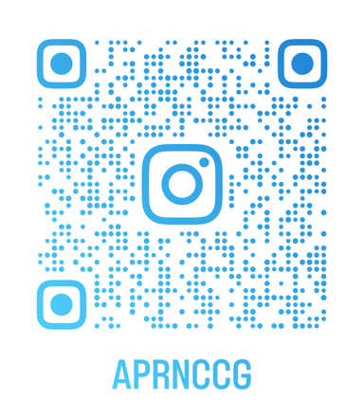

Facebook Page (public) Facebook Group (private, members-only)


