Michelle Rebello Board of Directors Bio

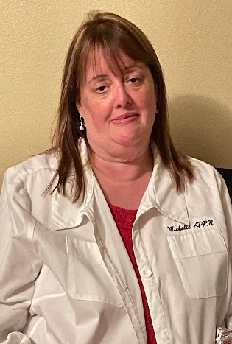

Thank you for the opportunity to serve on the board of directors.

I have been a registered nurse since 2004 and transitioned into the APRN role in 2018. I worked at Lakeland Regional Health from 2000 to 2007 in various roles before starting hospice where I found my calling. I have been in hospice from 2007 to present. I am currently in a primary practice position and work hospice PRN.

I have been a member on PCAPNA since 2014. I started as a student as was able to find much needed preceptors through PCAPNA. Serving on the board of directors will give me the opportunity to give back. I have been a board member since 2021. Thank you for the opportunity to be able to serve on the board.

Michelle Rebello