Advanced Practice Registered Nurses Council of Coastal Georgia

Dinner Meeting Minutes
June 15, 2023

Sponsor: APRN Council of Coastal Georgia
Special Guests: Georgia Southern University faculty, UAPRN representatives, and Georgia
Nurses Honor Guard – Savannah Chapter
Location: Georgia Southern University – Armstrong Campus

Dinner Meeting:
- Our meeting was sponsored by the APRN Council of Coastal Georgia and hosted by Georgia Southern University – a special thank you is extended to APRNCCG member Dr. Kat Trembly, GSU faculty, who helped to facilitate this meeting.
- We had special guests from the United Advanced Practice Registered Nurses of Georgia zoom into the meeting with us – Robin Pennington and Regina Canty of the UAPRN and Julianna McConnell lobbyist – and Nancy Hurlock, GSU faculty and UAPRN member, who joined the meeting in person from Statesboro.
  - The UAPRN representatives shared with the group the mission of the UAPRN and current goals to support APRNs in Georgia. They are very passionate and enthusiastic about the hard work they do, and we are very grateful for their time.
  - Current goals include working with the Secretary of State and the commission that is looking at licensing boards, including challenges APRNs are experiencing with their nurse protocol agreements. They are looking for real world examples to share.
  - MEMBER INPUT: This group would like to work with our members to improve access to care in Savannah and the surrounding rural areas. Please contact Christen if you would like to help.
- We had special guest Julie Anne Moser of the Georgia Nurse Honor Guard – Savannah Chapter.
  - She is the leader of this new group that exists to honor and comfort the families and loved ones of fallen nurses by participating in a ceremony during the service.
  - MEMBER INPUT: Please visit her group on Facebook or email Christen for a link if you are interested in learning more and participating in this service. Julie Anne is hoping to have volunteers to go to funeral homes to teach them about this service. She is also looking for help creating brochures, a mission and vision statement, and things of that nature.
- We also presented logo designs and survey results – please see the attached PowerPoint slides.
Business Meeting:
- Introduction of and welcome to new members and guests
- Treasury Report – the current balance is $18,378.23
- New Business
  - Dinner Meetings - Analicia
    - September Meeting – tentatively scheduled for Thursday, September 14
      - This will be hosted by the APRNCCG and lead by our members.
      - The topic will be: “Hot Topics in Healthcare” and will be short presentations by our APRNCCG members.
      - Current planned topics include:
        - Opioids
        - Post-Covid fibrosis
        - Post-Menopausal management
        - More to come!
      - MEMBER INPUT: If you are interested in sharing with the group a topic of interest, please let Christen know! We are looking for a minimum of 5 speakers with a casual presentation lasting about 10 minutes which we are happy to help you with.
    - November Meeting – the week of 12 – 18 during NP week
      - This meeting will be sponsored by the APRNCCG. We plan for this to be a family friendly event and would love our members to bring a NP friend for us to host and learn more about our group!
      - MEMBER INPUT: If you have ideas of where to hold this event, please let Analicia know!
    - Monthly casual meet ups
      - This is in process - please let Analicia know if you want to help set this up!
    - Pharmaceutical / representative sponsored meetings
      - MEMBER INPUT: Please send us any representatives that may be interested in sponsoring a meeting to Analicia.
  - Member Engagement
    - Logo re-design (see below)
      - The members did not like option #1.
      - Option #2 was too limited in use due to its shape.
      - The members like option # 3 with some modifications that we will be submitting to the graphic designer – specifically, we want to move #2 to where the GA / stethoscope is on #3, move the stethoscope over Savannah, and change the font for APRN to be more readable.
      - MEMBER INPUT: please let us know your thoughts!
    - Social media engagement
      - MEMBER INPUT: Please join our private Facebook group! If you have interest in managing social media, please let Christen know.
        - www.facebook.com/groups/aprnccg/
    - Survey
      - We have results! Please see the attached PowerPoint slides for the findings.
    - Small business highlight
      - MEMBER INPUT: We would love to share information about your business to the group!
  - Community Impact
    - Community activities / health fairs / etc
      - This is in process! We are waiting to hear about the AANP grant and finalizing the new logo before purchasing supplies.
      - APRNCCG Member Ingrid has been working on coordinating with local health fairs – thank you!
      - MEMBER INPUT: if you have any interest in helping with this or any contacts, please let us know!
    - Nurses’ week / APRN celebrations
      - This is in process! We plan to start with a November meeting during AANP week.
    - CME / educational offerings
      - For those who went to AANP this month, please let us know how it went!
      - UAPRN Conference September 22 – 23 at Jekyll Island
        - This conference offers 10.0 CE credits (2.0 pharmacology credits)
        - Please visit www.uaprn.enpnetwork.com for more information.
  - Subcommittees
    - The goal of the subcommittees is to create “bite sized,” smaller tasks for members to help with – if you have a little extra time and want to do something please let us know!
THANK YOU to those members who have offered time and energy for our
group! We appreciate you!
    - CME / educational offerings - Kat
    - Scholarship - Christen
    - Re-engage with local APRN political groups like the UAPRN - Christen
    - Help with marketing / website – Kim
    - Community engagement - Ingrid
    - Collaborate with other local nursing groups and APRN students – Kat
- Job opportunities
  - Dr. Devaro, dermatology, is looking for a NP
  - Georgia Southern University is looking for nursing faculty
  - The Georgia Infirmary is looking for someone PRN 1-2 times per week – contact Analicia for details.
- Don’t forget to check out the survey results on the PowerPoint slides!
- Logo
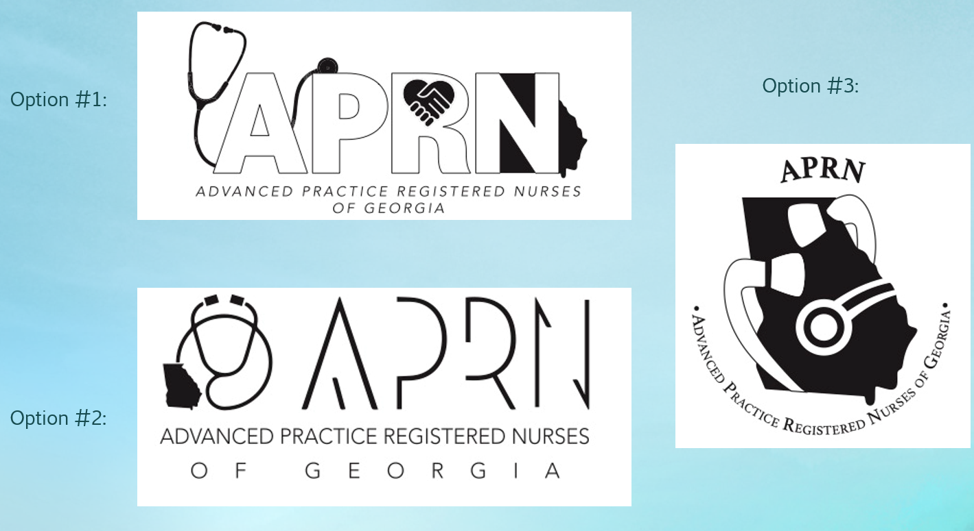

Next Meeting: September 2023 (GSU Member Presentations) and November 2023 (NP week celebration)

