Join TNP's Session Update & Member Q&A on May 16 - TNP Members Only Webinar – Free CE
The 88th Texas Legislature is now approaching the last 30 days of session. Join TNP for a policy webinar and update on TNP's legislative agenda and learn more about the bills impacting your patients and your profession.
We will dedicate a portion of the webinar for member Q&A. To make sure we get to as many of your questions as possible, please email your questions in advance to Erin. This activity is awarded 1 CE hour. Completion of activity evaluation is required and will be sent via email post event.
We hope to see you on May 16th!
Register Here
If you are not a member of TNP, but would like to participate in this update and receive other important practice updates throughout the year and access to Texas Specific CE, Join today and then you can register immediately for this webinar.

Fall Conference Poster Presentations

We are planning poster presentations for our Annual Fall Conference in Dallas, TX (September 28 – October 1. Please submit your poster presentation here. Feel free to contact bella@texasnp.org for questions.

Entry Into Practice – June 3, 2023
Entry Into Practice is back in person in Austin this June. As a student, new or recent graduate of an NP program, or seasoned NP who would like a refresher, please join us on June 3, 2023 at the UT Thompson Conference Center for a one-day conference to prepare you to successfully begin your new role as a Nurse Practitioner!


TNP’s Fall Conference – Opens May 15
TNP’s 35th Annual Conference Registration is now open! We’re proud to be the go-to for Texas Nurse Practitioners continuing education needs. TNP Conference +Workshops provides over 22 hours of continuing education including some of the most sought-after Texas specific required education. Join TNP prior to registering for TNP Conference and save over 50% on registration fees. It’s essentially like getting your membership for free! In addition, by being a TNP member you will be able to access free TNP member events! TNP’s Fall Conference has something for everyone! Join us this September!


Rural Health Virtual Conference – July 15
Join us for TNP's 3rd Telehealth and Practice Improvement Conference brought to you by the TNP Rural Health SIG. These conference sessions will be presented by Texas APRNs who work in rural settings, telehealth settings, as university faculty and in various clinical settings. All seek to provide their unique expertise and experience as they bring you the information you may be missing regarding practice improvement within telehealth.


TNPF’s Scholarship Applications Open May 1, 2023
TNP provides up to seven annual scholarships. Applications will be accepted from May 1, 2023, thru June 15, 2023. To be eligible for consideration, be sure to provide all required documents. Once the application is open, if you would like to save your application progress, you will need to make an account once you click on the application link below. No mailed applications will be accepted. For more information, click here.

Awards Nominations Now Open
Award nominations are now being accepted until July 1. All award recipients will be recognized during TNP’s Annual Fall Conference in Dallas, September 28-October 1, 2023.

For more information about the awards, nomination process and past winners, please click here.

TNP’s Spring Conference – Enduring – Available Until July 3, 2023
Earn 12 hours of CE including 12 hours of Pharmacology but registering and completing TNP’s Spring Conference Enduring program. Topics include: First Contact Headache in Primary Care, Diabetes and RX, Pediatric Dermatology and RX, Long Covid Panel, Bugs and Drugs: Antimicrobial Prescribing for the NP, GI Diseases from the Pharmacologic Perspective, Women's Health and RX, Functional and Integrative Medicine for Common Mental Health Disorders This program is available for purchase on TNP’s Online CE Center.

Texas Required CE – On Demand in TNP’s Online CE Center
Members of TNP receive 50% off. To obtain your Texas Specific CEs, please visit the TNP Online CE Center.


Legislative Session Updates
BON APRN Representation Bill Passes the Senate

On April 21, SB 1343, one of the priority bills on TNP’s legislative agenda that would add an APRN to the Texas Board of Nursing (BON) and ensure APRN peer review for cases brought to the BON involving the clinical standard of care, passed the Senate unanimously. Currently there is no requirement for APRN peer review if an APRN complaint is brought to the BON. And board composition for the agency has not been changed since 1999, during which time the number of APRNs has grown by 460%.

The bill was heard in the House Public Health Committee, where it needs to be voted on before going to the full House floor. We will continue to update members as this bill moves through the legislative process.

We want to thank Senator Morgan LaMantia and Rep. Joe Moody for carrying this important legislation. These changes will strengthen APRN representation and peer review at the Board of Nursing, while also working towards the mission of protecting patients and the public.

We also want to thank our President Cindy Weston and TNP Legislative Ambassador Co-Chair Holly Jeffreys for taking the time travel to Austin, testify in support of these bills, and represent Texas nurse practitioners.

For other legislative updates and information on bills we’re tacking, see our most recent Capitol Watch here.

The Stories of Texas NPs, Patients Shine in Newly Released Video

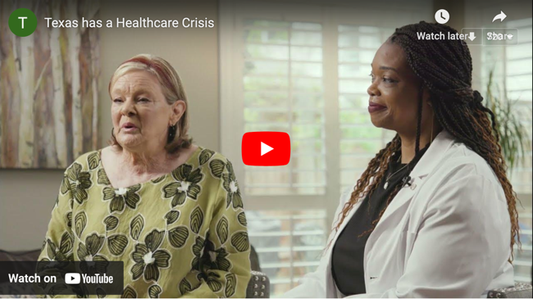

TNP, together with the Texans for Healthcare Access Coalition, released a patient voices video, urging Texas lawmakers to remove barriers to healthcare for Texans and pass the HEAL Texans Act (SB 1700).
The video follows the stories of three Texas patients and their healthcare journeys: a senior rural patient from Bedias; a patient from Longview who struggled with and overcame her substance use disorder; and a Texas mother who underwent emergency childbirth at a critical access hospital in St. Augustine. In each of these patient stories, access to a nurse practitioner close to home made a critical, life-saving difference.
Watch the video and share with members of your community here.

TNP PAC Launches – Don’t Mess with Texas NPs Campaign
The TNP PAC Campaign continues. The mission of the TNP PAC is simple: to make political contributions to elected officials who have supported nurse practitioners in the past, or who will be key gatekeepers to nurse practitioner legislation in the future – regardless of party.


TNP Membership Matters – Join TNP Today!
Membership is at most 42 cents a day and the savings you receive as a member pays for itself in just one transaction!


