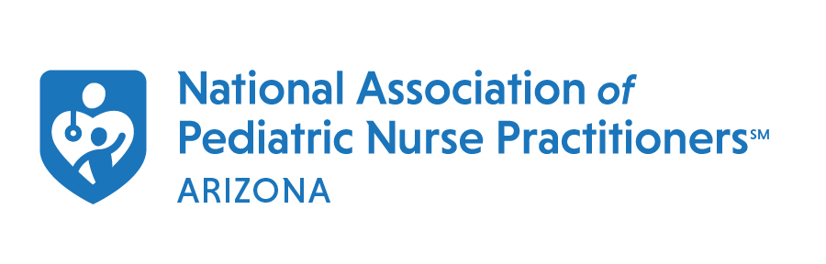
DNP Student Scholarship

The Arizona Chapter of NAPNAP recognizes that Nurse Practitioner students are our future and must be recognized and celebrated for all of the innovative ideas and energy they will bring to our profession. It is in this spirit that we are offering a scholarship to any DNP student who is currently a member of the Arizona Chapter of NAPNAP and is enrolled in an DNP program.
This scholarship will cover the cost of registration for the 44th Annual National Association of Pediatric Nurse Practitioners (NAPNAP) National Conference on Pediatric Health Care March 15-18, 2023 in Orlando, FL. This conference will be celebrating NAPNAP’s 50th year and promises to be a big event.
Applications for this DNP Student Scholarship are open until December 31, 2022. Winners will be notified in January of 2023. Incomplete or late applications will not be accepted.

Application:
Name:
First MI Last Degree/Certification

Mailing Address:

City State Zip Code

Cell Phone: ( ) - Email:
- Are you currently a member of AZ Chapter of NAPNAP?
  - Yes No
- Are you currently licensed and employed in pediatric nursing?
  - Yes No
- Are you currently enrolled in a doctorate program in pediatric nursing?
  - Yes No
- Have you received a scholarship from AZ NAPNAP in the past two years?
  - Yes No
- Please include a current CV or resume in .doc or .docx format.
- Please include a letter or recommendation from academic mentor submitted to AZnapnap@gmail.com

Each question should be answered succinctly and thoroughly in no more than 500 words. Must use professional writing style and APA formatting.
Please discuss your service and/or volunteer experiences. Please include organization information, role, length of service.
Please discuss your leadership experience. Please include organization information, roles, length of service.
Please discuss your personal and academic goals. Please explain what led to your goals; your vision of your professional life and expected contributions to your community after graduation.
Please describe your DNP Project. Please describe your project clearly and provides justification for scholarship funding.

