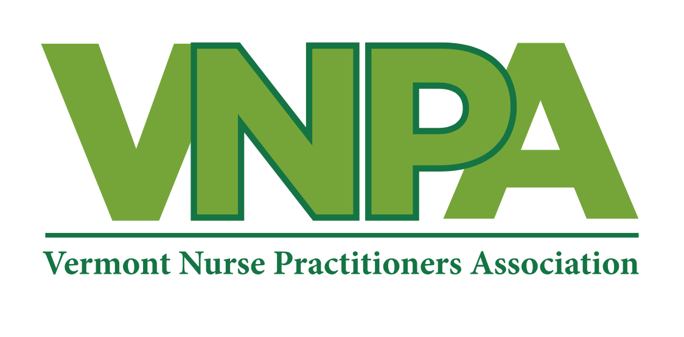

Vermont Nurse Practitioners Association

P.O. Box 64773   
Burlington, VT 05406

December 10, 2021

Executive Office of Governor Phil Scott

109 State Street, Pavilion Montpelier, VT 05609

Dear Governor Scott,

The Vermont Nurse Practitioners Association represents 600 practicing nurse practitioners in Vermont who work across the care continuum and serve Vermonters of all ages in all stages of health and disease.

We have been proud to care for our communities in Vermont during the pandemic as Vermont became a leader in the US because of your administration’s dedication to making vaccines widely available and instituting early guidelines for mask wearing.

However, with the rising number of COVID cases overwhelming our health care system at this time, we are writing to ask you to do more. We see the rising case counts, hospitalizations, and deaths in our state. There is ample evidence proving that wearing masks works. The CDC has taken a stance on recommending masks for all unvaccinated individuals. We are fighting COVID-19 alongside you and we are tired. We confront COVID-19 on a daily basis and simultaneously provide care to our communities. The burnout among our colleagues and associates is real, and it is real in our communities as well.

As nurse practitioners, we feel strongly that prevention and public health measures are the key to managing the pandemic and decreasing the risk to our patients and, frankly, the health care system in our state which feels precarious at best. Several recommendations have been made by other groups in Vermont and we agree:

* Require indoor masking in all public facilities and any setting with a high risk of COVID-19 transmission.
* We support enforcing masking requirements if access to care or other health equity measures is not affected.
* We support measures that improve access to rapid testing and widely available, free masks to the public.
* We support assisting each school district with increased access to rapid testing and expanding vaccine sites and availability to more schools.

We appreciate your administration’s communication and work as you have led our state through this pandemic thus far, yet we still have far to go. As nurse practitioners we rely on you to support our communities, our patients, our healthcare system as you collaborate with us to keep Vermonters safe. As Helen Keller said, “Alone we can do so little; together we can do so much”.

Thank you,

Michelle Wade APRN

President, Vermont Nurse Practitioners Association

[Vermontnp@gmail.com](mailto:Vermontnp@gmail.com) cell 802-236-6083