
Happy Nurse Practitioner Week!
In honor of NP week, Region 3 would like to recognize Dr. June Bryant. Dr. Bryant is an Assistant Professor at the University of Tampa and the current President of NAPNAP (Florida Gulf Coast). Dr. Bryant is a certified pediatric nurse practitioner who is realizing her dream of serving pediatric patients in all communities. For the last year (or more), Dr. Bryant has been working diligently to research, build, staff, and insure a mobile unit that will allow her (the PNP) to reach local and rural communities to provide much-needed pediatric healthcare.
As of this week, Dr. Bryant officially began her role as an autonomous nurse practitioner providing care to children in all communities as she officially opened Dr. JOONIE’S Exam In A Van to the community. This will be an excellent way to bring pediatric healthcare to the community and to the patients’ doorstep. Dr. Bryant is passionate about the care she gives to her patients and treats every patient as if they are her own children. As an Assistant Professor at the University of Tampa, Dr. Bryant is able to share her skills and her passion to nursing students and future nurse practitioners. As a volunteer in the community, Dr. Bryant is always willing and ready to help those in need. Tampa and the surrounding areas are lucky to have such an experienced, skilled, passionate, and innovative provider.
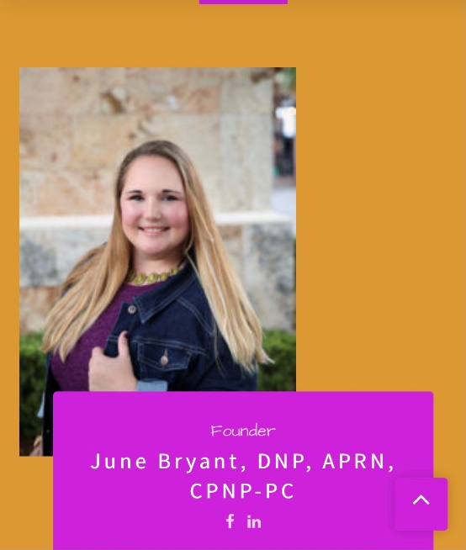
Submitted by Charrita Ernewein, DNP, APRN, FNP-C, SANE-A
Region 3 Director

