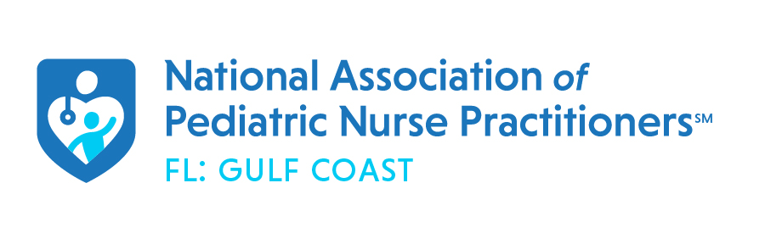

First Friday: Virtual Lunch & Learn
Friday, September 3rd, 2021
Friday, September 10th, 2021
12pm-1pm
Featuring:
Laura Sirak, APRN, FNP, CLC
Topic: Promoting Breastfeeding in the Primary Care Setting
Register Here via Zoom:
https://utampa.zoom.us/meeting/register/tJUtce6vqz4vGNRytzG9kzVjkzZwx8WSgNui

1 (ONE) Continuing Education (CE) contact hour approved through NAPNAP after attendance and completion of evaluation

