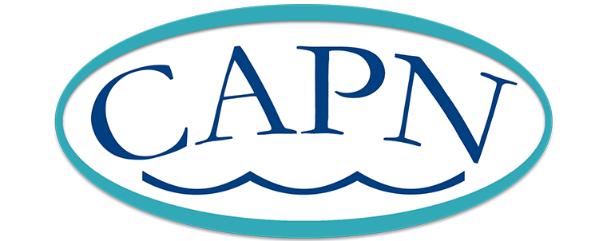

Advanced Practice Nurses in the Big Bend Region

In the early 1970s, Dr. Robert Hunter, a progressive physician in Tallahassee, obtained a federally funded grant to provide advanced practice education to capable nurses within the community. He recognized the potential for nursing professionals to successfully practice within a broader scope aligning with Dr. Loretta Ford and Dr. Henry Silver’s previous efforts to establish nurse practitioner education at the University of Colorado in 1965 (Brennan 2020).

Dr. Hunter’s educational program, entitled the “Florida State University (FSU) Student Health Center Nurse Practitioner Program,” was affiliated with FSU and graduated some of the nation’s first nurse practitioners. Geraldine “Geri” Bixler, ARNP was in the first graduating class; the Tallahassee Memorial Hospital (TMH) Bixler Emergency Department is named after her husband. Long time Tallahassee resident and nurse practitioner, Jo Davis, ARNP-C, was in the second class to complete this certificate program and Julie Holt, ARNP-C, was soon thereafter. The program evolved to the “FSU Program in Medical Science (PIMs).” Nurse practitioners from this program worked in areas such as family practice, student health, mental health, and the emergency department.

Despite completion of a certificate program and competent practice as nurse practitioners, licensure in the State of Florida was not obtained until 1979 when the title *Advanced Registered Nurse Practitioners* (ARNP) was added to the Florida Nurse Practice Act (Florida Nurses Association, 2004). The first few classes of the FSU nurse practitioner program were able to become licensed, but later graduates had to petition to the Florida Board of Nurses to obtain licensure. For Julie Holt, one of the later graduates, this meant retaining legal counsel, two trips to Jacksonville and one to Miami to present all education, preceptorships, and practice experience in order to finally obtain a Florida ARNP license.

Along with obtaining education and licensing, these early nurse practitioners were some of the first to gain certification, obtain hospital privileges, and acquire prescriptive privileges. Jo Davis took the adult nurse practitioner certification exam in 1982 and Julie Holt was the first in the Tallahassee area to obtain hospital privileges at TMH. Until 1988, ARNPs in Florida had full practice authority but no authority to sign prescriptions. A physician was sued over the “ghost signing” of prescriptions which began a widespread push to legitimize this practice so that ARNPs could truly practice to the full extent of their license. Julia Pallentino, JD, APRN-C was a nurse and attorney at the time. She was pivotal in getting this legislation passed. It was 1986 when prescriptive authority of non-controlled drugs was approved and change in prescriptive authority was later enacted into Florida statute. Furthermore, in this area, there became a requirement for a protocol to be filed with the Board of Nursing for all ARNPs (Florida Nurses Association, 2004).

The profession has continued to evolve through the years. Recognizing the need to advance the profession, graduate education was first required for ARNPs in Florida in 1998 (Florida Nurses Association, 2004). The requirement for certification for licensure began in 2006 (Florida Board of Nursing, n.d.). Legislature for prescriptive authority for controlled substances was approved and began January 1, 2017 (Florida Board of Nursing, 2016). In 2018, the nurse practitioner designation changed to *Advanced Practice Registered Nurse* (APRN), which is consistent throughout the United States (Florida Board of Nursing, 2018). Most recently, full practice authority for autonomous practice in primary care was approved by Florida Legislation in 2020.

Tallahassee Area Council of Advanced Practice Nurses (CAPN)

In the late 1980s, two of the original pioneers in Tallahassee, Julie Holt, APRN-C and Jo Davis, APRN-C fortuitously met as providers in the same practice for gynecological and primary care. They recognized the need for a professional organization to unite advanced practice nurses and assist in navigating widespread changes to scope of practice. Talks of establishing a local group to drive these efforts began led by Katie Wales, CNM.

The first CAPN meeting was held in a boardroom at Tallahassee Community Hospital, now Capital Regional Medical Center (CRMC), in the late 1980s. Initially, these meetings were ‘Cookies and Coca-Cola’ get-togethers whereby advanced practice nurses were able to meet and discuss current issues in practice, including newfound prescriptive privileges granted in 1988.  Gradually, these casual meetings grew in size and prestige with a consistent aim toward “Bridging the Gap in Healthcare.” A non-comprehensive list of these early members includes Katie Wales, Deborah Hults, Karen Myers, Julie Holt, Jo Davis, Vickie Spitzer, Julia Pallentino, Deborah DeBack-Wright, Mimi Dyer, Vicki Lund, and Mai Kung. Julie Holt served as the organization’s first president and was the first CRMC Nurse of Excellence awardee in 1997. The CAPN logo with a bridge over water was designed by founding member Deborah Hults’ father to signify how advanced practice nurses serve in “Bridging the Gap in Healthcare”

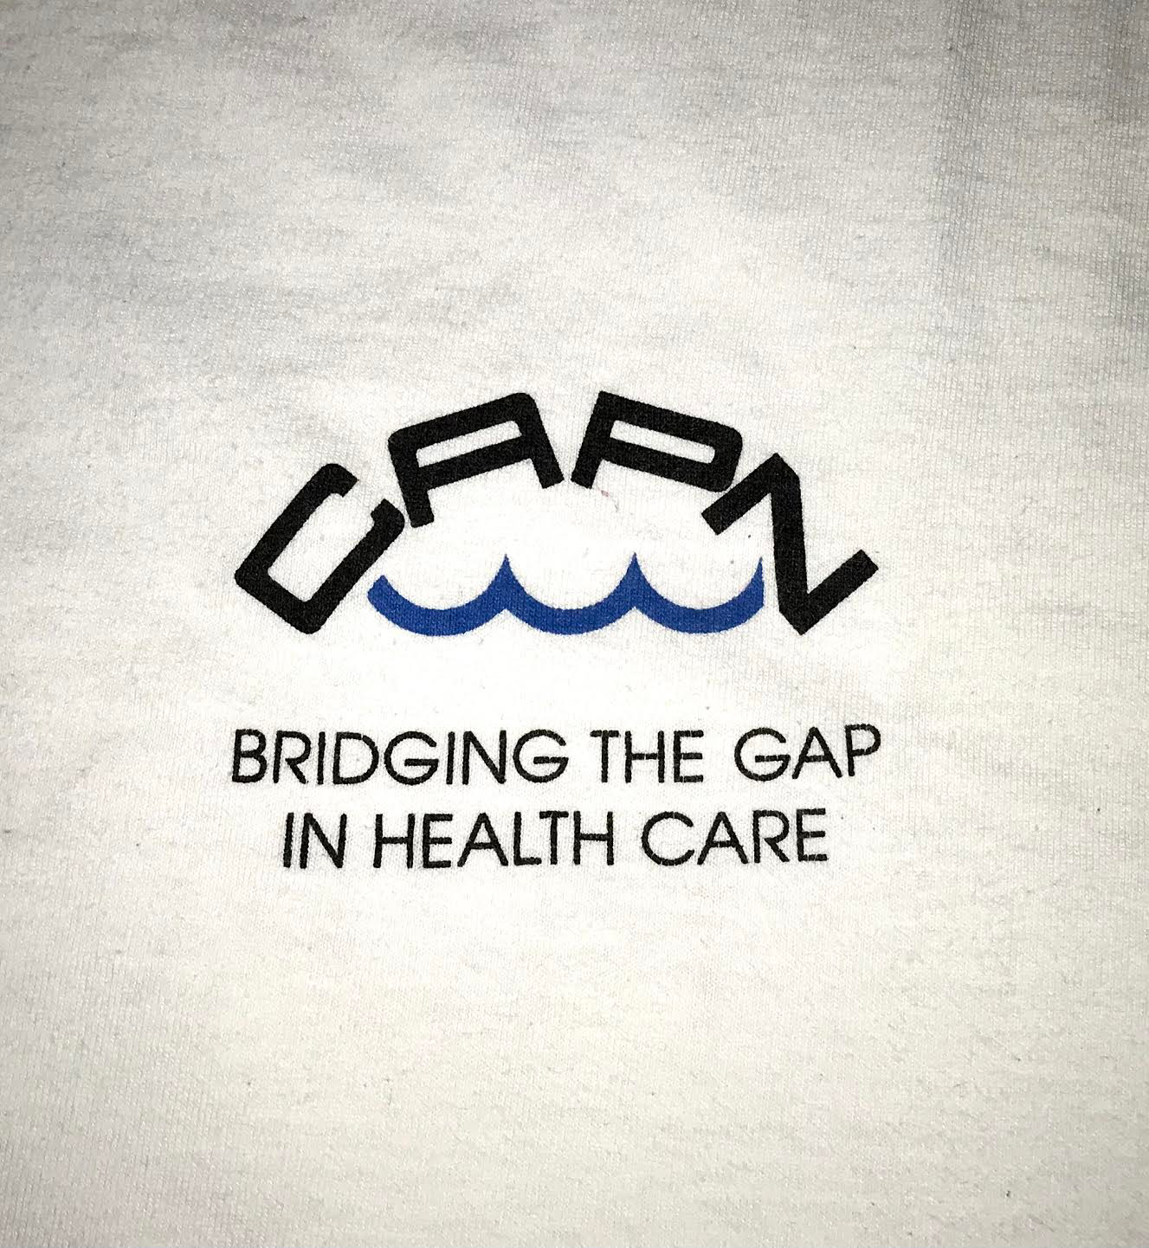

(Early logo and slogan for CAPN)

Over the years, CAPN has grown tremendously with over 100 active members and a database of more than 700 nurses. CAPN also joined the national American Association of Nurse Practitioners (AANP) in 2003 and became incorporated within the Florida Nurse Practitioner Network (FNPN) in 2004 creating a triad of local, state, and national organizations for advanced practice nurses. Taking advantage of its location in the Florida capitol, CAPN has played a pivotal role in advocating for legislative policies to advance the profession. The organization has always strived to be especially friendly to students and newly graduated advanced practice nurses in order to empower individuals to feel comfortable in new roles through opportunities for networking and continuing education. Without a doubt, CAPN will continue to effectively serve advanced practice nurses in the Tallahassee area and beyond and will evolve to respond to the needs of our growing community.



(T-shirt slogan as an effort to promote nurse practitioner visibility, early days of CAPN)

Acknowledgements

The 2020/2021 CAPN Board would like to extend our deepest gratitude to Julie Holt, APRN-BC, Jo Davis, APRN-BC and Julia Pallentino APRN-BC, JD for sharing their wisdom, experience, and the oral history of the organization with the authors. These women are pioneers in the field and through their efforts to unify Advanced Practice Nurses, have created an enduring organization to “Bridge the Gap in Healthcare.”

References

Brennan, C. (2020). Tracing the history of the nurse practitioner profession in 2020, the year of the nurse. *Journal of Pediatric Health Care, 34*(2), 83 – 84. <https://doi.org/10.1016/j.pedhc.2019.12.005>

Florida Board of Nursing. (n.d.). *Advanced practice registered nurse*. Retrieved May 4, 2021 from <https://floridasnursing.gov/licensing/advanced-practice-registered-nurse/>

Florida Board of Nursing. (2016, April 15). *Important legislative update regarding HB 423*. <https://floridasnursing.gov/new-legislation-impacting-your-profession/>

Florida Board of Nursing. (2018, October 4). *Advanced practice licensure change*. <https://floridasnursing.gov/advanced-practice-licensure-change/>

Florida Nurses Association. (2004, November). *Florida nurse practitioner SCOPE*. <https://cdn.ymaws.com/www.floridanurse.org/resource/resmgr/november_-_2004.pdf>