In Person Meetings are Back
Our April meeting was held at the Greune River Grill, and it was well attended! Dr. Allison Ellis, DPT provided an outstanding discussion on resiliency in healthcare. Our plan is live meetings every other month with either a Zoom meeting or a newsletter in-between. If the covid-19 vaccination rates continue increase, we hope to resume monthly meetings by Fall 2021.

  - Newsletter
  - May 2021

Upcoming Events
In Person Business Meeting: Our Next in-person meeting will be June 9th, 2021. Please watch the announcements on ENP for the venue.
TNP Spring Conference Enduring Option: The Texas Nurse Practitioners Spring Conference is available on demand for CNE through July 26, 2021. Fees for TNP Members: $249 TNP Non-Members: $449. For more information: https://www.texasnp.org/events/EventDetails.aspx?alias=spring21enduring
TNP Virtual Entry Into Practice Seminar Taking place May 28, 2021 0830-1700. Cost for members $95 Non-members $185. For more information: https://www.texasnp.org/events/EventDetails.aspx?id=1421368&group=&_zs=s5rCe1&_zl=cQSd7
TNP Seminar: Why Emotional Health is Integral to Professionalism 6/12/2021 1100-1200. Cost $25. For more information: https://www.texasnp.org/event/EIWebinar?_zs=s5rCe1&_zl=dQSd7

TNP Fall Conference The 33rd annual Texas Nurse Practitioners conference will be held in September 2021.

Blood Drive Success
Immediate Past President Dr. Mia Painter
Another Successful Blood Drive |  | 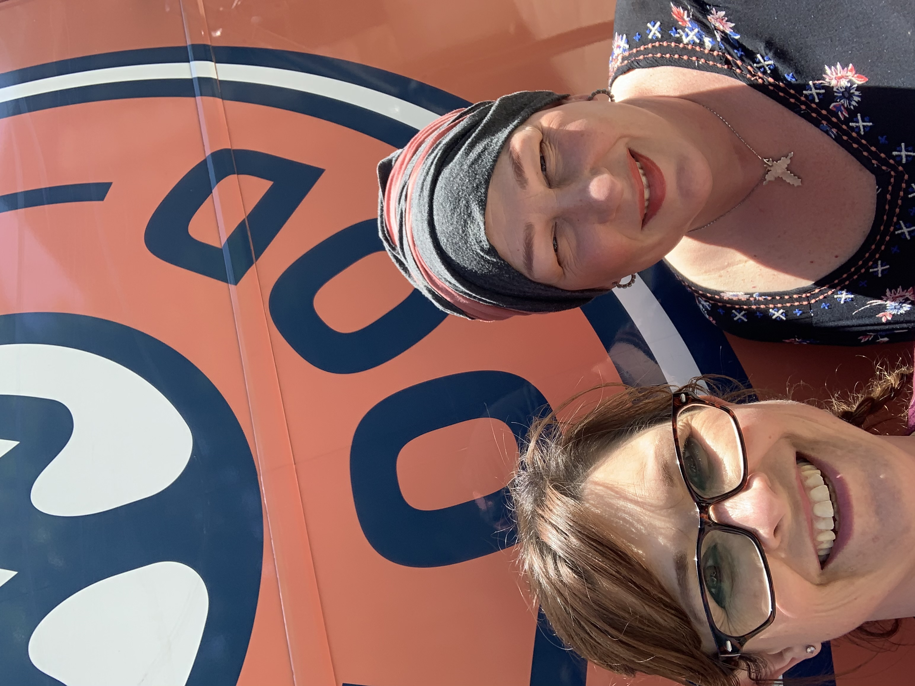
On April 10th, we held another successful blood drive. The We Are Blood mobile set up in the parking lot of the Fast Lane Clinic, and despite the short notice provided, we had a great turn out. |  | Dr. Mia Painter, APRN and Dr. Sharon Wright, APRN
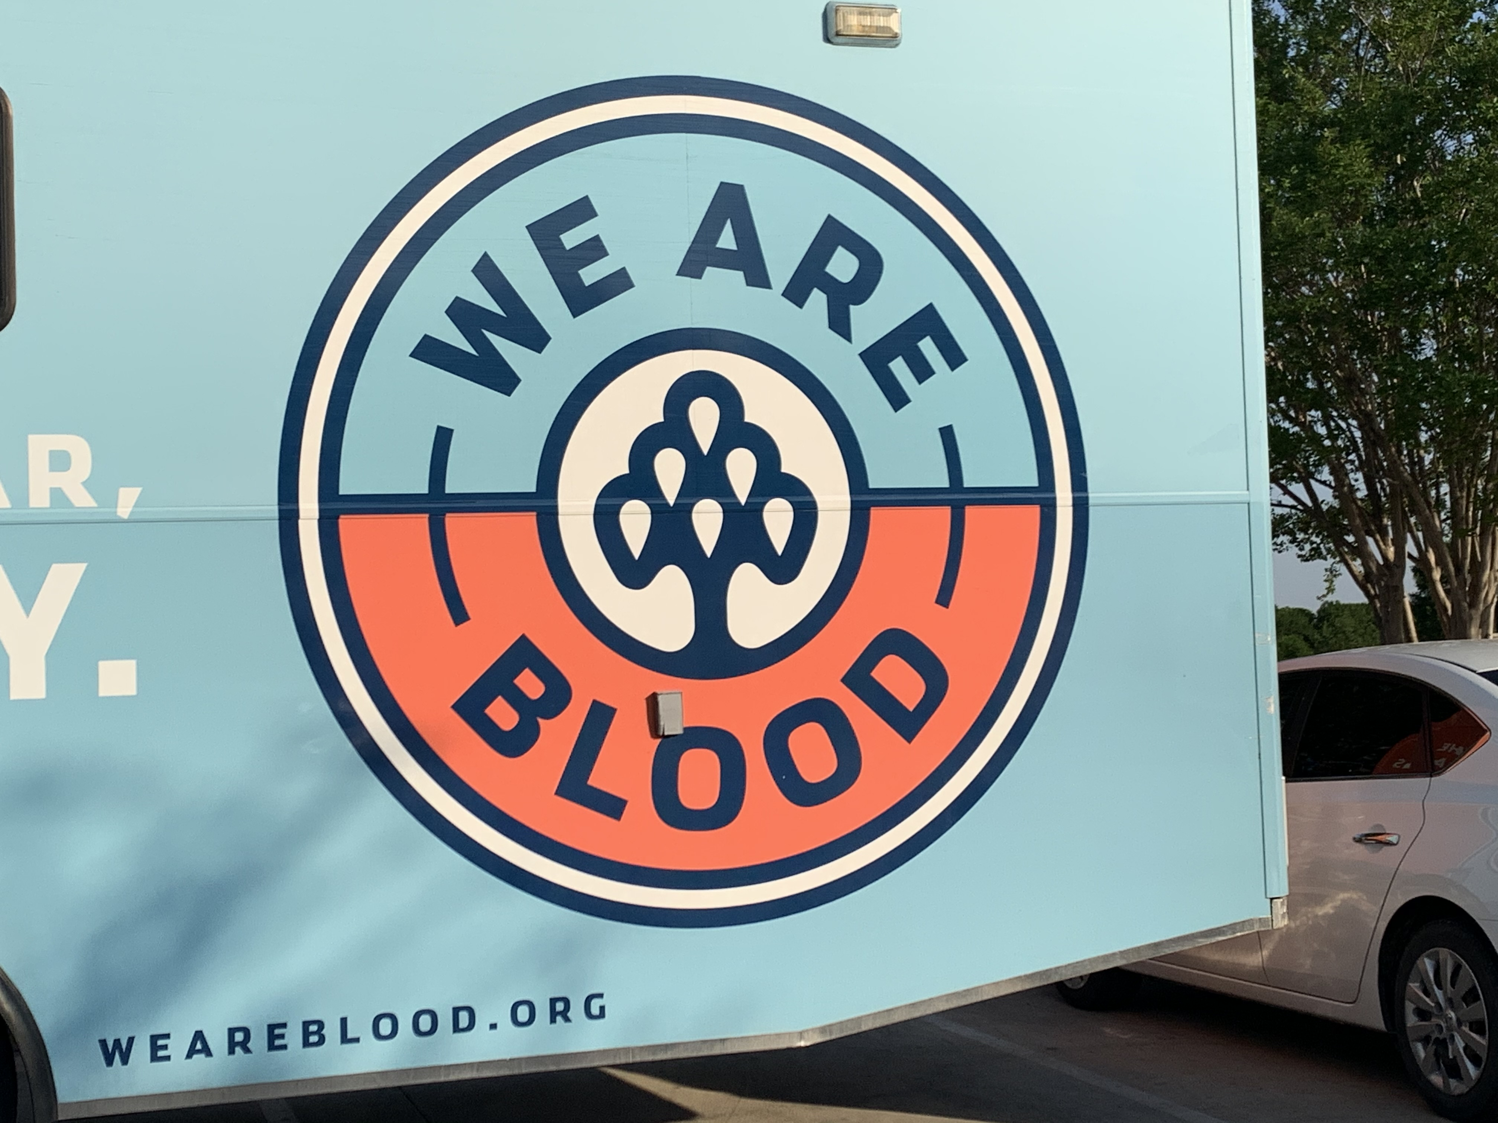
Vacancy and Committee Help
Our recording secretary, Maria Waterbury, was called back to her home state of Connecticut. The president of the organization can appoint a new recording secretary, but would love for some of our members to express interest. If you have an interest in filling this vacancy, you would become a steering committee member (SCM) of the Hill Country Nurse Practitioner’s Association. If you are interested in applying for this vacancy, please contact sharonwrightnp@gmail.com. The social committee and membership committee is also in need for members to help fill in.

