|  |  |
| --- | --- |
| /var/folders/fp/rlwjgt9x0v9bc05jbcc0nr1h0000gn/T/com.microsoft.Word/WebArchiveCopyPasteTempFiles/ARNPs_Washington_State.png?1437503717 |  |
| **Spring 2021 Newsletter**  **Happy Spring Season! Make sure to** [join ARNPS United](https://auws.enpnetwork.com/page/19541-join-renew-membership) **to support our lobbying efforts and attend our upcoming CE in 2021.**  **Upcoming CE Events**  At ARNPS United, we have had a very successful launch of our online CE events.  Please join us for the following upcoming events.  April 15:  [Incorporating the newest Migraine headache drugs and devices into your practice](https://auws.enpnetwork.com/nurse-practitioner-events/136455-incorporating-the-newest-migraine-headache-drugs-and-devices-into-your-practice#!registration) Pharmacology credit  May 20:  [POLST and Advance Care Planning Tips and Tools for patients facing dementia, mental health challenges and end-0f-life planning](https://auws.enpnetwork.com/nurse-practitioner-events/136477-advance-care-planning-tips-and-tools-for-arnps-to-help-their-patients-facing-dementia-mental-health-challenges-and-end-of-life-planning#!registration) | |

**Clinical Nurse Specialists: What makes them so SPECIAL?**

Clinical Nurse Specialists (CNSs) are Advanced Practice Registered Nurses, just like Nurse Practitioners, Certified Nurse Midwives, and Certified Registered Nurse Anaesthetists. CNSs are trained in the 3 Ps, certified as Advanced Practice Nurses, and Licensed as ARNPs in Washington state. But CNSs have a very different role in healthcare compared to their APRN colleagues.

The CNS operates in 3 equal spheres: Direct Patient Care, Nursing Leadership, and Systems Leadership. In Direct Care, CNSs are providers who assess, diagnose, treat, and evaluate patients. In Nursing Leadership, they evaluate how care is provided to patients to guide and advance practice. In Systems Leadership, they lead and participate in interdisciplinary teams for projects to improve quality and outcomes on a larger scale. Many NPs, CNMs, and CRNAs also participate in projects like this, but CNSs have it as a large part of their expectations and resource/time allotment.

To better understand the role, consider the example of a Wound Care CNS in a community hospital. She is consulted for a patient with an ulcer that is not healing as expected. She assesses the patient, performs a sharps debridement and punch biopsy and then orders appropriate daily dressing changes. As she is leaving the room, the nurse asks her how to apply the honey dressing and she shows them. The CNS creates a quick sheet on honey dressings and posts it and updates the nursing manual. Nurses can call her if they have questions. She coordinates with managers and educators to present at the next nurse staff meeting. She also sees that the hospital has recently switched to another brand of dressing that is not as effective. She puts together a workgroup with staff from outpatient and inpatient clinics, surgeons, Materials Management, and nurses. The group researches products, does cost/benefit analysis, facilitates a product trial, presents the results to the appropriate committees, gets the product approved, and coordinates roll out and education. The CNS then monitors outcomes for the next 2 years and works with team leaders to adjust elements of the plan as needed.

CNSs are a fusion of these three spheres and offer flexibility to focus more in one than another as healthcare needs change. With advanced training in Project management, Education, and Systems-level perspectives, CNSs are change agents that bring around advancement of practice and improved outcomes for our patients, our staff, and our communities.

Gaila Palo, MN, ARNP-CNS, AGCNS, CWON-AP

President

Northwest Clinical Nurse Specialists Association

gailapalo@gmail.com

**The Book Corner: Notes on Nursing**

Because of reduced travel due to last year’s lockdown, I’m reading more and thought to start this virtual reading group. The books below are fiction or historical accounts of nursing during war and peace – making a difference in health outcomes.

Thomas Keneally’s **Daughters of Mars** (Atria, 2013) has been a favorite book of mine since publication. Two nurses, sisters from remote Australia, leave a tragedy behind for the horrors of World War I. Keneally writes with sympathy and understanding; being thrust into a triage role, knowing you can’t and won’t get it right, but whatever mistakes you make are miniscule compared to the colossal tragedy others have wrought; “’I was so bad at it,’ said Naomi, beginning to sob. ‘I was so bad at it.’ ‘They got their lethal wounds ashore you know,’ said Sally, soothing the back of her sister’s head. ‘And not by you’”.

Keneally respects and honors both the fear and determination required to confront new demands – with only what you’ve read about but never before seen – one sister reads an anaesthesia text in the evening because that will be her job tomorrow. “She felt the panic Naomi had on the bad-lit deck last night, all alone in authority over the shades of life and death that were so hard to tell from each other.” Vivid and accurate descriptions of wounds, of sounds and smells and textures illustrate the story while revealing the story of each nurse.

Keneally gets the interactions right; among the nurses, between the nurses and the acrimonious and abusive orderlies, with the doctors who are sometimes arrogant and sometimes more frightened than the nurses, and the patients – who could be a brother, a friend or a husband. My book group hated it. I was wounded. But like every nursing experience nursing, I learned from this mistake and began reading with the only other nurse in the group. A bad day in nursing, especially in war, is not like a bad day elsewhere and Keneally captures the horror and exhaustion and determination to get up and do it next day and the next.

Vera Brittain’s **Testament of Youth** (Macmillan 1933) followed. While Keneally fictionalized true events, Brittains’s account is a memoir of experiences through World War I. From an upper middle class family Brittain fights for entry into Oxford only to discover academic study meaningless while those she loves leave to fight and die. She cannot focus on her studies, choosing “to get as far a I could from intellect and its torment, I longed intensely for hard physical labour which would give me discomfort to endure and weariness to put mental speculation to sleep.” Brittain’s writing is from another era, florid and lyrical and dense. A [five-part mini-series](https://www.youtube.com/watch?v=NUaNuP82y3M) is available on YouTube for those interested in seeing and not reading her story, but it is also florid and lyrical and dense. Brittain observes how nursing has eaten its young from inception. In England nurses originally came from the working class and were disdained, often considered immoral, drunkards rather than women trying to independently earn a living, denied education and respect. World War I opened nursing to wealthier, more educated women, who trained as probationers but often looked down upon serving in the Volunteer Aid Detachment, by sisters trained in hospitals.

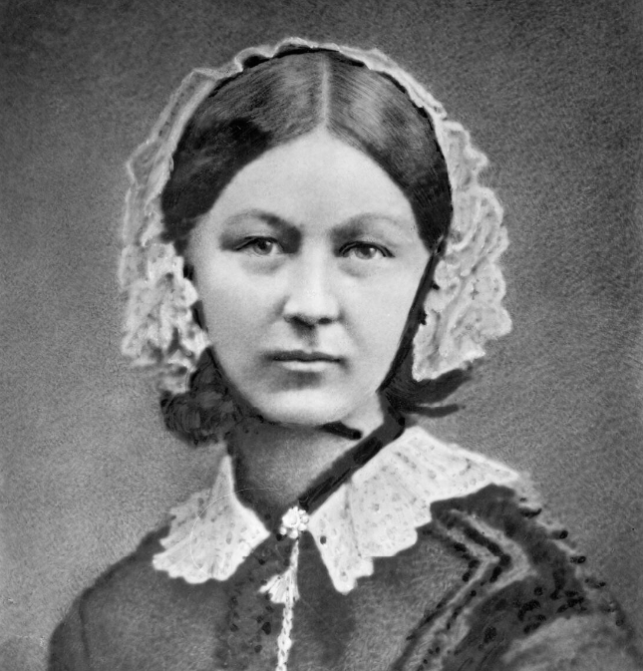Which brought us to Florence Nightingale. As a nursing student I confess to ignoring the assigned reading about her, not believing a romanticized legend was useful to the neophyte nurse I was becoming. Having now tackled Mark Bostridge's **Florence Nightingale, the Woman and her Legend** (Viking 2008) I realize I could have learned a lot from Florence – especially about how to have one’s voice heard by those controlling our work. Nightingale didn’t just revise nursing care, but hospital architecture, the supply chain and the entire British Department of War. She rightly endeavored to keep nursing focused on health and healing, not medicine and surgery, prioritizing nutrition, sanitation, hygiene and awareness of communicable diseases even as germ theory was just beginning to be expounded. What an odd creature she was – less than two years in Crimea and then effecting change from an invalid’s bedroom for thirty years. This book is a monster, over 500 pages of rigorous detail, from how her father adopted the name Nightingale to the statuary made to idolize her legend to the controversy over her efforts. Much of the divisiveness among nurses Brittain experienced a generation later was seeded by the exclusivity Nightingale promoted for her probationers.

History belongs to those who write it, so it is incumbent on us to listen to voices seldom heard. From Bostridge I learned of Mary Seacole, an Afro-Carribean Nurse who also served the soldiers of Crimea, but because of her skin color was denied authorization –she went anyway, aiding and attending soldiers but unrecognized for her contributions. “My father was a Lieutenant in the British Army and my mother a healer” from Jamaica. ​She brought her mother’s traditional Caribbean skills to the front line wounded in Crimea.

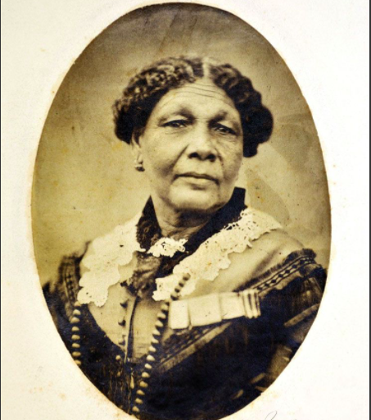

Mary Seacole appears in Bostridge’s book but also in former AANP President Angie Golden’s **The Nurse and the Vampyre: The Beginning.** (NP from home, LLC 2019) What a fun romp – and kudos to Angie for doing what many of us dream of, writing a novel encompassing our training and experience, for the fun of it. Heroine Eveline Richland leaves her upper class family to train as a nurse in 1853, serves with Florence Nightingale in Crimea but becomes a vampire before returning to England. Read it for the fun of it – and then the sequel, both available on-line.

Thanks to colleague, classmate, editor and friend Ann Horwitt who has studied, worked and read alongside me since 1978.

Next issue I’ll make recommendations on books regarding Infectious Disease and the following issues I’d suggest stories of immigrants and refugees that have impacted our practice. What books or topics do you recommend for the rest of us?

Nancy Lawton, ARNP, FNP-BC, FAANP