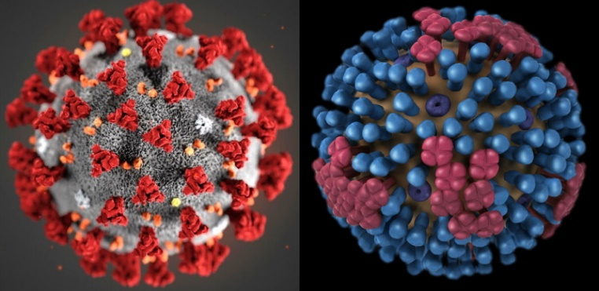

Please join us virtually on
Tuesday, February 2, from 12-1 for

Trends & Updates in COVID-19 and Influenza
Presented by Christine Symes, MSN, RN, APRN & Gina Weddle, DNP, RN, CPNP-AC/PC

Hosted by the Greater KC Chapter of NAPNAP
1 hours of CEU is available for this through the KSBON

Please email Tammie Wingert (twingert@cmh.edu) with any questions.

