**Family Nurse Practitioner Fellowship**

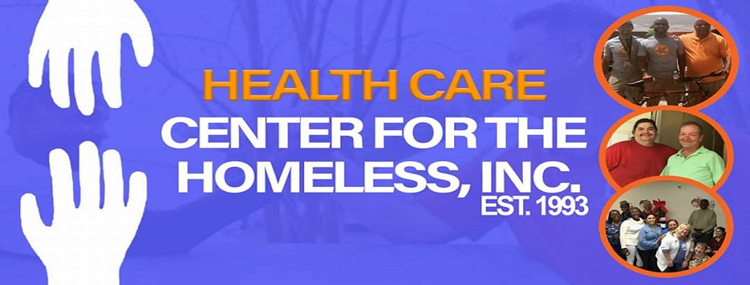

**Are you interested in a career providing care for homeless and other vulnerable populations? If so, this fellowship could be for you!**

**Program Description**

The **purpose** of the fellowship is to expand the knowledge, competence and job satisfaction of new nurse practitioners through in-depth educational and clinical experiences in Community Health Care settings. The long-range goal of the fellowship is to increase access to health and wellness care for the homeless and other vulnerable populations.

The salaried NP Fellows spend 60% of their time in mentored primary care practices with underserved patients. The remainder of their time is spent in didactic educational sessions and specialty rotations learning about providing optimal care in this unique environment.

**Quick Facts:**

**Location:** Orlando, FL

**Program Length and Time:** 12 months, full-time

**Number of Fellows accepted each year**: three

**Admission Requirements**: Graduate of an accredited NP program with national board certification as a family nurse practitioner and FL license (or license eligibility); interest in a career providing primary care for underserved persons

**Application Process Open:** December 1, 2020 to March 31, 2021

**Program Dates:** July 6th 2021 to July 2nd 2022.

**Interested?** Contact: Josie Weiss, PhD, FNP-BC, FAANP, Program Director:

**Email**: [JWeiss@hcnetwork.org](mailto:JWeiss@hcnetwork.org) or [josie.weiss731@outlook.com](mailto:josie.weiss731@outlook.com); **Phone:** 863-447-0119

**Website:** <https://obfh.org/> (Click Contact Us for more information)