Congratulations to our CAPN Student Scholarship Winners for Fall 2020: WELL DONE!

Iraida Miller, APRN, PMHNP, AGPCNP-BC Annie Reynolds, BSN, RN, CCRN

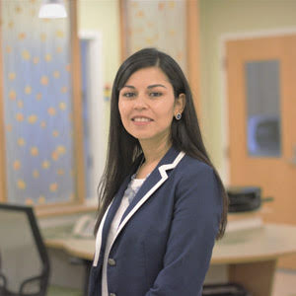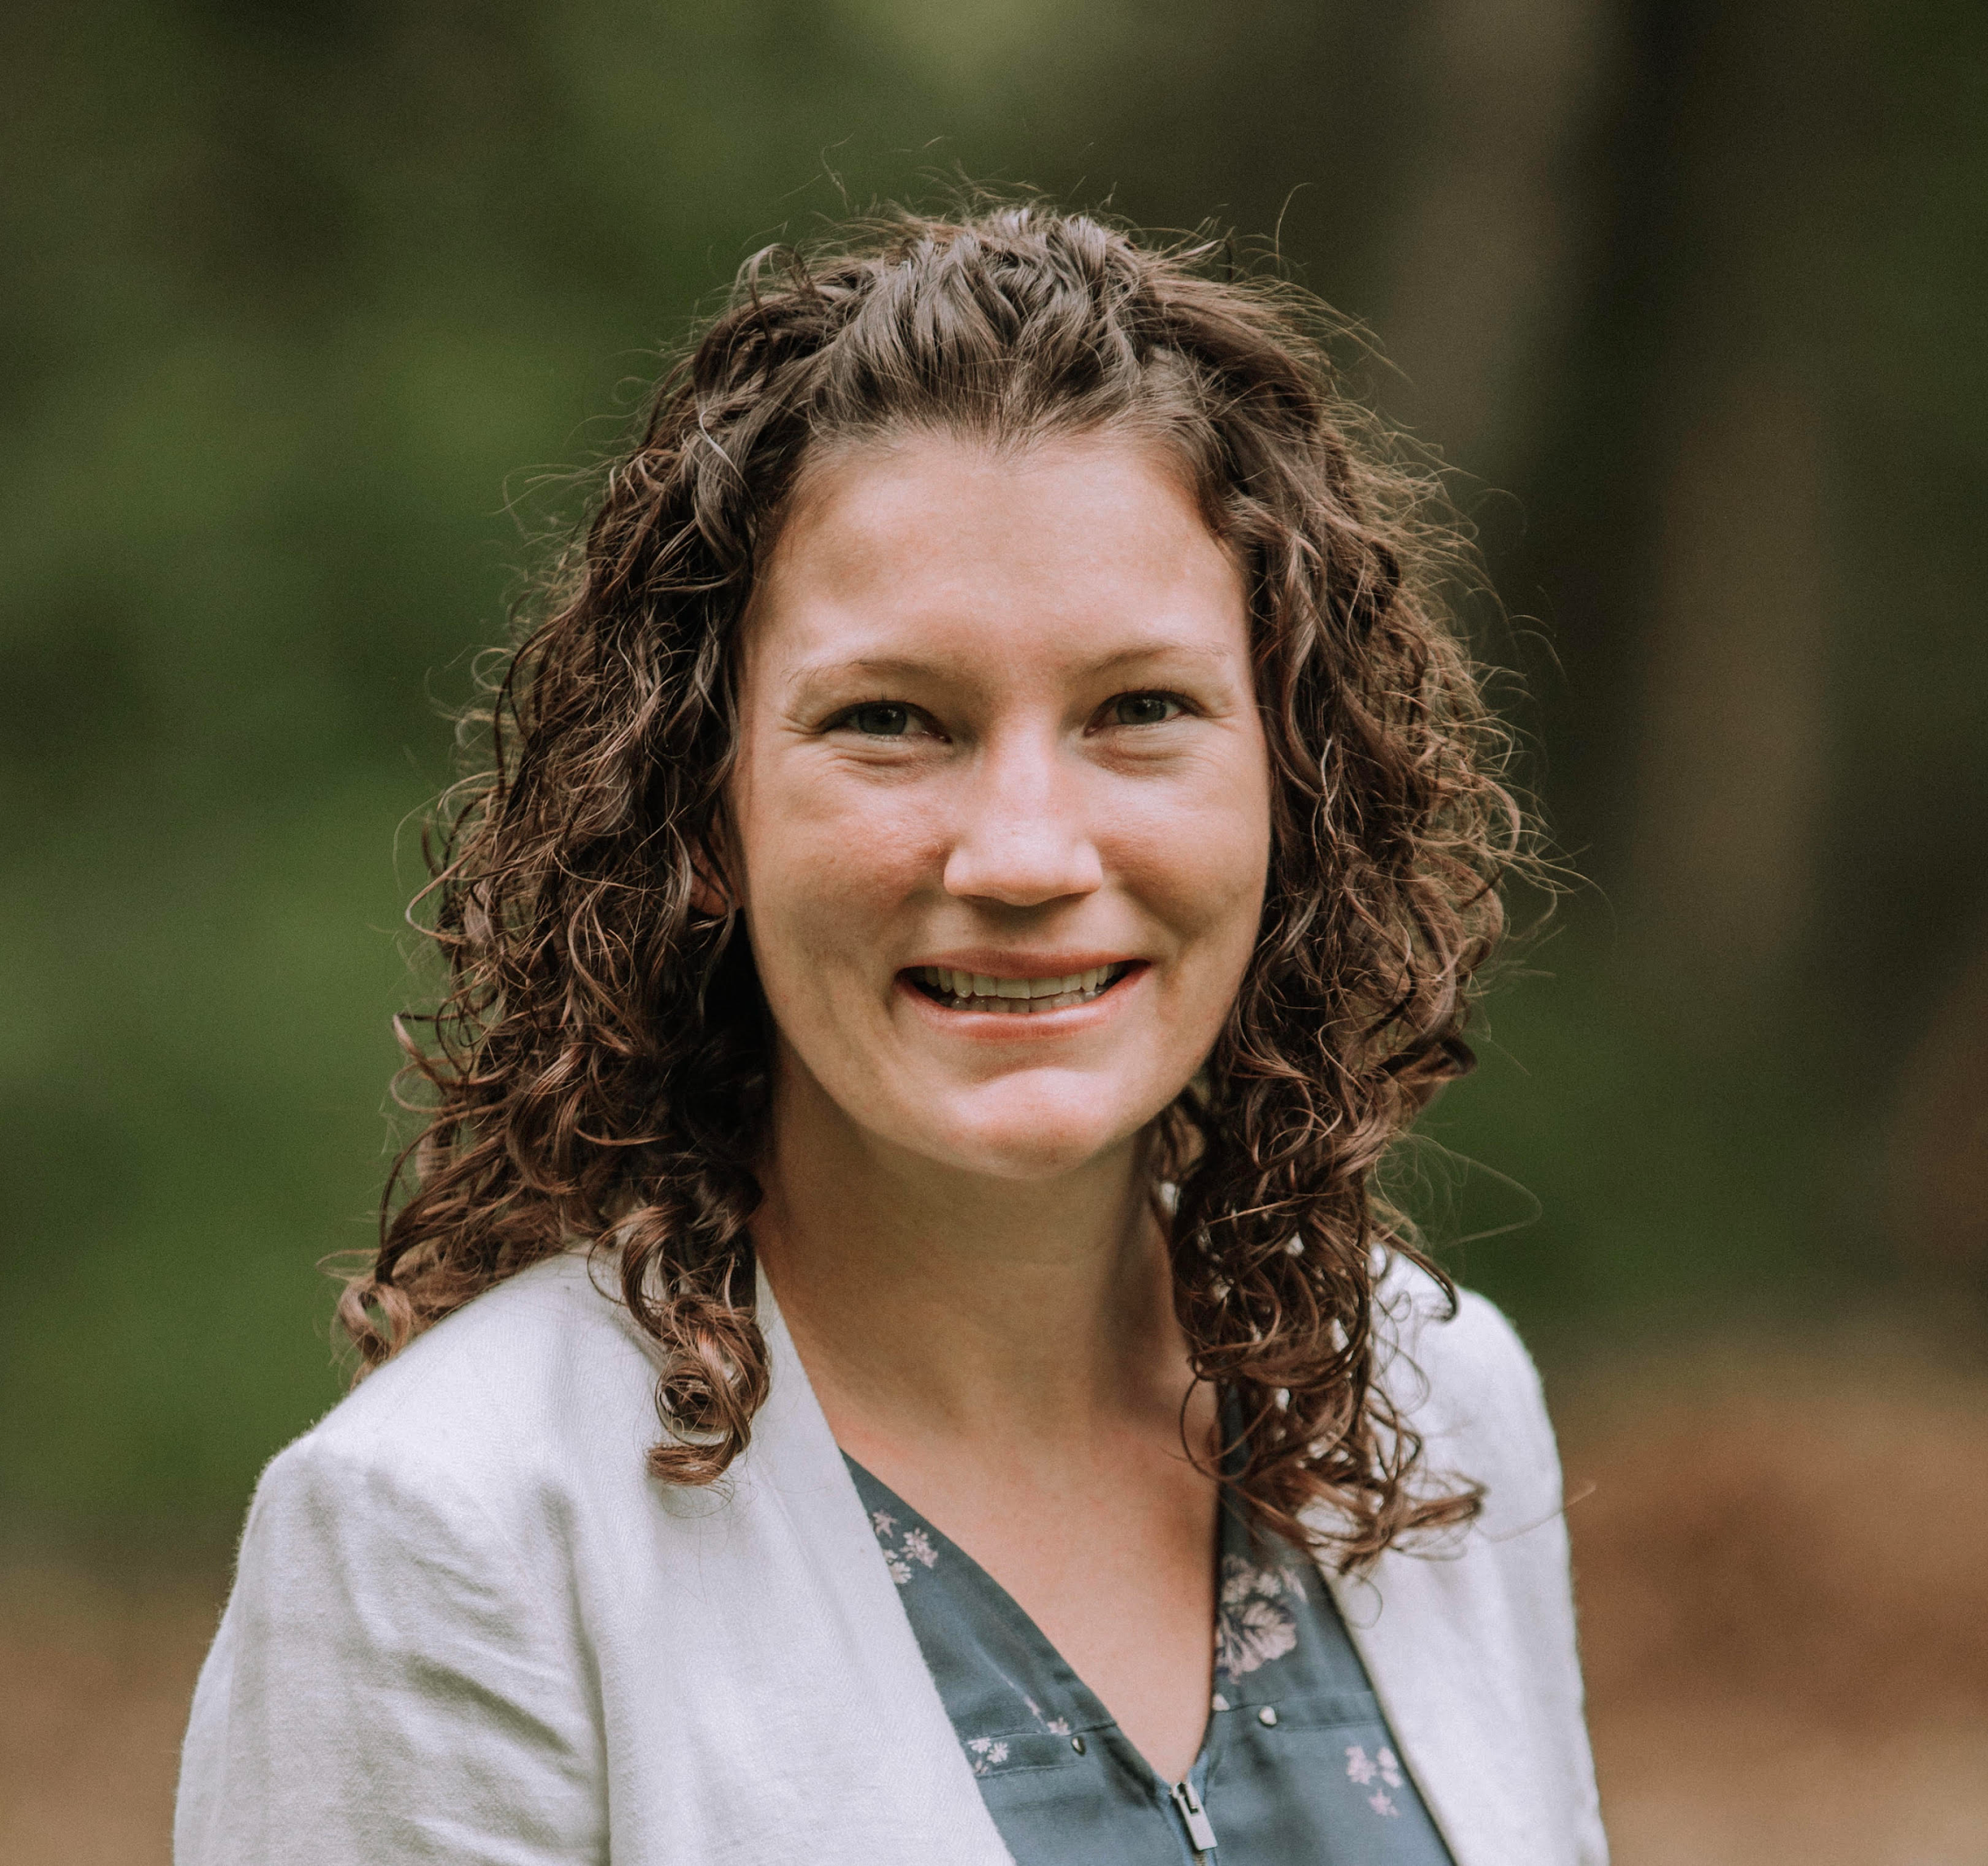

Iraida is studying to achieve her DNP while also working as a Psychiatric Mental Health Nurse Practitioner at the FSU Wellness Center. She believes completion of her post graduate curriculum will further expand her clinical expertise and improve outcomes for her patients.

Annie is a DNP student in the Family Nurse Practitioner track while also working at TMH in the Cardiovascular- Medical Surgical ICU as a nurse. She is projected to graduate Spring, 2021. Her DNP capstone project involves the study of nurse practitioners and prescription of scheduled medications.

CAPN is thrilled to be able to support the educational pursuits of these two gifted students and we hope to continue to be able to provide this scholarship in the coming years.

