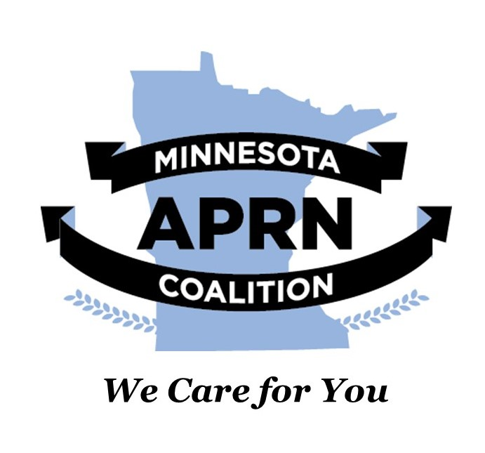

**May 2020**

**NEWS & ANNOUNCEMENTS**

**THE 2020 91st LEGISLATURE IS IN LIMITED SESSION DUE TO THE COVID-19 PANDEMIC. The Minnesota APRN Coalition continues to be busy representing APRNs in our efforts to move our bills forward. We have also been very busy in this session working to ensure APRN inclusive language in other bills of important to our provision of care for people in Minnesota. We continue to represent you through our lobbyist efforts and leadership presence and testifying remotely in committees. Please see this early May updated to legislation below. The session ends so, so we will update you with final outcomes.**

**Summary and UPDATES:**

* SF 1966/HF1916 Advanced practice registered nurses provisions modifications

Since the March newsletter, this bill has passed both House and Senate Committees and should move to the floor for voting, if this occurs this session. We will keep you updated. As a reminder, this is a bill that The MN APRN Coalition introduced in the spring of 2019. It is another “clean up” bill that updates statutory language to better align with current practice. The night before the bill was to be heard in the House Health and Human Services Committee, we received word from Minnesota National Alliance on Mental Illness that they had some issues with some language in our bill. We were able to come to an agreement and our bill moved forward. The bills were added to an omnibus Senate Health and Human Services Policy bill SF 3560, and was passed on the Senate floor on May 7, 2020. SF3560 was to be heard on the House floor on May 13, 2020 but was laid on the table. We are unsure why it was tabled but we will update when we hear. We expect these bills to pass this session. You can read the [Full Text Here](https://www.revisor.mn.gov/bills/text.php?number=SF1966&version=0&session=ls91&session_year=2019&session_number=0&format=pdf)

* **SF2902/HF2898 Civil commitment provisions modifications; engagement services pilot project establishment; appropriating money**

Since the last newsletter, we engaged in significant advocacy to include APRNs in the commitment language. Currently, while the session is held up due to COVID-19, it looks like the bill will move forward including APRNs working in Emergency Rooms listed as “examiners” who are able to order a 72-hour hold. APRNs working in other settings are considered “health officers” in this bill and can hold someone for transport to a center for further evaluation for a potential hold. This bill was added to the same omnibus bill SF3560 above and passed on the Senate floor. We are awaiting House action and will let you know when it occurs.

For your information, the Minnesota Department of Human Services introduced legislation that incorporates the Federal CARES act changes at a federal level, into state legislation to ensure APRNs are included in those ability at a state level. This state language is included in SF3560 as well.

* **SF4603 Criminal, Civil, and Administrative Immunity for Health Care Services: COVID-19**

This bill provides protection for a health care responder, acting in good faith, is immune from criminal , civil, or administrative liability for any harm or dames results from the responder’s act or omission in the course of performing duties related to the provision of health care services, including providing, allocating, withdrawing, or delaying health care services, arising out of the state’s response to the COVID-19 outbreak during the peacetime public health emergency. The language currently in the bill includes RNs, but not APRNs. We are working to have inclusive APRN language. This bill was introduced on 5/12/2020 and has been referred to Senate Health and Human Services Finance and Policy committee. We will keep you updated on the progress and language in this bill.

* **SF277/HF1126 Direct primary care service agreements establishment**

This bill allows providers to directly contract to provide primary care services and specifically excludes these agreements from the definition of insurance and excludes them other provisions required of insurance plans (e.g, the need for a health care provider to obtain a certificate of authority or license to market, sell, or offer to sell a direct primary care service agreement meeting requirement noted in this bill). Licensed APRNs who provide primary care services are included in this bill. The bill passed in the Senate, but the House bill was referred to Commerce Committee and has not yet been heard in that committee. The MN APRN Coalition continues to monitor this bill.

* **SF290 Preceptor temporary refundable income tax credit establishment**

This bill establishes a $5,000 tax credit for individuals who serve as preceptors as a physician, APRN, Physician Assistant, or Mental Health Professional. The credit is limited to individuals serving as a preceptor for 12 weeks OR 480 hours during the taxable year. This bill does not have a House Companion Bill, and was introduced and referred to the Senate Taxes Committee. It was not heard in the committee by the end of the first year of the biennium. The MN APRN Coalition supports this bill, although if it moves forward would address the high number of hours required to be eligible. We have offered our support to the Chief Author Senator Clausen. We will continue to monitor and notify you of any developments as the session progresses.

# FEDERAL CARES ACT UPDATE:

# President Trump signed the Coronavirus Aid, Relief, and Economic Security (CARES) Act. In addition to the provision of funds to fight the pandemic, it includes important changes for APRN practice at the Federal level.

# For many years APRN organizations have been lobbying to update the Medicare rules restricting APRNs from certifying and recertifying the need for home health care services. With this act, CMS is directed to remove this barrier for NPs and CNSs and CNMs within the next six months. This change also includes Physician Assistants.

# The act also allowed states governments to remove barriers to the provision of telehealth services including both video and telephone visits.

# OPIOID RESPONSE ADVISORY COUNCIL NEWS!

MN APRN Coalition member Dr. Kathryn Nevins, FNP was appointed to the Opioid Response Advisory Council. As you may recall, the MN APRN Coalition advocated last spring for an APRN seat on the council, we were not successful, but are very happy that Dr. Nevins was able to meet the criteria for membership consideration and a FNP sits on the council. Congratulations Dr. Nevin! Dr. Nevin joins another nurse leader Dr. Darin Prescott, DNP, MSN, MBA, RN on the council.

# MEMBERSHIP

Membership is only $45 per year. Less than dinner and movie. Please help us continue to ensure that all Minnesotans continue to have direct access to the health care provider of their choice and to continue to be a resource for all MN APRNs. Our work benefits ALL Minnesota APRNs so [Please join today.](https://mnaprnc.enpnetwork.com/page/22071-mn-aprn-membership)

# 2020 PHARMACOLOGY REVIEW: We will reopen this for registration in mid-June. We will send you a message with updates then.

**3rd ANNUAL PHARMACOLOGY REVIEW is open for registration. The two-day event is on September 17-18, 2020 at the Best Western Premier Nicollet Inn Burnsville, MN.**

**We are applying for 13.5 hours of pharmacology CEs.**

**We only have 50 seats left and they are going fast!**

**Register today!**

# For more information, visit our [Website](https://mnaprnc.enpnetwork.com/)

**ATTEND BOARD MEETINGS**

Our board meetings are open to the public. Members, Student APRNs and prospective members are all welcome to attend. You will find the schedule of future board meetings posted on our website under “upcoming events”.

No need to pre-register.

# 2020 NP WORKFORCE SURVEY COMING SOON!

This will be our best survey yet. Watch your email for survey announcement.

