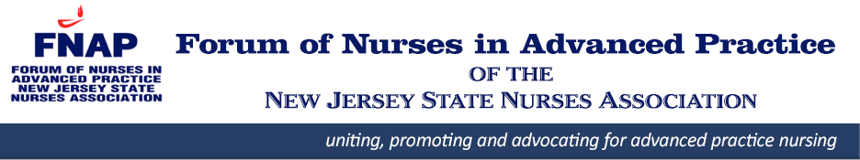

**FNAP Educational Program & Meeting**

March 21st, 2020 @ 9AM

***Agenda:***

1. 9 - 9.15 AM: Welcome
2. 9.15 – 10:30 AM: Educational Program

**Josh Schrecker, PharmD.**

Clinical Pharmacist, Healthcare Services

**Understanding the Impact: The Role of Pharmacogenetic and Drug-Drug Interaction Testing in Patient Care**

1. 10.30 - 10.40 AM: AANP State Representative’s Report
2. 10.40 - 11.15 AM: Executive Board Reports: President, Secretary, Treasurer
3. 11.15 – 11.30 AM: Announcements & Open Forum

***Changed Venue:***

**VIRTUAL – REMOTE ACCESS PROGRAM**

Saturday, Mar 21, 2020 9:00 am | 3 hours | (UTC-04:00) Eastern Time (US & Canada)

Meeting number: 791 838 207

Password: FNAP03212020

https://rutgers.webex.com/rutgers/j.php?MTID=md904dcca9696080074f3b887a6eff446

Join by video system

Dial 791838207@rutgers.webex.com

You can also dial 173.243.2.68 and enter your meeting number.

Join by phone

+1-650-429-3300 USA Toll

Access code: 791 838 207

**FNAP members - FREE**

**Non-members – FREE - please consider membership for free AANP CEUs and activities in the future**

*(apply* [*here*](https://fnap.enpnetwork.com/membership/new)*)*