**Family Nurse Practitioner Fellowship**

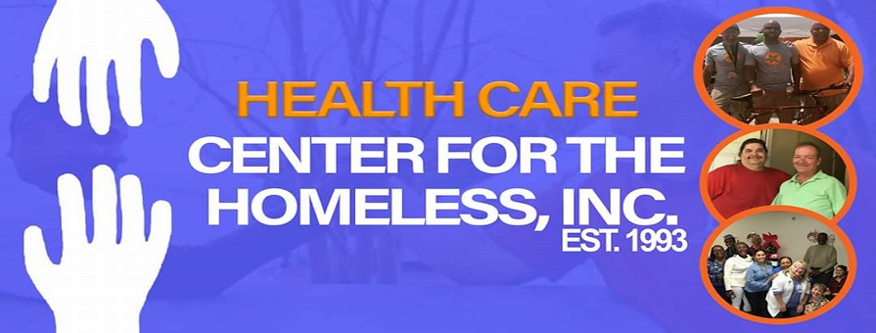

The Health Care Center for the Homeless (HCCH)/Orange Blossom Family Health (OBFH) **Fellowship** will help **Family Nurse Practitioners** develop career practices to help meet the health care needs of underserved populations

**Program Description**

The **Mission** of the HCCH/OBFH Fellowship is to expand the knowledge of new nurse practitioners through in-depth educational experiences in Community Health Care settings that will result in competence and job satisfaction as well as increased access to health and wellness care for the homeless and other vulnerable populations.

The salaried NP Fellows will spend 60% or more of their time in mentored primary care practices with underserved patients. The remainder of the Fellows time will be spent in a variety of activities learning about meeting the needs of homeless and other vulnerable populations.

**Quick Facts:**

**Location:** Orlando, FL

**Program Length:** 12 months

**# of FNPs accepted**: three per year

**Admission Requirements**: Graduate of an accredited NP program with national board certification as a Family NP and FL license (or license eligibility); stated interest in a career in primary care with underserved populations

**Application Process Open:** February 15, 2020 to April 30, 2020

**Program Start Date:** July 6, 2020

**Interested?** Contact: Josie Weiss, PhD, FNP-BC, FAANP, Program Director:

**Phone**: 407-428-5751 ext. 1314; **Email**: JWeiss@hcnetwork.org