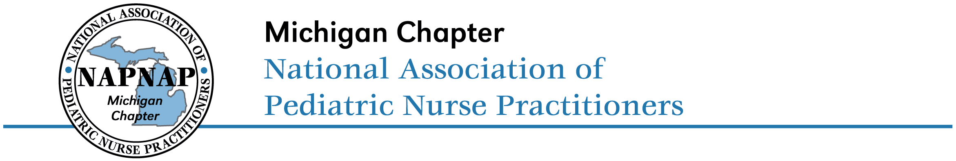

Dear Member,

We are excited to invite you to recognize your colleagues for their outstanding performance. The Michigan Chapter of NAPNAP (MI NAPNAP) is calling for nominations for the awards of Pediatric Nurse Practitioner of the Year, Preceptor of the Year, and Pediatric Nurse Practitioner Advocate of the Year. The awards will be presented at the annual MI NAPNAP Spring Conference on May 1, 2020.

PNP of the Year:
Award Criteria:
1. Current active membership in NAPNAP
2. Contributions in any of the following areas:
- Clinical expertise
- Innovative leadership
- Promotion of the health care of children
- Community involvement
- Advocacy for the role of the PNP
- Original publications or research
- Participation in NAPNAP at the state or national level
The recipient of the MI NAPNAP PNP of the Year will receive a $500 monetary award and a plaque commemorating this honor.

Preceptor of the Year:
Award Criteria:
1. Nominations may be submitted by colleagues and students of the nominee
2. PNP student preceptor in the past 2 years
3. Nominee may be a PNP or interprofessional colleague
4. Demonstrates leadership skills as an educator and professional
5. Demonstrates quality NP education through exceptional service as a preceptor
  - Seeks out new opportunities for students
  - Enthusiastic about mentoring students
  - Invested in professional development
  - Demonstrates a strong teaching ability
The recipient of the MI NAPNAP Preceptor of the Year will receive a $500 monetary award and a plaque commemorating this honor.

PNP Advocate of the Year:
Award Criteria:
1. Non-PNP professional colleague
2. Collaborates with NPs
3. Understands the role of the NP
4. Advocates for NP practice
5. Demonstrates professional leadership skills
The recipient of the MI NAPNAP PNP Advocate of the Year will receive a plaque commemorating this honor.

All nominators will be entered into a drawing for a free registration to attend the 2021 Michigan NAPNAP Spring Conference. Please complete the Awards Nomination Form and submit by March 2, 2020 to jessicalee1979@hotmail.com. Please provide as much information as possible when describing your nominee. All submissions will be reviewed and selected by a blinded committee of MI NAPNAP members.

On behalf of the Executive Board we thank you for taking this opportunity to acknowledge the outstanding work of your colleagues.

Sincerely,

Jessica L. Ott, MSN, CPNP-PC
Membership Chair

