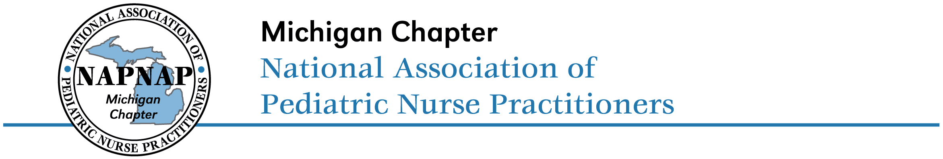
2020 Award Nomination Form

Please complete one form for each nomination for the Michigan NAPNAP Awards. In addition to the requested information below, please provide a description of the nominee and how they meet criteria for the award and exemplify the PNP role.

Award (choose one):
☐ PNP of the Year ☐ Preceptor of the Year ☐ PNP Advocate

Name of Nominee:
Credentials:
Practice site:
Email:

Name of Nominator(s):
Credentials:
Practice site:
Email:

Please submit nomination to Jessica Ott via email at jessicalee1979@hotmail.com by Monday, March 2, 2020.

