January 2020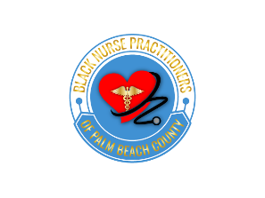

Member meeting

# join BNPPBC for the first meeting of the year

January 15, 2020

6:30pm to 8:00pm

American Cancer Society

621 Clematis Park Road

West Palm Beach, FL 33401

Join a committee

Meet the Board of Directors

Meet the Advisory Council

Meet the committee chairs

Ask questions, get involved

RSVP on the website