**Please review the candidate profiles and cast your vote.**

**Please note you must be an active member to vote.**

**The survey monkey link is sent to all the active FNAP members.**

**President Elect candidate**



**Lauren De Lucia ACNP-BC** is an advance practice nurse who has her independent Pain management practice in North Bergen. Lauren has been active with FNAP for more than 2 years and has presented at FNAP Annual education day. She is interested in this position as she is trying to assist other APNs in our field as well as educate APNs to want to make a difference in our profession. She has actively participated in meetings with regional political leaders and represented APN interest and supported independent APN practice.

**Secretary candidate**

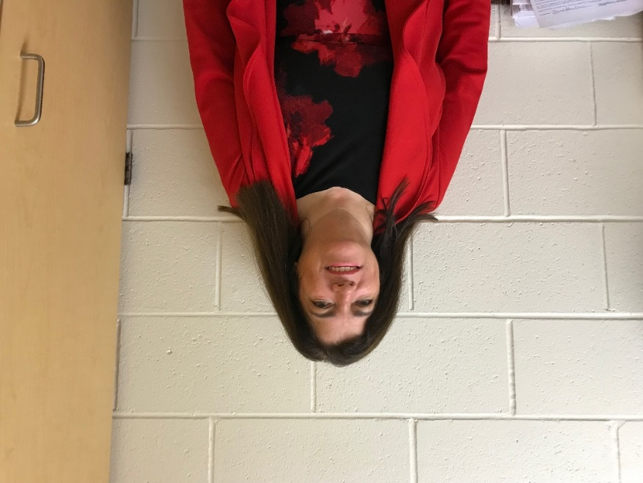

**Virginia Carreira, DNP, RN, APN, CCRN, CDE, CSN**

She has been active at FNAP Board for more than 4 years. Works at School Based Youth Services, Long Branch High School and part time at the observation unit at Jersey Shore University Medical Center (Hackensack Meridian Health). Also works in MICU as staff RN.  Teaches DM management education at CentraState in outpatient. She is the president of the Lambda Delta Chapter, Sigma Theta Tau International Honor Society of Nursing.  She assisted with Workshop Assistant for Neurological Exam Essentials at the American Association of Nurse Practitioners national conference in Indianapolis.  She presented on Head Injuries in High School Athletes at the American Association of Nurse Practitioners national conference in Indianapolis, Indiana.  She received the Hannelore Sweetwood Award from Lambda Delta Chapter from Sigma Theta Tau International for mentorship in nursing 11/18.  She also the Beacon of Light Award from New Jersey Nurses Association-Institute for nursing.

**Treasurer Candidate**



**Constance Kartoz PhD, RN, MS, FNP** is a Family Nurse Practitioner and an Assistant Professor at The College of New Jersey where she teaches in the graduate and undergraduate program. Her research interest is in aging families and anticipatory loss for parents. She has actively served FNAP as treasurer for past two years. She has presented at local, state as well as international nursing conferences and is actively engaged in continuing research of her interest areas.

Education Co Chair Candidates.

Candidate1

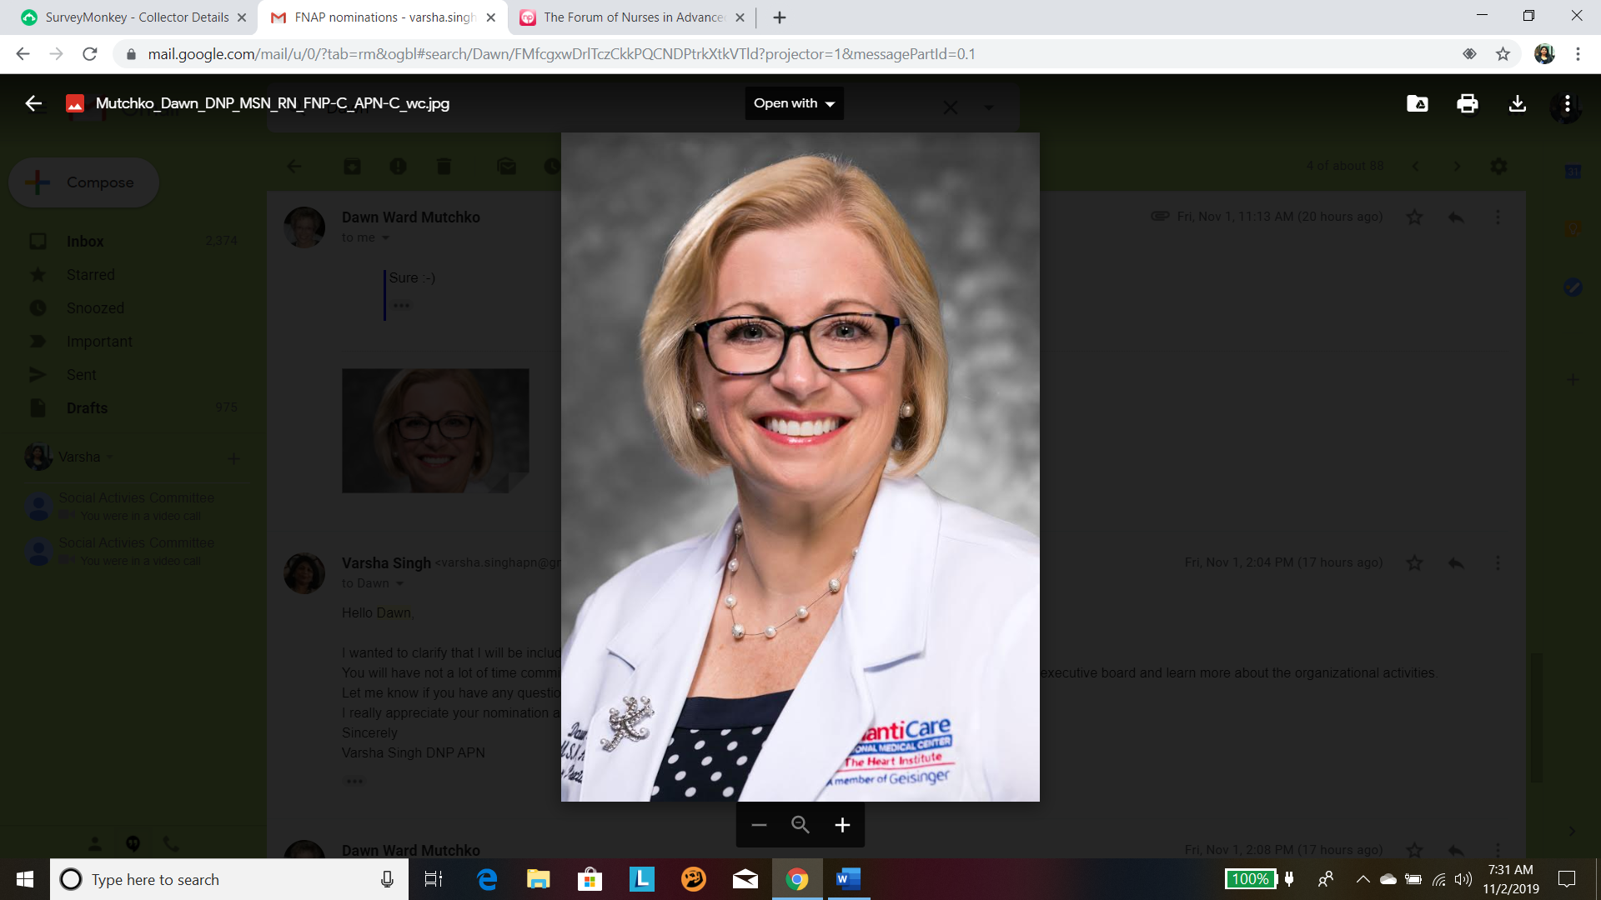

**Dawn K. Mutchko, DNP, MSN, RN, APN-C, FNP-C** is currently the Lead Advanced Practice Provider for the AtlantiCare Health System in southern New Jersey.  She represents approximately 300 APPs (CNMs, CRNAs, CNSs, NPs, and PAs) who practice both in acute and ambulatory care within two hospitals, one satellite ED, multiple surgery centers, over a dozen urgent cares, as well as multiple primary and specialty care office sites throughout southern New Jersey.  Clinically, she has 15 years of primary care experience and over 16 years within interventional cardiology. She currently practices within interventional cardiology at the AtlantiCare Regional Medical Center's Mainland Campus.   Dr. Mutchko has completed the Evidence-Based Practice Immersion Program with the Helene Fuld Health Trust National Institute at The Ohio State University and has been passionate about EBP since that time.  She is in the final phase of the EBP-C certification from Ohio State as well. Dr. Mutchko is an Adjunct Faculty member in the DNP program at Wilmington University in Delaware.  She teaches Applied Evidence-Based Practice and participates as a DNP Project Chair. Dr. Mutchko earned a BS in Health Planning at Administration from the Pennsylvania State University, a BSN from the Medical University of South Carolina, an MSN in Family Medicine from then Wilmington College, and a DNP from Wilmington University.  Dr.  Mutchko is nationally board certified as a Family Nurse Practitioner (AANP). Dr. Mutchko is an undergraduate and graduate member of Sigma Theta Tau.  She is active in ANA and serves as a mentor to nurses within the ANA and is increasing her involvement with the NJ State Nurses Association.  She is a member of the American Organization of Nurse Leaders (fka AONE) and the NJ affiliate of ONL-NJ as well as the Advanced Practice Providers Executives (APPex). She is also a member of AANP and the Forum of Nurses in Advanced Practice (FNAP) with the NJSNA. She is interested in increasing her involvement with advanced practice issues, practice optimization, and advocacy for advanced practice throughout the State of New Jersey as well as at the national level.

Candidate 2

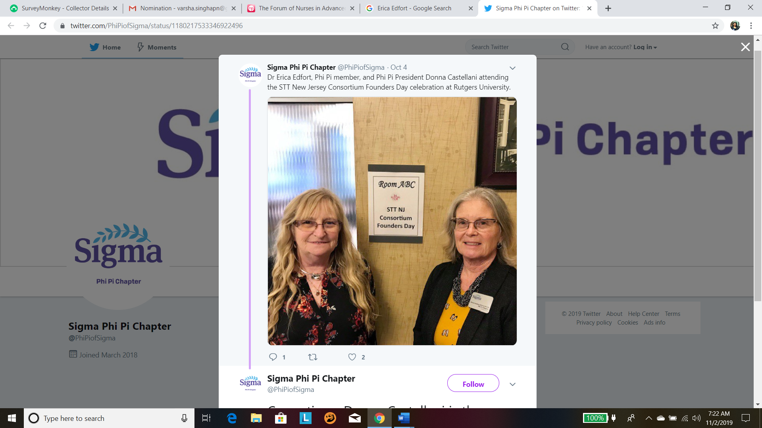

**Erica Edfort, DNP, RN*, NVRN-BC, FAHA is an** Assistant Professor at University of Chamberlain and is Fellow, American Heart Association/American Stroke Association.

Dr. Edfort is a Master Instructor II and ATI Champion. She is serving NJSNA as VP Congress on Policy &Practice and State Chair for Policy and Practice Committee. As an educator she is interested in the position of Education Co-Chair for FNAP. She has experience in CNE application preparation in prior positions as Lead Planner and education dept. management for Stroke presentations.  As a nurse educator, she is constantly working to improve the process of disseminating information to her students.