|  |  |
| --- | --- |
| /var/folders/fp/rlwjgt9x0v9bc05jbcc0nr1h0000gn/T/com.microsoft.Word/WebArchiveCopyPasteTempFiles/ARNPs_Washington_State.png?1437503717 |  |
| ARNPS United of Washington |The Summer - 2019 | |
|  | |
|  |  |
| 2019 Legislative Season | |
| The legislature convenes for two years, or biennially. The session in 2019 was the first of two sessions and lasted 105 days. During this first session, the legislature conducts budget writing and considers policy bills. The 2020 session will last only 60 days and will focus on a supplemental budget and high priority bills. All bills introduced in 2019 that did not pass can be carried forward to 2020 and reconsidered. AUWS will be working for you during the interim to have HB 1433 receive a hearing to assure ARNPs be paid the same as physicians when providing the same service. Help us accomplish this goal as a member of ARNPs of Washington State! | |
|  |  |

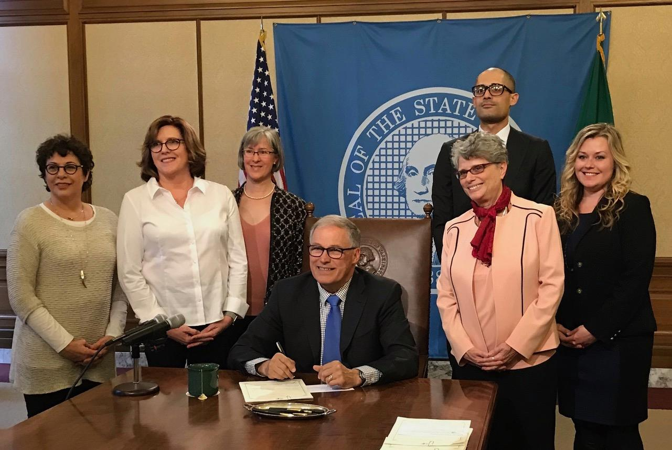

Legislative Success In our third attempt, HB 1432, concerning hospital privileges for ARNPs and physician assistants (PAs) passed unanimously in the House and Senate. This law will require hospitals to use the same process for hiring and privileging ARNPs and PAs as is used for physicians. It was signed by the governor on April 23, 2019 and becomes effective July 28, 2019.

A Step Forward to Same Pay for the Same Service

For the first time since asking in 2009 to have a bill to require private health plans to pay ARNPs the same pay for the same service, Representative Eileen Cody supported drafting legislation. HB 1433 was sponsored by 11 members of the House of Representatives and the companion bill, SB 5647 was sponsored by 12 members of the Senate. Unfortunately, the bills never received a hearing in committee. A debrief with the prime sponsors will be conducted before the 2020 legislative session to determine how to move the legislation forward. AUWS will contact ARNPs to assist with contacting legislators to educate them about the importance of the bills.

Other Significant Healthcare Legislation

**HB1087** Long Term Care Benefit Program: The first in the national long -term care benefit program, active in 2025, that provides individuals money to pay for in home care, assisted living, LTC. This will be funded by a .58% employee payroll tax.

**HB1638** Measles Exemption: The legislature voted to eliminate the philosophical/personal exemption for the measles, mumps, and rubella vaccine.

**EHB 1074** Washington becomes the ninth state to raise minimum age to buy tobacco and vape products from 18 to 21

**HB1870** This passed Affordable Care Act protections at the state level, in case of a federal repeal, this included the protection of pre-existing condition clause and a prohibition on limits on insurance benefits

Testimony and Positions on Other Legislation

In an advocacy role in 2019, AUWS supported, opposed all or sections of bills, or raised concerns about the potential effect of legislation on ARNPs. Examples of these bills include the following.

**SB 5446** would have required all prescriptions in Washington State to be prescribed electronically beginning January 1, 2020. AUWS testimony noted that while the requirement may contribute to safer prescribing practices it neglected other issues. There is a staggering cost of compliance to small ARNP owned practices who are already being adversely affected by cuts to reimbursement rates by private insurance companies. Patients often prefer printed prescriptions should a pharmacy not accept their insurance or if there is a transmission error. SB 5446 failed to make it out of committee.

**SB 5380** was the governor’s request legislation concerning opioid use disorder treatment, prevention, and related services. AUWS testimony noted the consequential public health impacts of the epidemic but stressed concerns with the legislation’s electronic prescribing mandate and costs for small ARNP owned practices to integrate with the prescription monitoring program (PMP). Beginning January 1, 2021, SB 5380 requires facilities with ten or more prescribers must integrate their EHRs with the PMP, unless DOH grants a waiver or the entity or facility is a critical access hospital. A funding mechanism will assist smaller practices in offsetting IT costs. It was signed by the governor on May 8, 2019 and becomes effective July 28, 2019.

**SB 5387** allows an originating site hospital to rely on a distant site hospital's decision to grant credentials, when granting or renewing credentials of any physician providing telemedicine or store and forward services. AUWS testimony noted the intent of the telemedicine collaborative which promoted the bill was to use provider neutral language however the bill only used the term physician. The passage of HB 1432 adds ARNP to the section of the law affected by SB 5387 which will make the language provider neutral. SB 5387 was signed into law on April 17, 2019 and becomes effective July 28, 2019.

**HB 1415** ends the use of the Health Professions Account to fund the administration of the Medical Marijuana Authorization database. It instead requires that fees collected for the recognition card issued by a medical marijuana retailer be deposited in the Dedicated Marijuana Account. This will allow the health professions boards and commissions to have access t0 all fees collected for regulating their professions. The bill was signed April 17, 2019 and becomes effective July 1, 2019.

**HB 2158**, creating a workforce education investment account to fund Washington students for Washington jobs. A 20% B&O surcharge on healthcare providers and members of other industries was included in this legislation. Hospitals were able to negotiate an exemption from the surcharge. Ultimately, lawmakers held their ground despite tremendous pressure from the rest of the healthcare industry in refusing to grant further exemptions. AUWS remained neutral despite the surcharge. The reason for this neutrality was due to the inclusion of funding to increase nurse educator salaries. Although the bill passed on April 28, 2019, it has not been signed into law as of May 15, 2019 nor was any funding for the nurse educator salaries included in the state’s budget.

|  |
| --- |
|  |

|  |  |  |
| --- | --- | --- |
|  | | |
|  |  |
|  |

**Member Profile: Bradley Jellerichs**

My name is Bradley Jellerichs and I am a dermatology nurse practitioner in independent practice. During ARNP school, I knew I wanted to specialize in dermatology, so I did extra training at the VA derm clinic in Seattle. Within one year after graduating, I opened my solo practice named Bellevue Acne Clinic. In 2019 I opened my second clinic, in Federal Way, named Clinic Dermatology.

Working independently has its joys and challenges. I get to provide high-quality, unrushed patient care, and every patient gets instructions typed up for them during each appointment. I can make a decent living on 12-15 patients a day. I can make changes in clinic process without going through committee. The challenges I face are those of all small business owners, including staffing, cash flow, and demand. I started with 0 employees which meant that I had to see every patient, answer every phone call, and swipe every credit card. Since then I have expanded my clinic to 10 employees, then shrunk it when 2 dermatologists moved onto my street and demand fell. There are some years I do well and some where I work for free.

ARNP leadership and advocacy is very important to me. I have served on Boards of Directors for AUWS and the Dermatology Nurses Association. I publish, speak, precept, and work in committees. The ARNPs that came before me have overcome great hurdles in ensuring that I can practice independently and prescribe. One thing that continues to surprise me is how difficult it can be to ensure that nursing gets a seat at the table, on the state and national and international level.  That is why organizations like AUWS are so important; membership dues pay for lobbyists to remind state lawmakers that we exist and ensure we don’t get ignored.

I am of course very pro-ARNP and I want to ensure that everyone has what they need to be happy and successful in your practices. In order to make the biggest difference, we need your contributions to the profession. This includes joining organizations on the state and national level (AUWS and AANP, respectively), participating in journals, giving talks, taking part in committees, and just in general being active to push forward our practice.