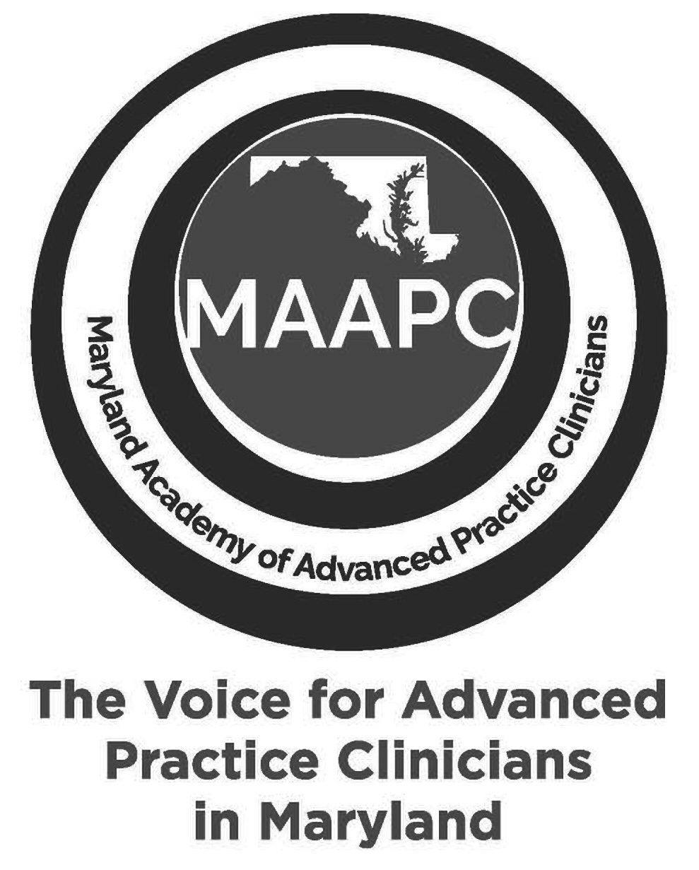
Pharmacology Update: A Regional In-Person CE Conference
Saturday, April 18, 2026
7: 00 AM – 5:00 PM
Doordan Institute at Anne Arundel Medical Center
Belcher Pavilion, 7th Floor
2000 Medical Pkwy, Annapolis, MD 21401

This conference is designed for healthcare professionals who are passionate about staying ahead of the curve in pharmacology and clinical care and will feature expert speakers and the latest pharmacology updates.
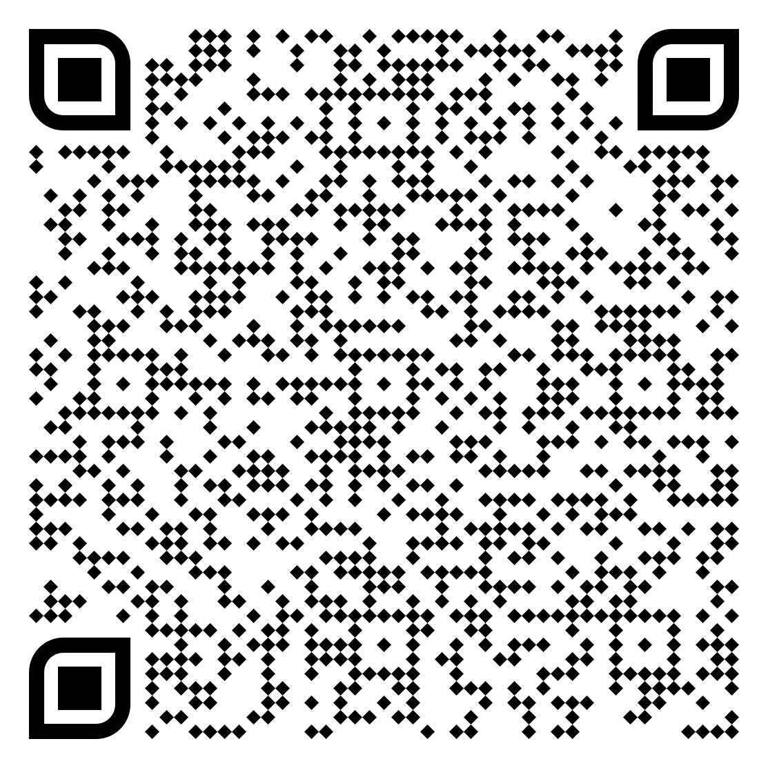
An opportunity to showcase your organization and network with healthcare professionals.

Register now at www.maapconline.org or scan

🎯 Attendee Demographics
- 200 healthcare providers expected from MD, DC, DE, PA, VA, WV
- 50% Primary Care, 25% Acute Care (ED & hospital-based), 50% specialty care, and pediatrics

🏢 Display Opportunities (20 Booth Spaces Available)

🔹 Exhibitor Package – $600
- 6-foot table + 2 chairs
- Company logo & URL on conference registration page
- Branded signage with logo at conference entrance
- Post-conference attendee list

⭐ Sponsorship Package – $1,000
Includes everything in the Exhibitor package, plus:
- Company logo and URL featured in pre-event email blasts
- Branded signage with logo and QR code in high-traffic networking areas

✨Premier Sponsorship Package – $2,500 (3 Spaces Available)
Includes everything in the Sponsorship package, plus:
- Social media recognition featuring logo and QR code
- Preferred booth placement
- Branded signage with logo and QR code at attendee check-in table and breakfast/lunch/beverage station

Exhibit Times (2 hours 30 minutes total)
- Breakfast: 7:00–7:50 AM
- Break: 10:00–10:30 AM
- Lunch: 12:30–1:30 PM

👉 Reserve your spot today
- Display portion is physically separate and apart from any independent educational activity
- All exhibitors being charged the same fee for the same display opportunity
- No consumers/patients are being invited to register for this event

