

**District 3 - Arkansas Nurse Practitioner Association Dinner Meeting**

March 28, 2019

Time: 6:00 PM

Sponsor: Dr. Amir Qureshi / Arkansas Spine and Pain

Guest Speaker(s): Nisa Kahn, APRN, Michelle Parish, APRN, Angela Chukwuanu, APRN

RSVP: Brad Barber – 501 773 8787 or bradleybarber@AIORM.com

**Riverfront Steakhouse**

**2 Riverfront Place**

**North Little Rock, AR 72114**

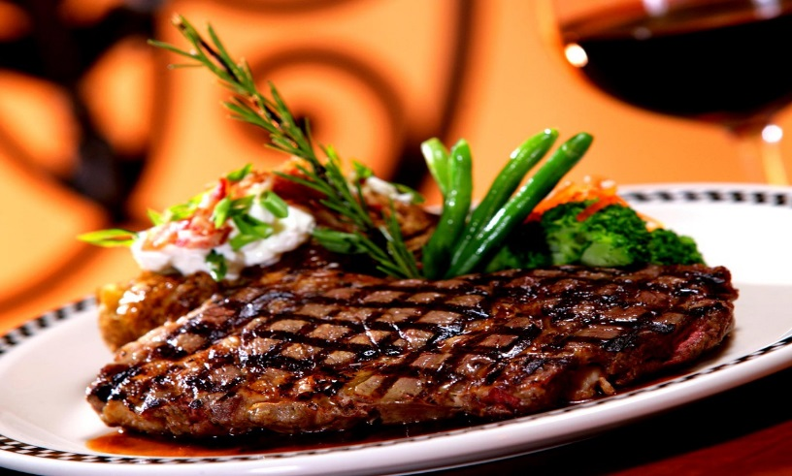

***SPONSORED BY***

