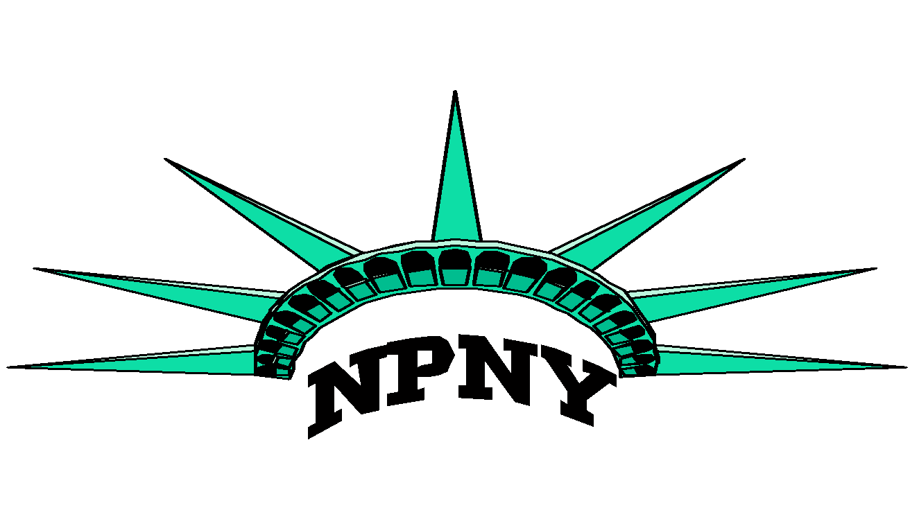
Nurse Practitioners of New York
Invite you to attend:

NP Annual Advocacy Day in Albany 2019

Wednesday, March 13th 2019

We offer members a round trip to Albany from Midtown Manhattan
8 CEs applied for
Learn how to influence public policy and experience firsthand how to interact with legislators regarding issues of importance to NPs!

Members: FREE
Non Members $30

RSVP to reserve your seat on the bus by February 25th
Please visit npny.enpnetwork.com to secure a spot
E-mail NPsofNY@gmail.com

