RICK SCOTT

GOVERNOR

*NURSE PRACTITIONER WEEK IN FLORIDA*

WHEREAS, nurse practitioners in Florida are referred to as advanced practice registered nurses who have advanced clinical education and training, building upon their initial registered nurse preparation; and

WHEREAS, there are more than 250,000 licensed nurse practitioners in the United States, with over 25,000 advanced practice registered nurses licensed by the State of Florida, providing high-quality, cost-effective, patient-centered, personalized health care; and

WHEREAS, nurse practitioners order, perform and interpret diagnostic tests; diagnose and treat acute and chronic conditions; and prescribe medications and other treatments; and

WHEREAS, nurse practitioners treat patients through a caring, patient-centered, holistic model of care; and

WHEREAS, Florida is proud to recognize and honor the service of nurse practitioners in our state;

NOW, THEREFORE, I, Rick Scott, Governor of the State of Florida, do hereby extend greetings and best wishes to all observing November 11-17, 2018, as *Nurse Practitioner Week in Florida.*

IN WITNESS WHEREOF, I have

hereunto set my hand and caused the Great Seal of the State of Florida to be affixed at Tallahassee, the Capital, this 31st day of October, in the year two thousand eighteen.

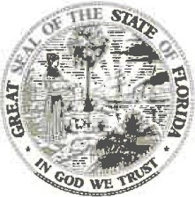

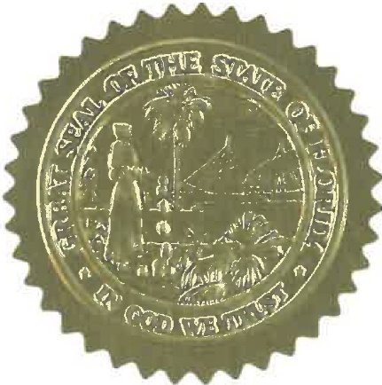  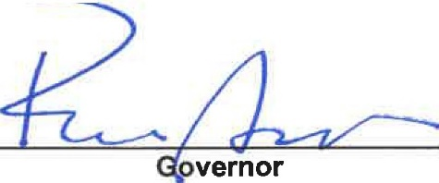

'l# @FLGovScott

THE CAPITOL

TALLAHASSEE, FLORIDA 32399 • (850) 717-9249 [www.FLGov.com](http://www.FLGov.com/)