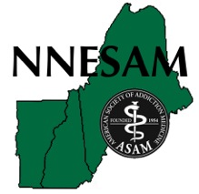

**Northern New England Society**

**of Addiction Medicine**

**2018**

**8th Annual Scientific Conference**

**& Business Meeting**

**ADDICTION MEDICINE**

**CURRENT ISSUES / TIMELY TOPICS**

**(This activity has been approved for 9.5 AMA PRA Category 1 Credits™.)**

**____________________________**

**November 2 & 3, 2018**

**(Friday evening, all day Saturday)**

**Trapp Family Lodge, Stowe, Vermont**

**A LITTLE OF AUSTRIA…A LOT OF VERMONT ®**

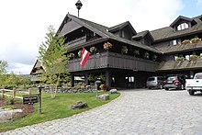

**HOTEL ROOMS SOLD OUT**

**Go to:** [**www.gostowe.com**](http://www.gostowe.com) **for alternative room locations**

[www.trappfamily.com](http://www.trappfamily.com)

700 Trapp Hill Rd. / P.O.Box 1428

Stowe, VT 05672

**Who should attend:** Physicians and other health care professionals seeking up-to-date information about addiction issues affecting their patients. Practitioners interested in networking with other regional addiction professionals.

**Educational objectives:**

1. Learn how we, as treatment providers, can influence public perception and policy re: SUD.

2. Understand an up-to-date protocol for alcohol detox of an out-pt. in a residential setting.

3. Learn the concept of getting an OD patient into treatment before leaving the ER.

4. Understand better the value of 12-Step / self-help programs.

5. Understand "harm reduction" w/ pros and cons of legal safe injection sites and needle exchange.

6. Understand the role of Professional Health Programs in treatment and support of impaired professionals.

7. Understand the complex concerns of in-pt. treatment of NAS and a family-centered approach to ongoing healthy recovery of mother and infant.

**____________________________________________________________________**

**CONFERENCE SCHEDULE**

**ADDICTION MEDICINE - CURRENT ISSUES**

**( & some controversies )**

**Friday**

**5:00 – 6:00 PM** Welcome Reception / Registration w/ buffet

**6:00 – 6:30** Michael Venn – talk by the filmmaker, followed by the acclaimed film

**6:30 – 8:00 PM** Film – The Heroin Effect – perspective in New Hampshire

**Saturday**

**7:00 – 9:00 AM** Buffet Breakfast

**7:45 – 9:00 AM** Annual Business Meeting for NNESAM members

**9:10 – 10:40 AM -** Outpatient Alcohol Detox in a residential center in Maine W. Allen Schaffer, MD & Bruce Campbell, LCSW, LADC

- Non-CIWA  Protocol for Scheduled Benzodiazepines for Alcohol Withdrawal  - Dr. Schaffer

**10:50 – 11:50 AM** Initiating Buprenorphine in the Emergency Room

Randy Knight, MD

**11:50 – 12:35 PM** Lunch

**12:35 – 1:35 PM** What Medical Practitioners Need to Know about 12 Step Recovery

Tom Allan, LCSW, LADC, CCS

**1:45 – 2:45 PM** Harm Reduction – Needle Exchange – Safe Injection Sites - The Vermont experience

Grace Keller, MA

**2:55 – 3:55 PM** Vermont Professionals Health Program

Lisa Lambert, MD

**4:05 – 5:35 PM** Opioid-exposed Newborns - a Baby-Friendly, Family-centered approach

Bonny Whalen, MD, Julia Frew, MD, Daisy Goodman, DNP, CNW

**About the speakers:**

Tom Allan, LCSW, LADC, CCS

Tom is the former Executive Director of the Milestone Foundation, Former Program Manager at Mercy Recovery Center and is currently in private practice in Portland, Maine. He is a past Co-Director of Kindred Spirits Camp at The Rowe Center currently serves on their Board of Trustees at Rowe. He is a member of The Motivational Interviewing Network of Trainers and is a former Change Leader for the Network for the Improvement of Addiction Treatment (NIATx). Tom is also in his own long-term recovery. He has been working to help people recover from substance misuse for over twenty years

Bruce A. Campbell, LCSW, LADC, CCS

San Jose State University, San Jose, CA: May 1990, Master of Social Work, with academic distinction, cited. He is Clinical Director of Wellspring in Bangor, Maine’s oldest, licensed substance use treatment program and provides long-term residential services, gender specific for men and women, as well as outpatient and intensive outpatient programs substance use and mental health programs, including Infinity House, a long-term residential treatment program for women with children, and New Horizons, a social model detox program.

He is a founding member of the Bangor Area Recovery Network (BARN). He has served with the Maine Coalition of Recovery Communities, Maine Alliance for Addiction Recovery and Public. He has consulted for the Pacific Health Institute, Covered Bridge Foundation, Watsonville Community Hospital, Sun Street Centers, States of Maine and Massachusetts, National Center for Substance Abuse and Child Welfare, and the National Association on Alcohol, Drugs, and Disabilities.

Mr. Campbell was born and raised in The County.

Julia Frew, MD

Dr. Frew received her MD from Brown Medical School through the Brown-Dartmouth Program in Medical Education and completed her psychiatry residency training at Dartmouth-Hitchcock.  An Assistant Professor of Psychiatry, Obstetrics & Gynecology, and Medical Education at the Geisel School of Medicine at Dartmouth, Dr. Frew is the Associate Director of the psychiatry residency program and is involved in medical student education in psychiatry.  Her clinical work focuses on the care of pregnant and postpartum women with psychiatric illness, including substance use disorders.  She directs a perinatal psychiatry clinic as well as the D-H Moms in Recovery program, which provides integrated psychiatric, addiction, obstetric, and pediatric care to pregnant and parenting women with substance use disorders and their young children.

Daisy Goodman, DNP, MPH, APRN, CNM

Dr. Goodman is a certified nurse midwife, a Clinical Assistant Professor of Obstetrics and Gynecology at the Geisel School of Medicine at Dartmouth, a core investigator with the NIDA Clinical Trials Network Northeast Node and directs women’s health services at the Dartmouth-Hitchcock Moms in Recovery Program.  She teaches health care quality improvement methods at The Dartmouth Institute, and is actively in involved in resident and undergraduate medical education. Her research focuses on improving access to substance use treatment for women through integrated delivery models. She is a principal investigator for a multisite study comparing models of care delivery for women with opioid use disorders, funded by the Patient Centered Outcomes Research Institute (PCORI), and leads a three-year dissemination and implementation project to improve maternity care for women with opioid use disorders, sponsored by the Northern New England Perinatal Quality Improvement Network.

Grace Keller, MA

Grace Keller is the Program Coordinator for Howard Center’s Safe Recovery Program, Vermont’s oldest and largest syringe exchange. In that capacity, she has had extensive hands-on experience providing case management support to clients who struggle with opioid dependence. In addition, she frequently provides testimony for the Vermont State Legislature on bills related to substance use, recovery, and treatment, such as the 911 Good Samaritan Act and the Naloxone Bill. In 2013, she was instrumental in implementing Vermont’s first community-based naloxone program through Safe Recovery. The program provides naloxone to clients, their families, and community providers. Grace has a B.A. from Trinity College in Hartford, CT.

Randolph Knight, MD

Randy is in active ED practice, and is Director of Emergency Medicine at Valley Regional Healthcare, Claremont, New Hampshire. He has 21 years’ full-time work experience in Emergency Medicine, including work at hospitals in rural areas of New Hampshire and Maine.

He received his MD degree from the University of Virginia and completed a Family Medicine residency at Oregon Health & Science University. He is board certified in Family Medicine and Emergency Medicine.

For several years, he has an appointment as Associate Clinical Professor of Community and Family Medicine, Geisel School of Medicine at Dartmouth College.

He is also currently involved ED-CONNECT (CTN-0079) an NIH-funded implementation study of treatment of Opioid Use Disorder in the Emergency Department. He is the Principal Investigator for the Valley Regional Hospital site. The work for this trial began July of 2017 and is expected to continue through 2019. This is the topic of his talk with us at our 2018 NNESAM conference.

Lisa Lambert, MD

Lisa A. Lambert completed her M.D. at Loyola University Chicago Stritch School of Medicine and her Adult Psychiatry residency training at Warren Alpert Medical School of Brown University.  She has been working in the fields of Addiction and Consultation-Liaison Psychiatry since 2004.  She was previously on faculty at Brown and Geisel School of Medicine at Dartmouth where she was involved in medical education, residency training and addictions fellowship training.  She is currently serving as Medical Director of the Vermont Practitioner Health Program of the Vermont Medical Society and is currently providing clinical care at the Brattleboro Retreat on the Co-occurring Addictions/Mental Health Inpatient Psychiatry Unit.

W. Allen Schaffer, MD

Dr. Schaffer is practicing in Bangor, Maine. He currently serves as Chief of Psychiatry at Community Health and Counseling Service, the Regional Mental Health agency for Down East Maine. He is Attending Psychiatrist at St Joseph Hospital, at Wellspring Substance Abuse and Mental Health Service, Penobscot County Jail, and Aroostook Mental Health Center. Dr. Schaffer received his medical degree in 1975 from the University of Washington, Seattle. He served his IM Residency at the Tulane Service of Charity Hospital in New Orleans and at Baptist Memorial Hospital in Memphis. In 2009 he completed his residency in Psychiatry at the Univ. of VT.

His interests include Collaborative Care Psychiatry, Consultation Liaison Psychiatry, Co-occurring Substance Use Disorders, and Treatment of Impaired Professionals.

He has been CMO for The Acadia Hospital, a behavioral health and substance treatment campus in Bangor, ME; Chief of Psychiatry at Eastern Maine Medical Center, both in Bangor, Maine. He also spent 20 years as a Medical Executive in three Fortune 500 healthcare companies, including CIGNA, Aetna, Humana. He has held faculty appointments with regular patient care duties in The Department of Internal Medicine at the University of Louisville, and University of Connecticut Schools of Medicine; and the Department of Psychiatry at the University of Vermont School of Medicine.

Michael Venn - filmmaker

Northern New England is one of the “hotspots” in the opioid crisis. Michael Venn, a celebrated filmmaker from New Hampshire, has created a documentary to show the disturbing web of painful personal, social and community issues with a local perspective. One disturbing focal point of the film is the video diary of Daniel Couzins, a local who recorded his personal struggle with a daily video. Couzins documents how he tried to savor the euphoria of his drug use without descending into compulsion. ( [www.theheroineffect.com](http://www.theheroineffect.com) )

Bonny Whalen, MD

Dr. Whalen is an Assistant Professor of Pediatrics at the Geisel School of Medicine at Dartmouth and is a newborn hospitalist and Medical Director of the Newborn Nursery at the Children’s Hospital at Dartmouth-Hitchcock (CHaD). Dr. Whalen is a general pediatrician who received her MD from the University of Vermont College of Medicine, trained in residency at MGH, Boston, MA. She practiced newborn and pediatric medicine in Madison, WI for 6 years before moving back to New England to join CHaD in 2005.  She specializes in the care of opioid-exposed newborns and breastfeeding support for new mothers.  She leads quality improvement (QI) efforts in her hospital and Northern New England to improve care for newborns at risk for, and with, Neonatal Abstinence Syndrome (NAS) due to in-utero opioid exposure. Her work focuses on increasing baby- and family-centered care, improving neonatal outcomes and mother-baby bonding through rooming-in couplet care, empowering families to best care for their newborns through prenatal education and in-hospital support, and increasing breastfeeding for newborns through education of mothers and health care providers.  Dr. Whalen is co-developer of the “Eating, Sleeping, Consoling (ESC) Care Tool”, a new assessment and care tool for in-hospital care of opioid-exposed newborns. She is leading efforts to study its effectiveness and safety in a regional QI/learning collaborative in Northern New England, as well as co-leading efforts to improve safe transitions to home for these newborns.

MD from UVM, 1996, Pediatrics residency, MGH, 1996-99

**CME credit**

The American Society of Addiction Medicine (ASAM) designates:

**This activity has been approved for 9.5 *AMA PRA Category 1 Credits*™.**

Physicians should claim only the credit commensurate with the extent of their participation in the activity.

**ACCME Accreditation Statement:**

This activity has been planned and implemented in accordance with the Essential Areas and policies of the Accreditation Council for Continuing Medical Education through the joint sponsorship of the American Society of Addiction Medicine and the Northern New England Society of Addiction Medicine. The American Society of Addiction Medicine is accredited by the ACCME to provide continuing medical education for physicians.

________________________________________________________________________________________

**Conference Faculty and Planning Committee Disclosure Information**

Planning Committee:

* James Berry, MD No disclosures
* Mark Bucksbaum, MD No disclosures
* Judy Burk, MD No disclosures
* Earl Freeman, DO No disclosures
* Audrey Kern, MD No disclosures
* Todd Mandell, MD No disclosures
* Mark Publicker, MD No disclosures
* Deborah Wachtel, DNP No disclosures

Faculty:

* Tom Allan No disclosures
* Bruce Campbell, LCSW, LADC No disclosures
* Julia Frew, MD No disclosures
* Daisy Goodman, DNP, CNW No disclosures
* Grace Keller, BA No disclosures
* Randolph Knight, MD Vermont Medical Society: independent contractor
* Lisa Lambert, MD No disclosures
* W. Allen Schaffer, MD Community Health & Counseling Services, Maine: employee
* Bonny Whalen, MD No disclosures

SAVE THE DATE - 2019

November 8 & 9, 2019

NNESAM 9th Annual Meeting and Scientific Conference

tentatively scheduled for

The Wolfeboro Inn

Wolfeboro, NH

**REGISTRATION**

Online: Go to [www.nnesam.org](http://www.nnesam.org) - pay with credit card

or

By mail: Print this page, complete it, and pay with a check made out to NNESAM to:

NNESAM, C/O Earl Freeman, DO, P O Box F, Kennebunkport, ME 04046

Questions re: registration: send to [efreeman.do@gmail.com](mailto:efreeman.do@gmail.com)



**Northern New England Society of Addiction Medicine**

**2018**

**8th Annual Scientific Conference & Business Meeting**

**ADDICTION MEDICINE: CURRENT ISSUES / TIMELY TOPICS**

**November 2 & 3, 2018**

**(Friday evening, all day Saturday)**

NNESAM member – $60

Non-NNESAM members (physicians, NPs, PAs, and others) - $125

Residents – $25 / Students - $10

*\*\*\*\*\* PLEASE NOTE: Meals are included in the NNESAM registration \*\*\*\*\**

*Please circle special meal need if applicable, the Inn will attempt to accommodate:*

*vegetarian vegan gluten-free*

Name: _____________________________________________________________

___MD ___DO ___NP ___PA ___Student/Resident ___ Other __________________

Specialty area? ______________________________________________________

Street Address: ______________________________________________________

City: _______________________________ State: ______ Zip Code: __________

Email address: ______________________________________________________

**Trapp Family Lodge, Stowe, Vermont**

**A LITTLE OF AUSTRIA…A LOT OF VERMONT ®**

Mozart Conference Room

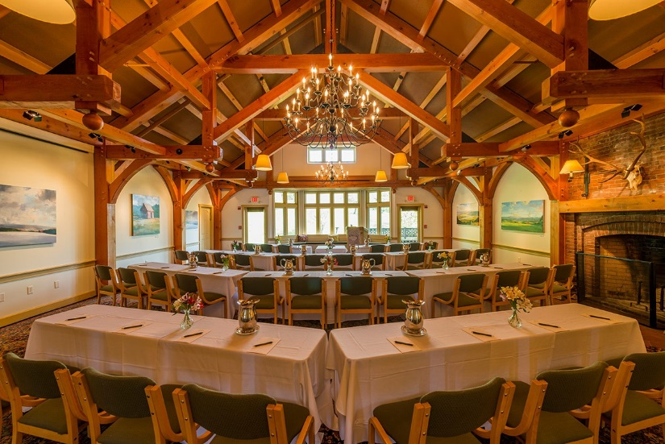

Sunset in Stowe



For overnight accommodations, we have arranged for **special room rates listed below, which will be**

**in effect through 10/6/18. Reservations made after that date will be at the Inn’s regular rates.**

Please contact the lodge directly and request the NNESAM room rate when making your reservation.

NNESAM room rate - - - - - - - - - $ 187.00 (double or single occupancy)

**HOTEL ROOMS SOLD OUT**

**Go to:** [**www.gostowe.com**](http://www.gostowe.com) **for alternative room locations**

This rate has been extended to Saturday, 11/3/18, for anyone wishing to spend the night before travelling.

Room rates are subject to a 9% Vermont tax and a 1% Stowe Local tax

*For hotel reservations:*

*800-826-7000*

www.trappfamily.com

**Mention conference rate for NNESAM**

