September 2018

Dear New Hampshire NP Colleagues,

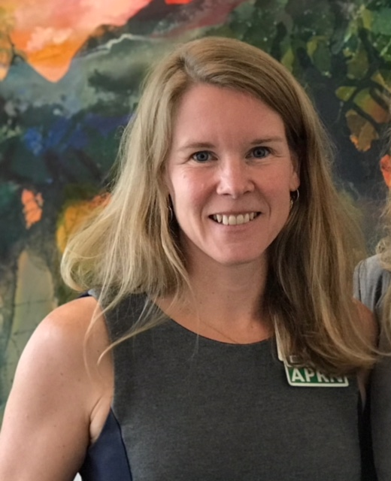
The recently passed Medicaid expansion bill, SB 313, establishes a commission to evaluate the effectiveness and future of the New Hampshire Granite Advantage Health Care Program. The New Hampshire Nurse Practitioner Association (NHNPA) is granted a seat on this commission. The Board of Directors is very pleased to announce that Bridget Linehan Logan, PhD, APRN, has been appointed to represent NHNPA on this Commission. Dr. Logan is a nurse practitioner in Pediatric Surgery at DHMC, providing care to Medicaid patients on a regular basis. She also brings experience as a published researcher, preceptor and educator, and years of committee work including service on a legislative commission. We are very happy to have Dr. Logan represent NHNPA on this Commission.
Team NHNPA had a great showing for the Cigna/Elliot Corporate 5K Road Race on August 9, 2018. Thank you to Team Captain Meg O’Leary for coordinating this fun and important event! We look forward to next year.

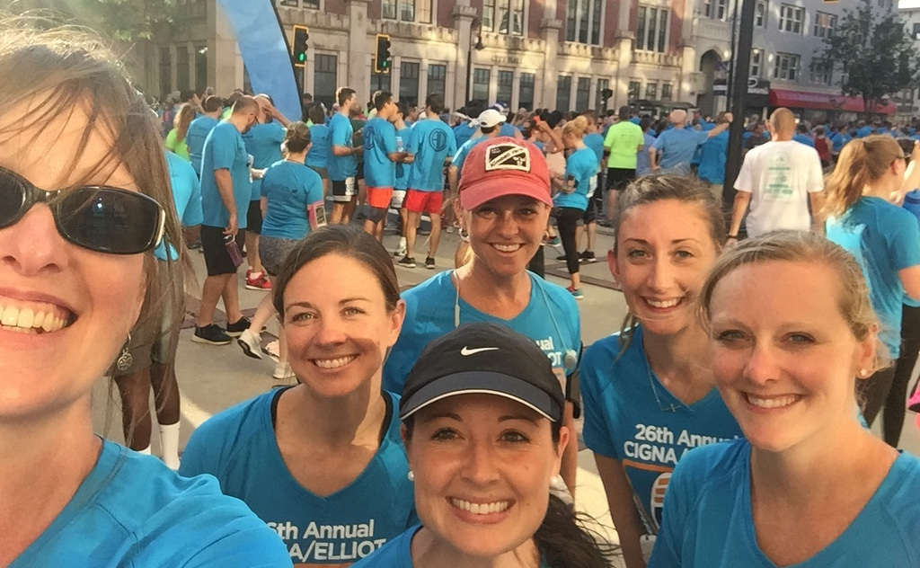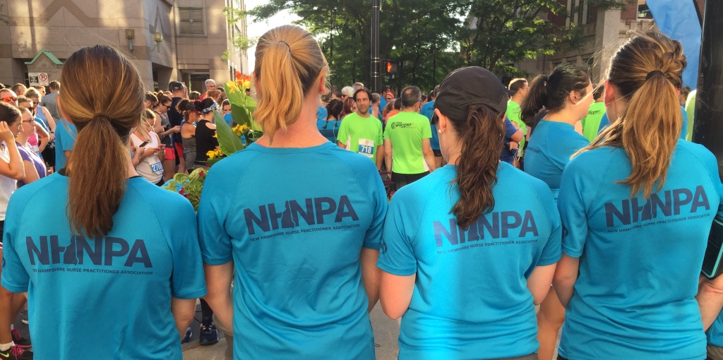

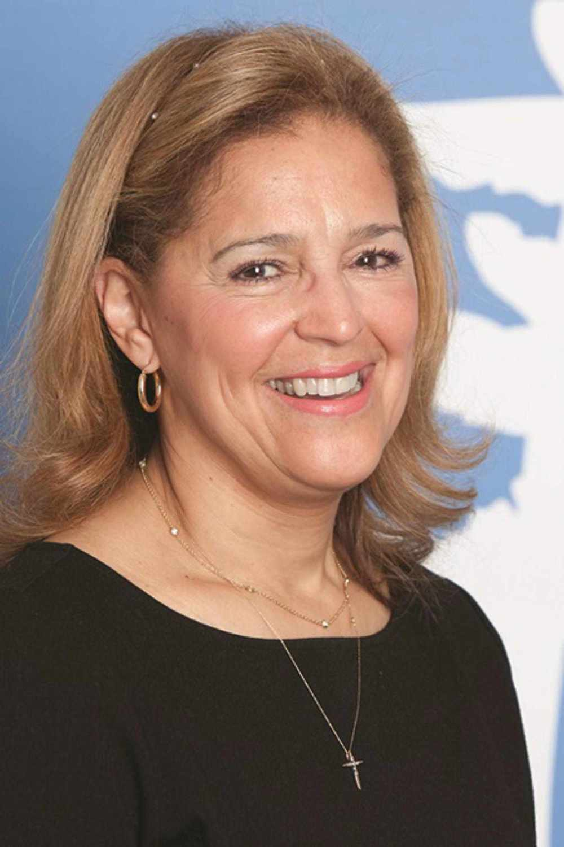
Congratulations to Mary Vigeant, APRN, Emergency Department at Memorial Hospital in North Conway, NH, who worked collaboratively with her medical staff colleagues, to change hospital bylaws to include NPs as fully credentialed medical staff members. Mary worked with her colleagues to propose changes to the hospital bylaws allowing NPs to hold any office within the Medical Staff and to be credentialed as voting members of any Medical Staff committee. These changes to the bylaws were passed by Medical Staff, then approved by the Memorial Hospital Board of Trustees. Mary now is the Vice President of Medical Staff.

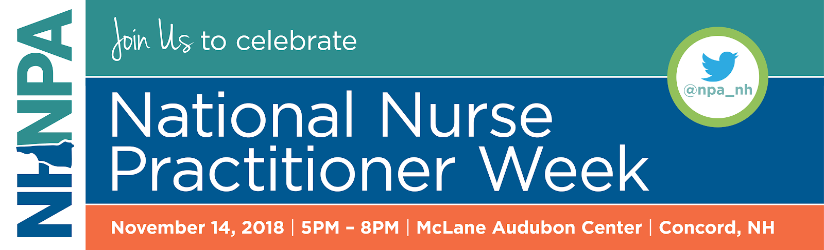

We are starting to gear up for the AANP’s National Nurse Practitioner Week. In New Hampshire, our 2018 NP Week event is: Planting the Seed of Health. Once again, we will focus on taking care of ourselves, with an evening of dinner, wine, and networking. For our main event, Lisa Howe, MSN-ANP, BC, founder of iMindBody, will teach us about recognizing and managing the stress response using the Stress Management and Resiliency Training (SMART) model. This event sold out last year. Do not miss your opportunity to network with other NPs from around the state and invest some time in yourself.

Reserve your spot today at: https://nhnpa.enpnetwork.com/. I look forward to seeing you there!

I am honored to be able to serve the nurse practitioners of New Hampshire. Together, we can do great things.

Sincerely,
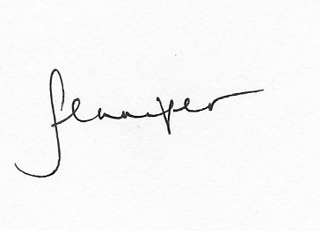
Jennifer Thompson, MS, APRN

Jennifer Thompson, MS, APRN
Executive Director
New Hampshire Nurse Practitioner Association
jenniferthompson@nhnpa.net
603-867-4002

