Join the Mount Baker Nurse Practitioner Association on **September 9th**

for a full day of lovely hiking up at Mount Baker Recreational area.

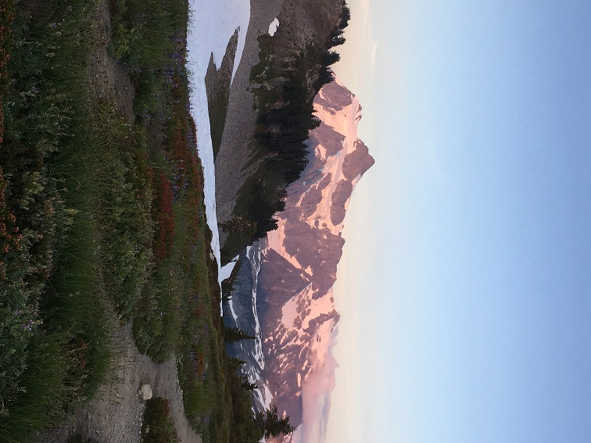We will meet in the back of the Safeway parking lot on Sunset Ave, at 9am sharp to carpool from there if you like. The plan will be for a full day of hiking out of Artist Point with the option to share a meal/brew at Chair 9 Pizza at the end of the day. Bring your packed lunch for the trail, water, containers to collect blueberries, and if you are adventurous, swimwear for a dip in the lakes. The hike is considered “easy” traversing behind table mountain, flat with stunning views of the surrounding mountains out to the point. There is a well established trail, no snow crossings at this time of year, and there are options to go down to the lakes or up to the ridge for views if you want more hiking. NW forest parking pass is required for vehicles, and day passes are available at the ranger station in Glacier.

We may break into different groups based on hiking speed and have meet up points throughout the day or at the end of the hike for dinner depending on what your hiking hopes are. Bring your families too! Dogs are welcome up there, but must be on a leash and this trail can be *busy*.

This is a great chance to grow community within our MBNPA while hiking in our glorious mountains!

We hope you will join us!

Please RSVP on the website so we know how many to expect.

(If hiking is *not* your thing, please consider the 40min lovely drive to Glacier for a dinner meet up at chair 9 restaurant by 5pm.)

Email any questions you might have to Kirstin Curtis ARNP: kasha_loo@yahoo.com