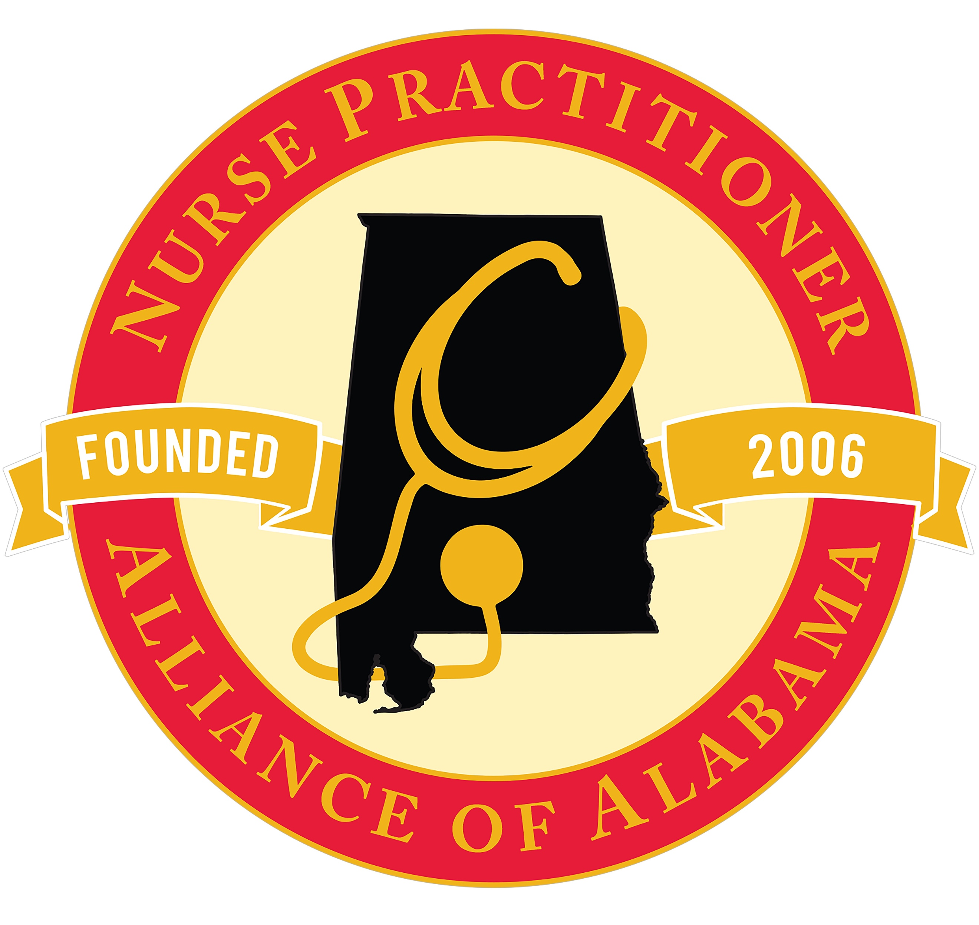

**Talking Points**

Nurse Practitioners are efficient, high quality, cost-effective and comprehensive healthcare services, particularly in rural areas.

States with signature authority for NPs have:

* Significantly **fewer emergency room visits** for non-emergent health care needs and lower admission rates
* **Better access to care**, particularly for the most vulnerable populations
* **Increased** access to care
* **Decreased** health care cost

**Death Certificates:**  
**Currently:** NPs cannot sign a death certificatein the state of Alabama but coroners and physician can.

**Passage of SB46** willimprove access to timely receipt of benefits, decrease costs, increase accuracy of cause of death

**Texas, Arkansas and North Carolina,** along with 26 additional states,allow providers such as NPs, and CNMs sign death certificates.

**DNR:**  
**Currently:** NPs are not able to sign Do Not Resuscitate (DNR) forms.

**Passage of SB46** will result in timely initiation of DNR orders/strong relationships between provider and patient, especially in hospice and rural settings. NPs are first line with the patient in many cases, especially with patients in hospice.

**Ambulance Transfer:**  
**Currently:** NPs are unable sign for ambulance transport.

**Passage of SB46** will result in timely transfer to home, nursing home, assisted living, or hospice

* MASSIVE **cost savings**
* Patient comfort
* Family emotional support
* Ensures **safe transport to home or nursing home**

**Conclusion:**Passage of SB 46 **WILL NOT** increase scope of practice. However, passage of SB 46 bill **WILL**

* + **Decrease** healthcare costs
  + **Increase** access to care in rural areas & inpatient settings
  + **Improve** outcomes for patients and/or their families
  + **Facilitate** a timely response and eliminate patient suffering
  + **Reduce** complications that arise when no one is there who can sign the paperwork/forms
  + **Increase** patient/ family satisfaction