

Objectives

* Understand lung cancer statistics and staging.
* Determine appropriate patients for screening & reinforce importance of smoking cessation.
* Understand the difference between solid, part solid & ground glass nodules.
* Understand Lung-Rads classification & follow up routine lung nodules to include complex cases.
* Understand Nursing role in educating patients about cancer screening guidelines for multidisciplinary teams.

**Registration is free**

RSVP by calling the CME Registration Line @ 239.343.9557 or FAX Completed Form to 239.343.9515

or Email to [Debbie.Manee@Leehealth.org](mailto:Debbie.Manee@Leehealth.org) by 1.16.18

Name_________________________________________________

Healthcare Profession_______________________________

License #_____________________________________________ Presented by

Phone#_______________________________________________

Email_________________________________________________ Regional Cancer Center

**Wednesday, January 17, 2018**

**5:45-8p.m.**

**Regional Cancer Center, 4th Floor Conference Room**

8931 Colonial Center Drive, Fort Myers, Florida 33905

**Guest Speakers** **Schedule**

**Keith L. Miller, M.D., 5:45 pm.** Registration/Dinner

Radiation Oncology Welcome/Introductions

21st Century Oncology **5:55 pm. James W. Orr, Jr., M.D.**

Fort Myers, Florida Medical Director,

Regional Cancer Center

**6:00 pm. Keith L. Miller, M.D.**

**Sharik K. Rathur, M.D.,** Lung Cancer Early Diagnosis, Staging Diagnostic Radiologyand Prevention

Florida Radiology Consultants  **7:00 pm. Sharik K. Rathur, M.D.**

Fort Myers, Florida Low Dose Lung Cancer Screening CT Image Interpretation & Follow Up

**8:00 pm. Question & Answers**  **Questions & Evaluations**

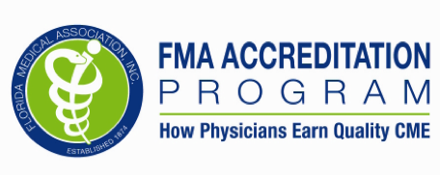 Lee Health is accredited by the Florida Medical Association to provide continuing medical education for physicians.

Lee Health designates this live activity for a maximum of 2 AMA PRA Category 1 Credit(s) TM. Physicians should claim only the credit commensurate with the extent of their participation in the activity. This activity has been reviewed and is acceptable for up to 2 prescribed credit(s) by the American Academy of Family Physicians.

Lee Health is an approved provider of Continuing Nursing Education (FBN2151). Lee Health has applied for 2 Contact Hours for this lecture.

**Faculty and Lee Health will disclose any real or apparent conflict of interest related to the content of the presentation. Faculty will also identify any off label or investigational uses discussed as such.**

**Winter Oncology Conference for Clinicians**

**Current Best Practices in**

**Lung Cancer Screening**

**For Physicians, Oncologists, Radiologists,**

**PAs, ARNPs, RNs, RTs, SWs, PTs, OTs, SLP**