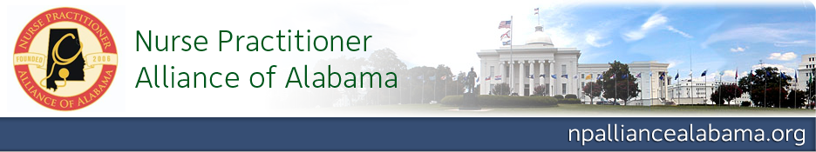
Call for Abstracts
7th Annual Conference: Prescribing for the Future
September 12 & 13, 2013 Hilton Birmingham Perimeter Park

Abstracts are now being accepted for poster and podium presentations. The deadline for submission is Friday, July 12, 2013. All submissions will be subjected to a blind review. All accepted presenters will be expected to register and pay for the full conference.

Poster Presentations (Thursday, September 12)
Preference will be given to clinical practice topics and research pertinent to nurse practitioners. Graduate student research is also welcomed and encouraged. At least one poster author will need to be present for a specified 2 hour viewing period on Thursday.

Podium Presentations (Friday, September 13)
Presentations of 25 minutes should focus on pharmacology and prescribing topics appropriate for nurse practitioners. Accepted speakers will be required to submit a CV, conflict of interest statement, and topic outline and objectives for continuing education credit approval.

For abstract submission
- Submit a cover sheet with the following information:
  - Title of presentation
  - For each presenter

    - Name
    - Credentials
    - Employer or Institution
    - Mailing address
    - E-mail address
    - Phone number

- Submit the presentation abstract on a separate page, adhering to the following guidelines:
  - Title of presentation
  - Type of submission (podium, poster, or either)
  - Abstract
    - 350 words or less, double-spaced
    - Times New Roman or Arial, 12-point font
  - No identifying information (school, author(s), etc.)
- Submit cover sheet and abstract electronically by July 12 to amaddox@samford.edu

For questions regarding the abstract submission process or requirements, contact:
Andrea Collins, DNP, NP-C, Continuing Education Committee Chair at awcollin@samford.edu

