

Oncology Grand Rounds

Cardio-Oncology Patient Evaluations

For Physicians, Family Medicine Residents, PAs, ARNPs, RNs.

Friday, August 25, 2017 at 12:00 Noon - 1 p.m.

Family Medicine Residency Classroom

8th Floor, Lee Memorial Hospital, MOC

2780 Cleveland Avenue

Fort Myers, Florida, 33901

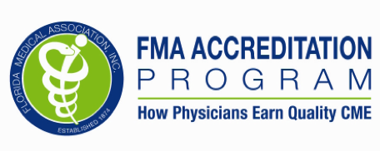Lee Health System is accredited by the Florida Medical Association to provide continuing medical education for physicians.

Lee Health System designates this live activity for a maximum of 1 AMA PRA Category 1 Credit(s) TM. Physicians should claim only the credit commensurate with the extent of their participation in the activity. This activity has been reviewed and is acceptable for up to 1 prescribed credit(s) by the American Academy of Family Physicians.

Lee Health System is an approved provider of Continuing Nursing Education by the Florida Board of Nursing (FBN#2151). Lee Health System has applied for 1 Contact Hours for this lecture.

**Faculty and Lee Health System will disclose any real or apparent conflict of interest related to the content of the presentation. Faculty will also identify any off label or investigational uses discussed as such.**

Guest Speaker

Anita M. Arnold, D.O., FACC, FSCAI, MBA

Noninvasive Cardiology

Director of Cardio-Oncology Division

Lee Physicians Group/Lee Health

Fort Myers, Florida

Schedule

11:50 a.m. Registration/Lunch

11:55 a.m. Welcome/Introductions

James W. Orr, Jr., M.D.  
Medical Director, Regional Cancer Center

12:00 p.m. Anita M. Arnold, D.O.

Cardio-Oncology:

What It Is & How It Helps

1 p.m. Questions/Evaluations

Objectives

* To understand the new specialty of Cardiovascular Medicine known as Cardio-Oncology.
* Identify complications of common chemotherapeutic

agents.

* To recognize what some of the long-term sequelae can be of treating cancer.
* To learn how to follow these patients in Survivorship status.

Registration is free

RSVP by calling the CME Registration Line at   
239-343-9557 or FAX Completed Form to 239-343-9515  
or Email to [Debbie.Manee@LeeHealth.org](mailto:Debbie.Manee@LeeHealth.org) by 8/24/17

Name__________________________________________

Healthcare Profession_____________________________

License #_______________________________________

Phone#_________________________________________

Email___________________________________________

