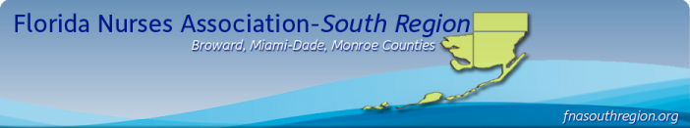
Announcing The
Second Annual Florida Nurse’s Association
South Region
Symposium and Awards Ceremony
Plan on joining us for this special event!
Saturday April 14, 2012
9:30A-4:00P Luncheon Included
Signature Grand Davie, Fl
Featuring
- Special Guest Speaker Sessions with Contact Hours Applied For
- Nursing Student Mentorship ~ Professional Networking
- Evidence Based Poster Session ~ Sponsor Display Area
- Nursing Scholarship Presentations ~ Schools of Nursing
Open to All Nurses, Students and friends of Nurses!
More Details to Follow so Mark Your Calendars
We Will Be Accepting Nominations for:
FNA South Region NURSE of YEAR AWARD
Registered Nurse Practice Award ~ Nursing Research Award
Advanced Practice Nursing Award ~ Nurse Educator Award Organizational Excellence in Nursing Award
Specialty Nursing Organizations Encouraged to Participate
Open Call for Poster Presentations contact: dhain@fau.edu
Nursing Scholarship Opportunities to be announced
Organizational and Corporate Sponsorship Opportunities Available
Additional Information contact: CONFERENCES@FLORIDANURSE.ORG

