HANP 2011-2012 Officer Nominees

President-Elect Nominee
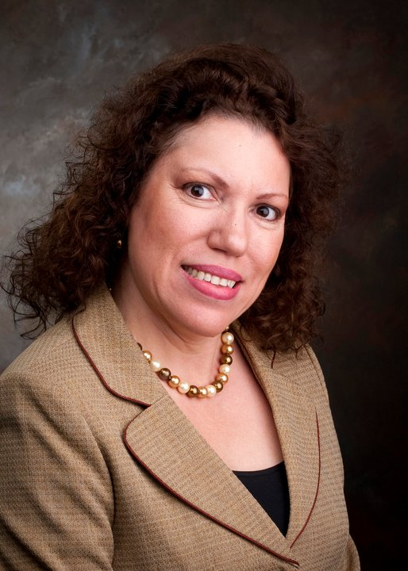
Martha B. Hinojosa, PhD, RN, FNP- BC
Post-Doctoral Associate, Menninger Department of Psychiatry, Baylor College of Medicine, Houston, TX
Dr. Hinojosa has had over 23 years of nursing experience. She graduated with a BA in Biological Sciences and a BSN from the University of Texas (UT) at Austin. She initiated her nursing career in the military as a commissioned officer in the Army Nurse Corp and completed an Ob-Gyn Specialty course at Fort Bragg. Dr. Hinojosa completed her MSN from Texas A & M- Corpus Christi in 2002, and obtained certification as a Family Nurse Practitioner from ANCC in June 2002. Dr. Hinojosa’s experience includes being a maternal-child nurse with primary care experience in prenatal care, women’s health, and pediatrics. As a staff nurse, Dr. Hinojosa worked and maintained her clinical skills in many areas of nursing, including labor and delivery, nursery, home health, triage nursing, and case management. She has taught at
The UTMB School Nursing as a clinical instructor in the areas of maternal-child, pediatrics, health assessment, and community health. She has utilized her bilingual skills in all aspects of her career. Dr. Hinojosa recently completed her doctoral work in the area of acculturation, intimate partner violence and cultural construct in young Latinas at the University of Texas Medical Branch. She currently holds a position as a post-Doctoral Associate at Baylor College of Medicine working in clinical trials. By working with professional organizations such as HANP, Dr. Hinojosa plans on providing a positive image of Nurse Practitioners and demonstrate the versatility of the role. In addition, by being active with an established professional group, Nurse Practitioners can network and expand their role as the future leaders and providers of healthcare to our communities

Treasurer-Elect Nominee
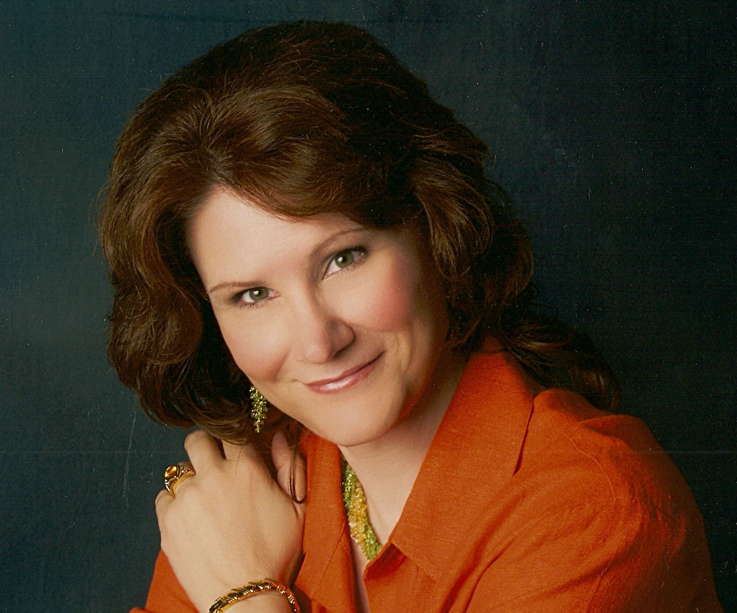
Terry L. Hale, MSN, RN, PMHNP-BC
Terry is a Psychiatric Nurse Practitioner in private practice in The Woodlands. Board certified in Family Psychiatry, she works with patients across the life span and often with a complex set of psychiatric co-morbidities. Her youngest patient was 2 years old. Her most mature patient was 104 years old. Most of her patients are seen at the office; however, she also follows patients as necessary to inpatient facilities for treatment and stabilization. She is also frequently on call at Kingwood Pines Psychiatric Hospital for emergency assessment and interventions.
Background
Terry came to nursing as her third career. She spent many years in the legal field as a contract paralegal, usually supervising massive document production and review for medically related class action suits such as asbestosis and silicosis cases. Having been a professional violinist and a harp student for some time, she became a full-time musician as a second career. She performed on the harp, made recordings, gave music lessons and has edited many musical publications for the violin and harp. After the birth of her twins, she decided a job with regular hours and steady income was called for, so she went back to school for a BSN followed immediately by and MSN. While working nightshifts in a neurosurgical ICU, she attended a MSN program full time and pursued the psychiatry specialty. Upon graduation, she sat for the Family Psychiatry Board exam and went into private family practice. In addition to inpatient and outpatient face-to-face care, she helped start a telepsychiatry company providing services to rural geriatric patients. After gaining licensure in other states, she saw patients in Iowa, Kansas and Nebraska via the Internet, from her office in Houston.
Education
- BS Physiology, Oklahoma State University
- BSN, Summa Cum Laude, UT School of Nursing, Health Science Center, Houston
- MSN, UT School of Nursing, Health Science Center, Houston
Vision
Her top three goals as Co-Treasurer of Houston Area Nurse Practitioners are:
- To provide accurate and timely bookkeeping and accounting activities with association funds.
- To facilitate timely membership registration and renewals.
- To provide accurate and accessible RSVP methods for the meetings in order to promote regular attendance by the members as well as produce a reliable accounting of expected guests for the host company.
Technical Support
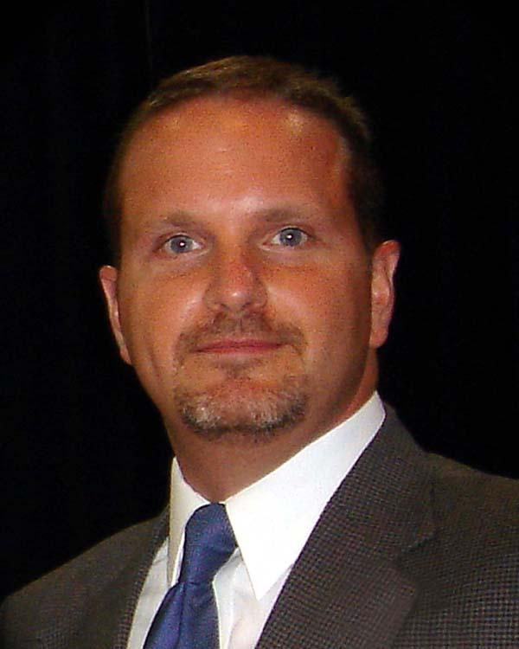
William “Billy” Johnson, MSN, RN, NP-C
Billy is a recent graduate from the University of Texas Medical Branch in Galveston and is certified through the AANP as a Family Nurse Practitioner. He is currently employed at Total Family Care, a Houston based family practice clinic, where he serves as the sole nurse practitioner alongside two family practice physicians. Billy’s background was as an emergency room nurse at Methodist Hospital, Cy-Fair Hospital, and most recently, North Cypress Medical Center. Billy received the Mary Beth Lott Upchurch Award for Outstanding Master’s Student while at UTMB and is a member of Sigma Theta Tau. He is proud of his academic accomplishments and hopes to bring an eagerness to learn along with a promise of dedication and comradery to the group.

