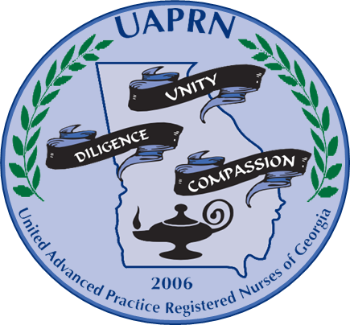

**UARPN: Shining a Light for Georgia Health**

UAPRN Atlanta Chapter Presents: The Fourth Annual

**Transition’s Day**

|  |  |
| --- | --- |
| Time | Agenda |
| 10:00-11:00 | Registration, Breakfast, and Networking |
| 11:00-12:30 | Speaker Presentations:   * Introduction & Welcome—   Dr. Joan Cranford- Assistant Dean of SON at GSU  Michelle Nelson, PhD, FNP-C, UAPRN State President   * Professional Development—Nicole Bello, DNP, FNP-C * Legislative Issues and Updates—Molly Bachtel, DNP, FNP-C * DNP Program—Susan Breslin, Director of GSU DNP Program * Boards, NPI/DEA Application, Collaborative Agreements—Olushola Alaka, DNP, FNP-C * Legal Issues of APRNs—Cheryl Garcia |
| 12:15-12:30 | Organization Introductions:   * GAPNA- Ga Gerontological Advanced Practice Nurses Association * APRN Council of Coastal Georgia * Preceptor Blog Video |
| 12:30-1:30 | Lunch and Learn:  Title: *Managing Professional Boundaries* |
| 1:30-2:00 | Speaker Presentations:   * Resume Preparation—John Milner * Interviewing—Renzie Richardson |
| 2:00 | Closing/Networking/Survey/Raffle |

**Please become a member on the UAPRN Atlanta Chapter Website**

**agaprn.enpnetwork.com**