**Rodney Wooters**

**Vice President - Sales / National Sales Manager**

DFW, TX 972-489-7131 ♦ [rwooters@hotmail.com](mailto:rwooters@hotmail.com) ♦ <https://linkedin.com/in/rodneywooters> ♦ <https://rodneywooters.workfolio.com>

***Sales Management & Forecasting /*** ***P&L Management / National Account Management /*** ***Business Development / Product Development & Management Product Marketing & Packaging / Marketing Strategy / Competitive Analysis Pricing Strategy / Brand Management / Consumer Products / Fast Moving Consumer Goods / International Sales / Procurement / National Accounts Private Equity / International Trade / Team Leadership***

An entrepreneurial sales manager with numerous successes expanding sales in US, Canada, and Mexico markets with extensive international sourcing experience in Asia. History of recruiting and leading high-performance sales teams, growing top-line sales, and maximizing profits in companies ranging from start-ups to established companies.

* Led start-ups and new company growth initiatives from ideation to implementation and profitable operations.
* Hired, built, and managed North American sales teams for four companies.
* Conceived, developed, sourced, and introduced 100s of new products and introduced new categories.

**BA** - Business Economics, Brown University, Providence, Rhode Island.

**Career History**

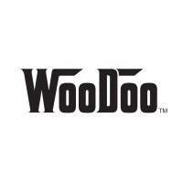**Vice President Sales**

**WooDoo LLC**

05/2016 – Present

*Provided sales, marketing, and product development consulting services.*

Founded firm as the sales and marketing arm for a Chinese manufacturing company.

* Introduced manufacturer to the North American marketplace, developed the go-to-market strategy and sales plan, product mix, pricing policy, and hired sales representation organizations.
* Secured new accounts with Lowe’s Canada, Home Depot, Target, Menards, Neiman Marcus, Amazon, Ace Hardware, and Wayfair.
* Increased sales from zero to $5.0M in two years.
* Negotiated sales agreement with Canadian distributor, resulting in $200K sales in 2017, $1.5M in 2018, and $2.8M in 2019.

*“I am a hands-on sales leader helping companies maximize sales velocity, increase market share and improve profit margin through excellence in sales leadership.”*

* Overcame buyer costing objections through modifying and implementing product line changes, displacing existing vendor, and winning $625K in business.
* Designed and developed two different off-shelf pallet floor merchandising displays, driving $1.2M in sales to the Lowe’s account.
* Managed complex product recall, re-work, and sale of 252 containers to Big Lots.
* Directed the product development team introducing 32 new designs, shapes, and price points adapted to the North American market.
* Developed Vendor relationships with Home Depot and Target through their online direct to consumer model.

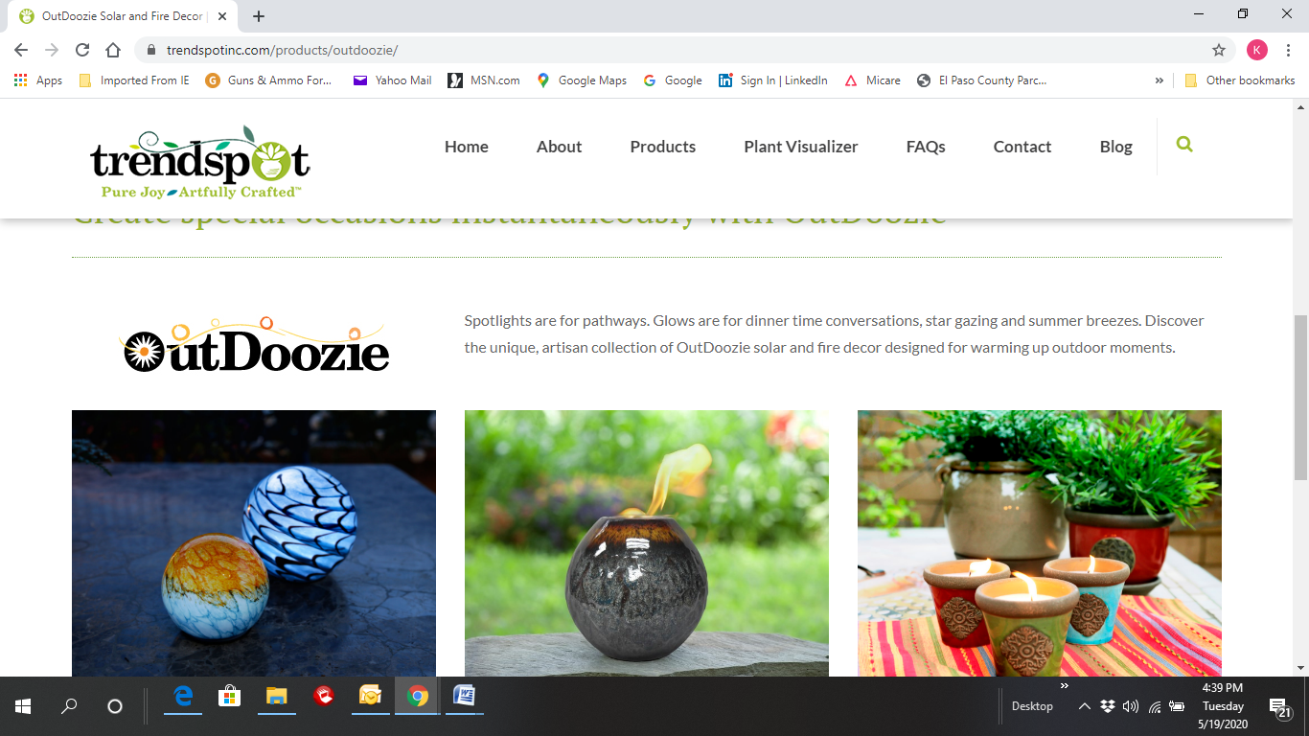**Vice-President Sales**

**OutDoozie**

01/2015 – 07/2015

*Produced and marketed outdoor solar and fire décor items.*

Served as senior sales executive.

* Directed all sales activities with specific responsibility for Walmart, Lowe's, Menards, Canadian Tire, and Meijer accounts producing $4.9M in revenue in the US and Canada.
* Developed and implemented distributor program, producing $925K in sales from 12 new lawn and garden distributor accounts.
* Secured Sam’s Club Christmas promotion resulting in $815K in revenue.

**Director of Sales**

**Dyno Seasonal Solutions**

01/2014 – 01/2015

*Designed and marketed seasonal products.*

Directed the USA and Canada account portfolio, overseeing two account managers and three sales representative organizations.

* Managed $12.5M USA and Canada accounts including Walgreens, Target, Canadian Tire, Big Lots, Michaels, Hobby Lobby, Ace Hardware, True Value, Menards, and Safeway.
* Increased sales across the major accounts by 18.4%.

**President**

**Crown Sports**

11/2008 – 01/2014

*Developed and distributed seasonal, outdoor living, and tabletop fountains.*

Founded and managed company. Directed team in creating products, manufacturer sourcing, importing, establishing partnerships, and managing sales.

* Established a China-based sourcing office, hired two employees, engaged US product development team, and managed factory relations ensuring factories met account guidelines and requirements.
* Led company from startup to $4.5M in sales and $500K in profit while financing all operations.

*“Rodney is one of the most honest and hard-working people I have ever met. He cares about his client's needs and goes the extra mile to offer the best solutions at the best value while giving the ultimate customer service.”*

* Managed USA and Canada sales efforts including Mass Market, Home Center, Warehouse Clubs, and Food/Drug from presentation to shipment with 98% on-time shipping record.
* Secured Walgreens program by developing an innovative packaging display for St. Patrick's Day wearables, producing $550K in sales.
* Opened 17 accounts including Lowe’s, Menards, Costco, BJ’s Wholesale, Kroger, Cracker Barrel, QVC, and HSN during the 2008-09 financial crisis.
* Navigated complex situation and prevailed in China civil litigation regarding a defective merchandise reimbursement claim.
* Designed new seasonal product and developed an innovative, motion-activated display with interactive Try Me packaging, producing $1.75M in orders.

**President**

**Square Island**

03/2006 – 11/2008

*North American sales and marketing arm for Chinese manufacturing group with product categories including seasonal, outdoor living, lighting, and home decor.*

Founded company with Chinese manufacturing company owner.

* Recruited and led sales team with two national account managers and twelve independent sales representative organizations.
* Opened 45 accounts across the USA, Canada, and Mexico including Walmart USA and Canada, Target, Home Depot, Lowe's, Walgreens, CVS, Menards, Kroger/Fred Meyer, Canadian Tire, Liverpool and Soriana.
* Developed new products for North American retailers, growing the business from $0 to $20M and EBIT of $920K in less than three years.
* Directed the product development team in a full line of new seasonal products for Target, becoming exclusive supplier landing $5.5M in sales.
* Modified and changed design and packaging for outdoor fireplace program, reducing the packaging size and the landed cost, winning $2.2M in sales to Sears.

**Vice President of Sales & Marketing**

**Westinghouse Solar**

03/2005 – 03/2006

*Produced and marketed outdoor solar lighting.*

Senior Sales and marketing executive managed VP - sales, two national account managers, and twelve sales representative agencies.

* Drove $90M in revenue from major accounts including Walmart, Sam's Club, Target, Lowe's, Home Depot, and BJ's Wholesale Club.
* Increased US and Canada sales revenue by 28% and managed the Costco sales team producing $24M in revenue.
* Opened three new accounts resulting in $8.5M in sales growth.
* Developed distributor program with $3.5M in sales.

**Earlier Career:**

Director of Sales - Gemmy Industries, 12/2001 – 03/2005. Managed the USA and Canada account portfolio for this industry leader in the seasonal decor space.

National Sales Manager - New England Pottery, 03/2000 – 11/2001.

National Sales Manager - American Designer Pottery, 01/1997 – 012000.

International Sales Manager - Williamson-Dickie Manufacturing Company, 01/1993 – 01/1997. Hired distributors in six countries for this premium US workwear brand.

**Additional Information**

Community Service:

Co-chair - Brown Football Association Captain's Network, Member - Executive Committee. Member - Brown Alumni Interviewing Program